UI/UX

Experiment 2 roll no:231701054

AIM:

To create a donation page for wayanadu

Tools:

Figma

Procedure:

-> Change the color of the background .

-> Add shapes according to the donation design

-> insert images related to wayanadu or design a image for that

-> create a normal log in page or a signup page and a donation page with payament.

-> connect it with other pages using prototype

-> preview it and change if needed.

Output:

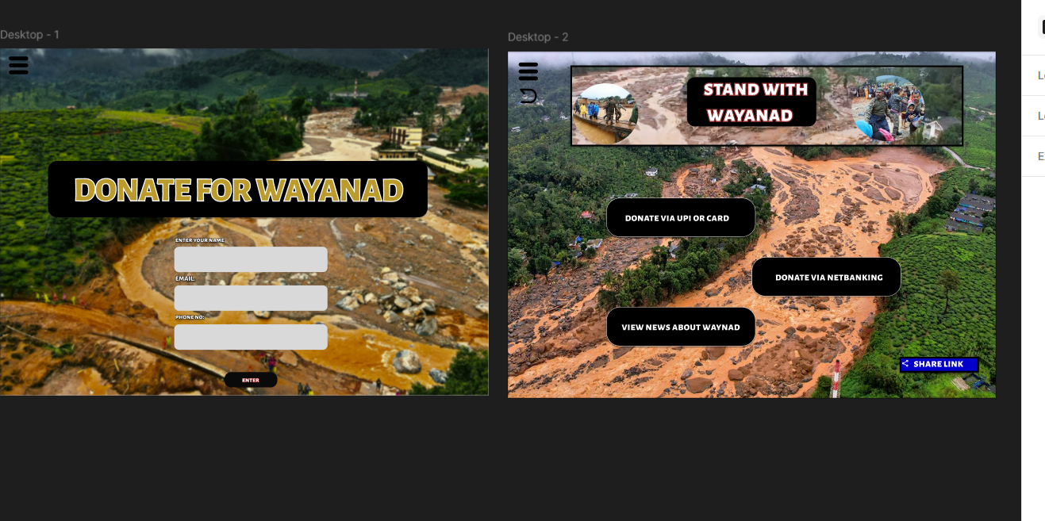

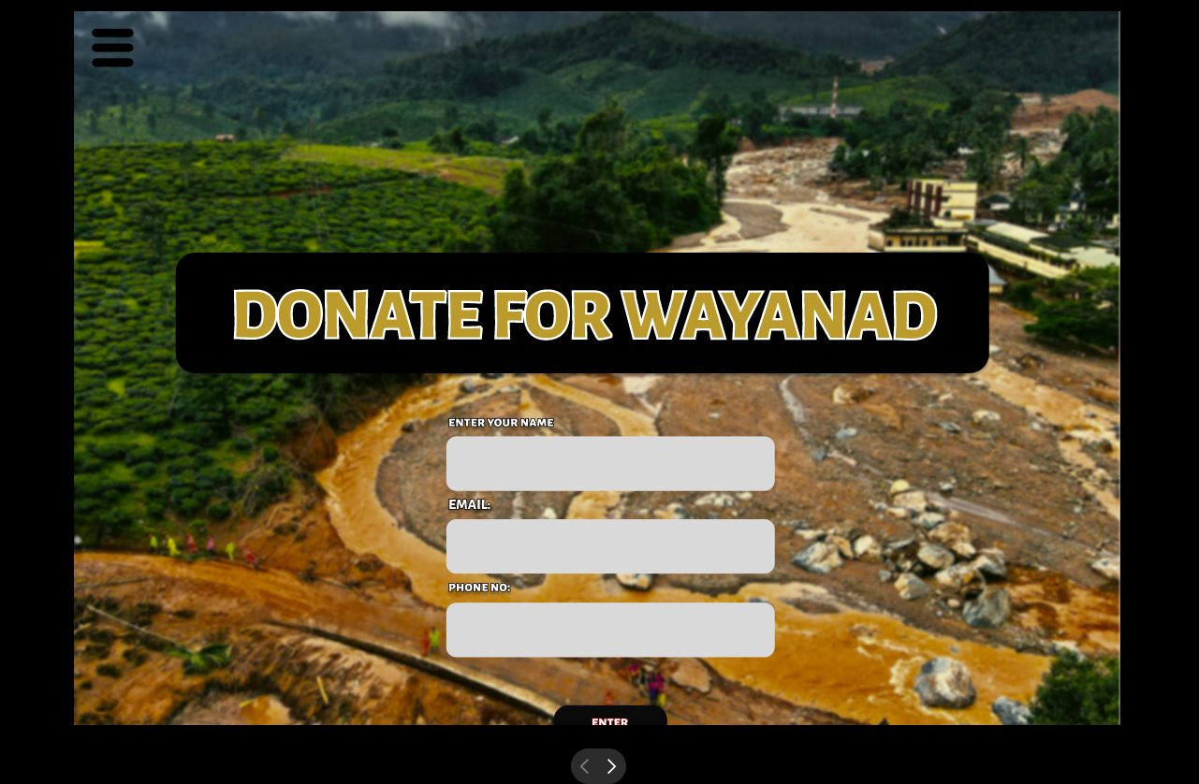

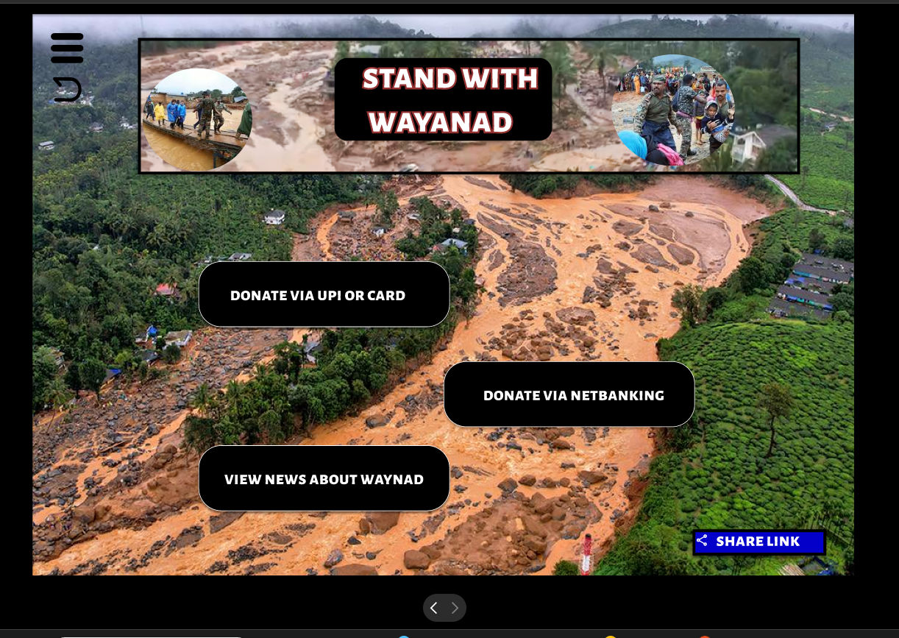

Result:

The desired user interface has been created and previewed.