UI/UX

Experiment 3 roll no:231701054

AIM:

To create a remote app

Tools:

Figma

Procedure:

-> Change the color of the background .

-> Add shapes related to a remote

-> insert images that resembles a remote or design it.

-> create a normal log in page or a signup page and create a remote which can be used in absence of original.

-> include animations. Make a smooth transatition

-> connect it with other pages using prototype

-> preview it and change if needed.

Output:

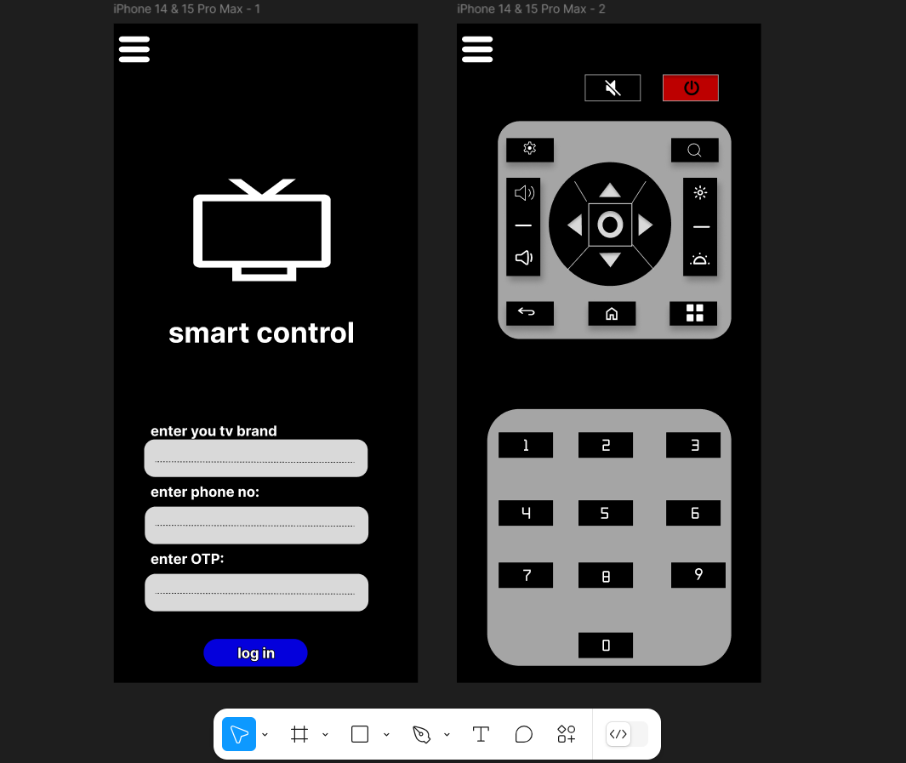

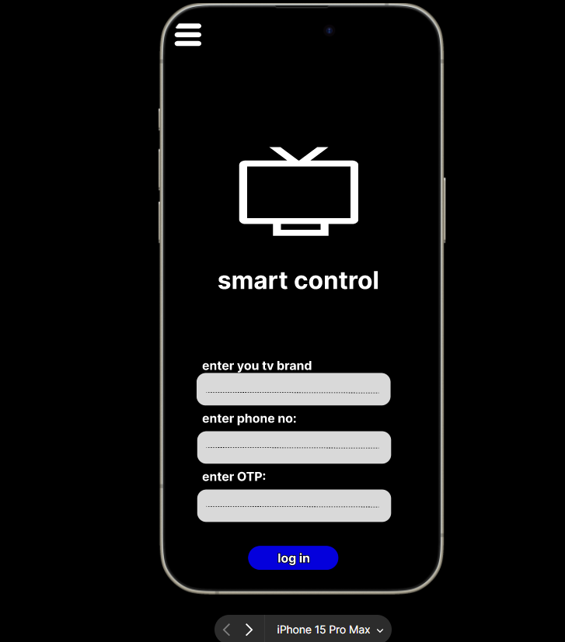

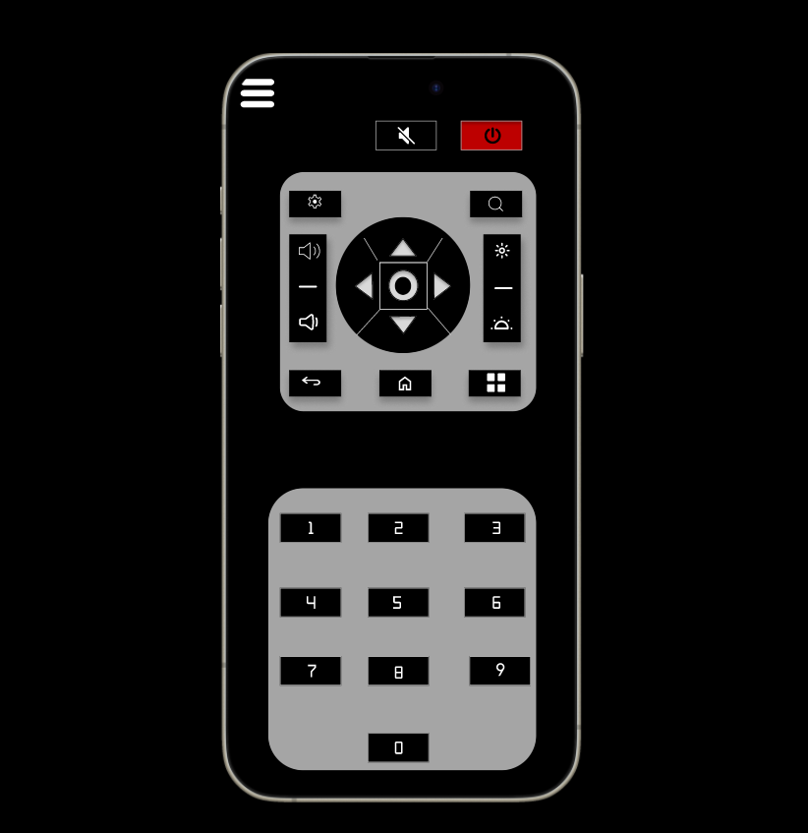

Result:

The desired user interface has been created and previewed.