UI/UX

Experiment 4 roll no:231701054

AIM:

To create a canteen menu app

Tools:

Figma

Procedure:

-> Change the color of the background .

-> Add shapes related to a food

-> insert images of food and related items.

-> create a normal log in page or a signup page and create a menu so you don’t waste time for waiting .

-> include animations. Make a smooth transatition

-> connect it with other pages using prototype

-> preview it and change if needed.

Output:

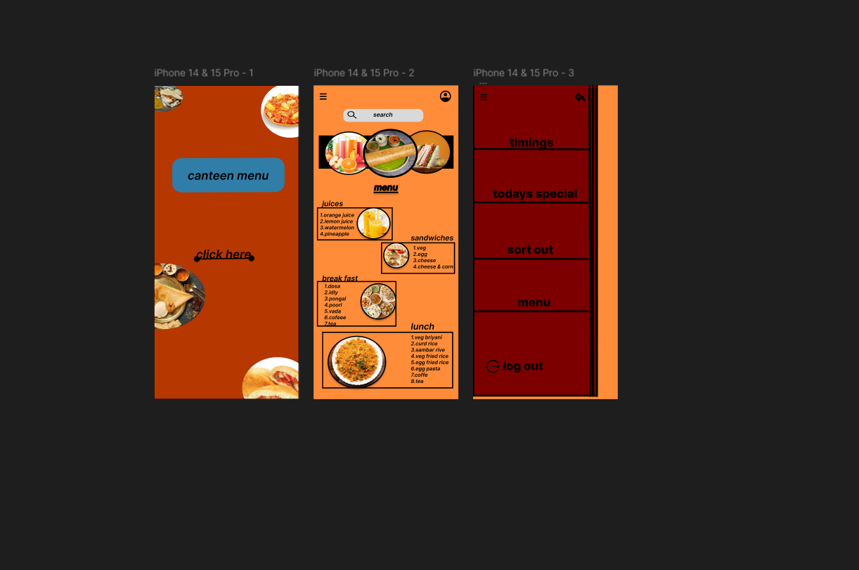

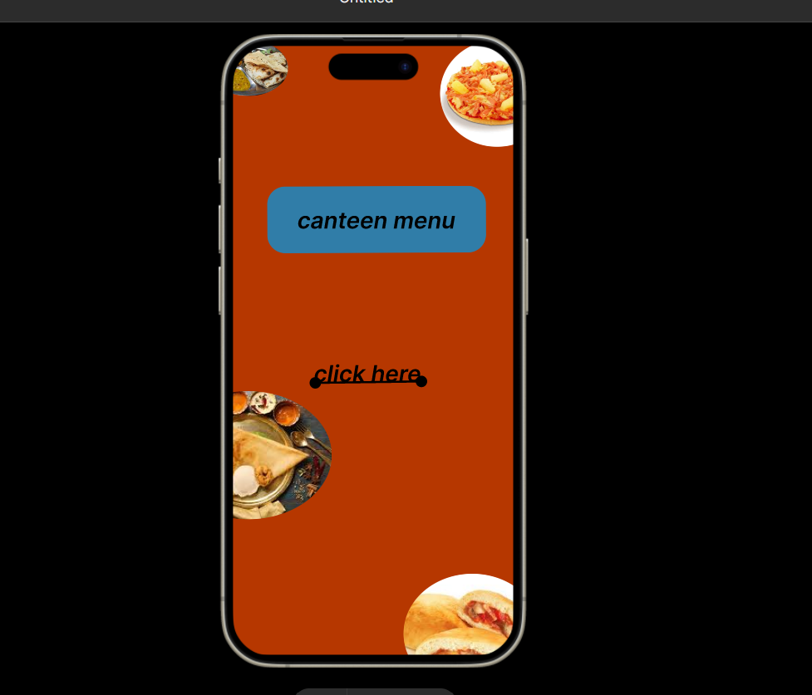

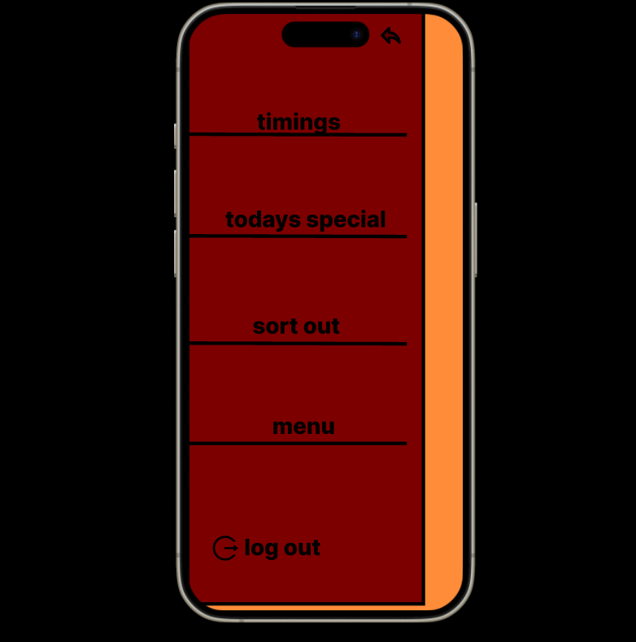



Result:

The desired user interface has been created and previewed.