UI/UX

Experiment 5 roll no:231701054

AIM:

To create a car rental app

Tools:

Figma

Procedure:

-> to design a car rental app so that every one can have their own luxary car

-> like always changing the background and addinf details to it.

-> by adding brands and their models we have to ensure that user understand everything.

-> by giving details and everything and providing information.

->finally a payment page is created.

Output:

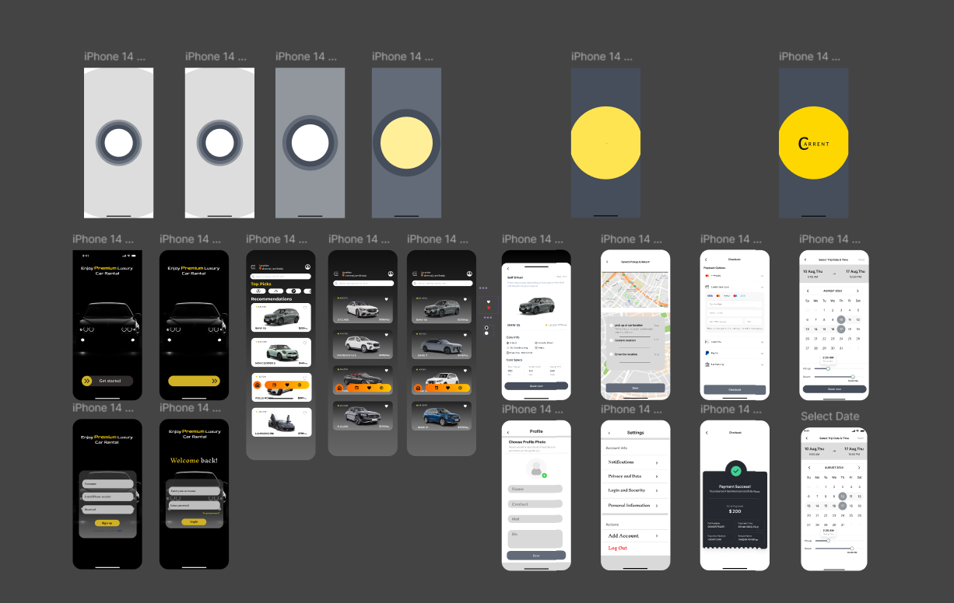

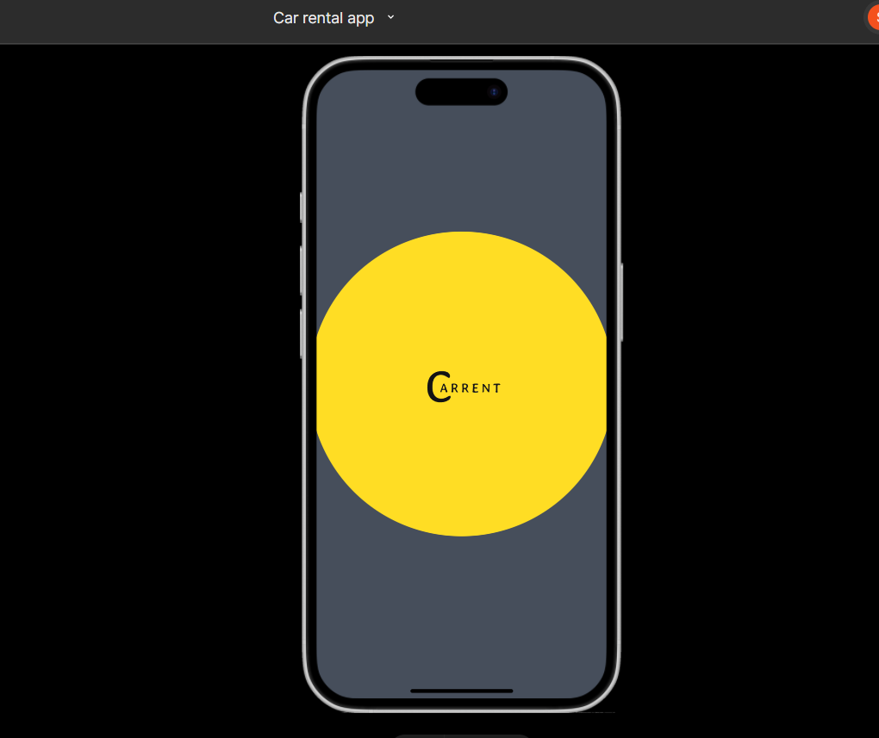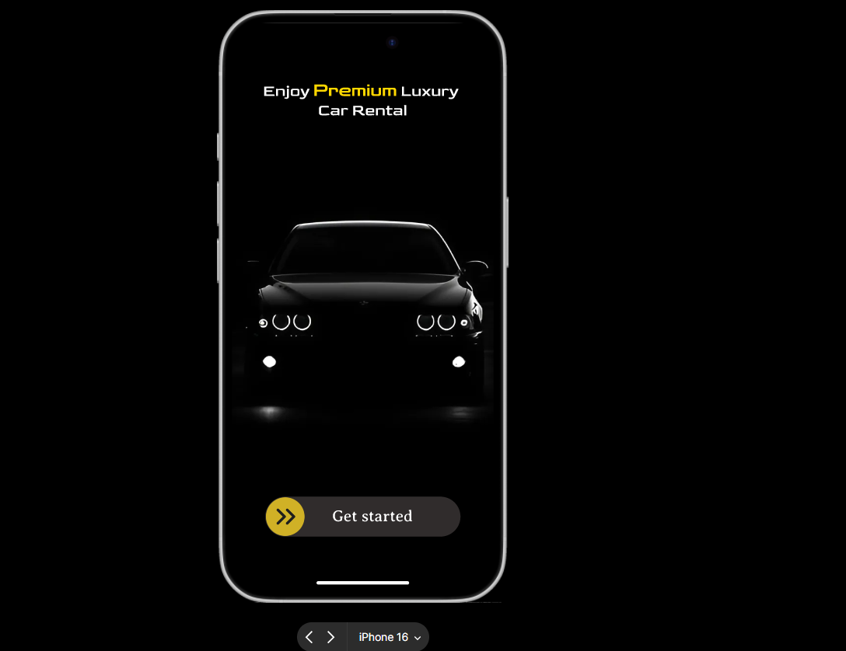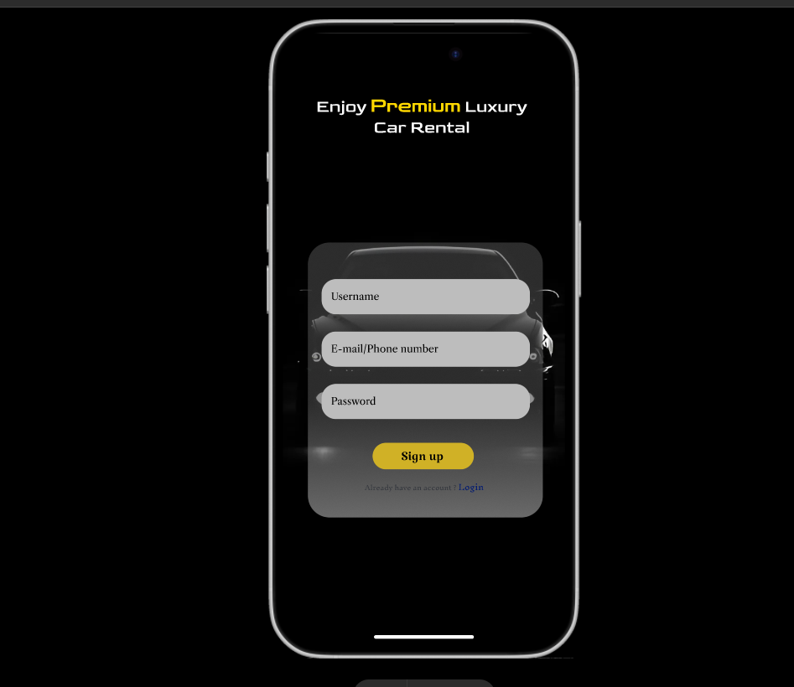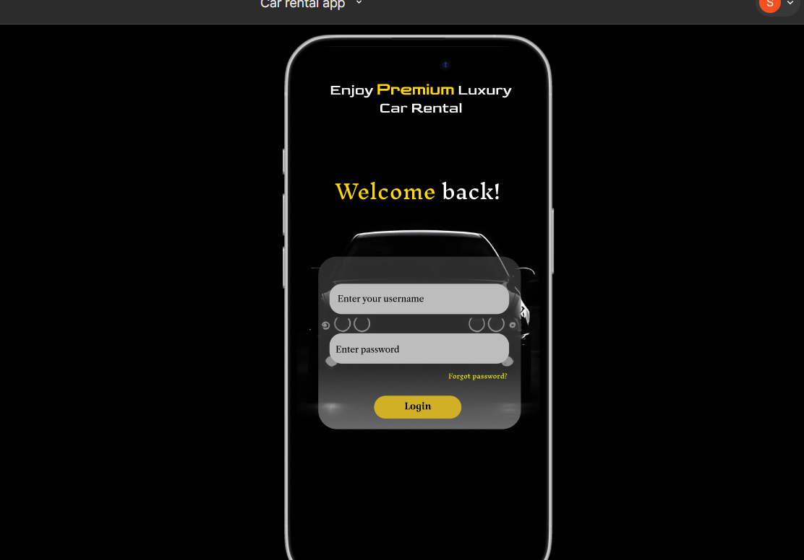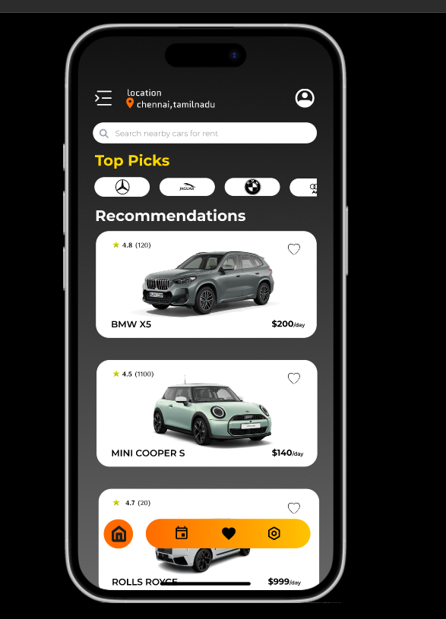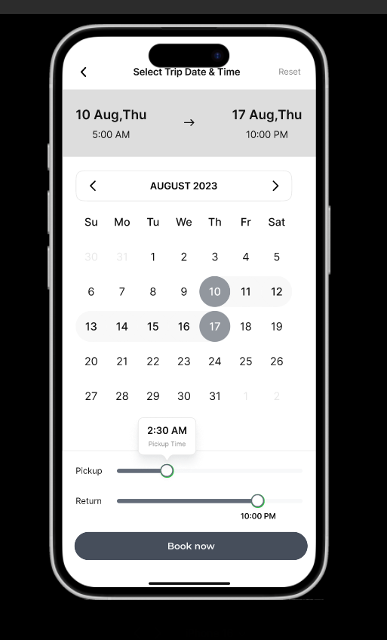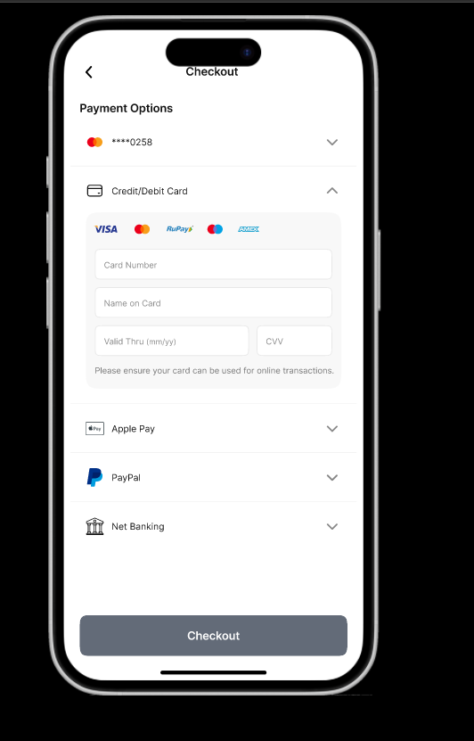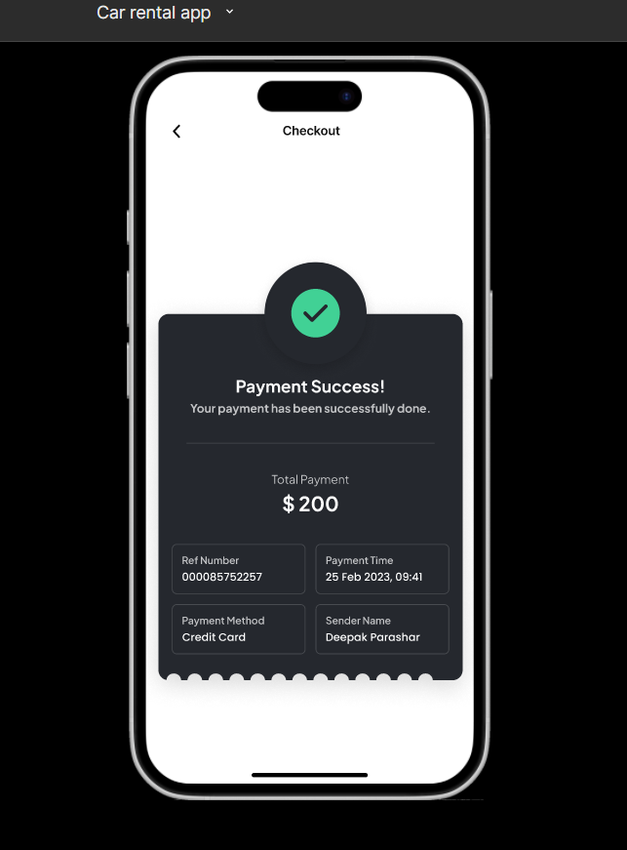

Result:

The desired user interface has been created and previewed.