UI/UX

Experiment 7 roll no:231701054

**AIM: To create a lanshop app page.**

**PROCEDURE:**

**1.To create required layouts.**

**2.To add the required texts.**

**3.Selecting the appropriate colors,fonts and font sizes.**

**4.To connect the texts with the appropriate layouts with the help of prototype.**

**5.Adding images wherever needed.**

**6.Finally watching the preview with the desktop view.**

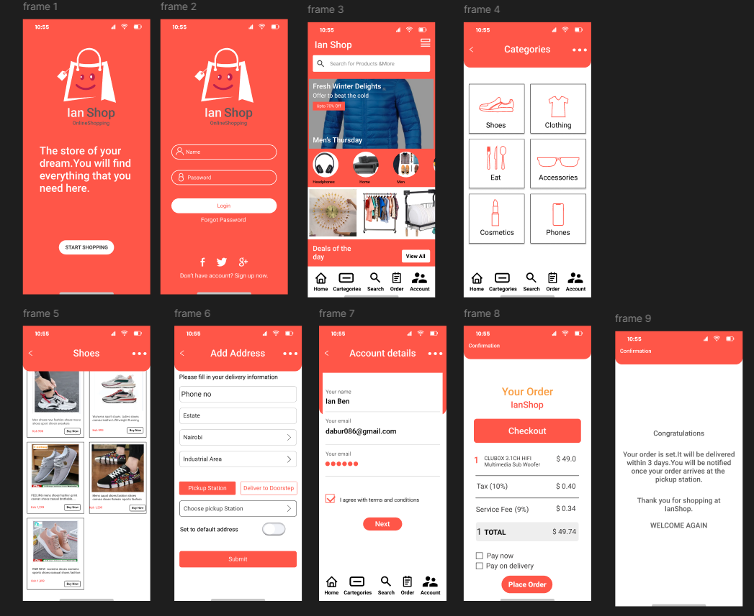

**RESULT: Hence the design is completed and output is verified.**