1. **Installation**

Download from c:\ua3\Source\Utilities\Dev\SQLConverter\SQL Converter 1.0.zip

Extract zip file and double Click on SQL Converter.exe

1. **The SQL Converter will convert the Oracle DDL and DML as SQL Server scripts.**

This tool will help the developer to migrate ORACLE DDL and DML statements to SQL statements.

The Oracle DDL and DML syntax should be verified before processing the statements in this tool.

The tool can process multiple statements in a single go.

The generated SQL output should be tested and validated in SQL Server environment before check-in.

**Refer the documents before using this tool.**

a) Oracle to SQL Comparison.xslx 🡪 Sample Oracle statement and its equivalent SQL statements.

\Documentation\Architecture\Info Arch\DBA\Reference\Oracle to SQL Comparison.xslx

b) Oracle to SQL DDL scripts conversion guidance 🡪 Coding guidance to convert Oracle to SQL scripts.

\Documentation\Architecture\Info Arch\DBA\Processes\Sql-Training\OracleToSQLServerConversion\ Oracle to SQL DDL scripts coding guidance.docx

c) Oracle to SQL Migration Checklists.xslx 🡪 Links to SQL Server documentation.

\Documentation\Architecture\Info Arch\DBA\ Processes\Sql-Training\OracleToSQLServerConversion\ Oracle to SQL Migration Checklists.xslx

1. **The SQL Converter Datatype mapping guideline**

See the [Determining Consistent Data Field Definitions](https://mygainwell.sharepoint.com.mcas.ms/teams/hchppinnovations/Checklists/Determining%20Consistent%20Data%20Field%20Definitions.aspx)​ checklist, Data Type Mapping Additional Guidance section.

1. **SQL Convertor tool.**

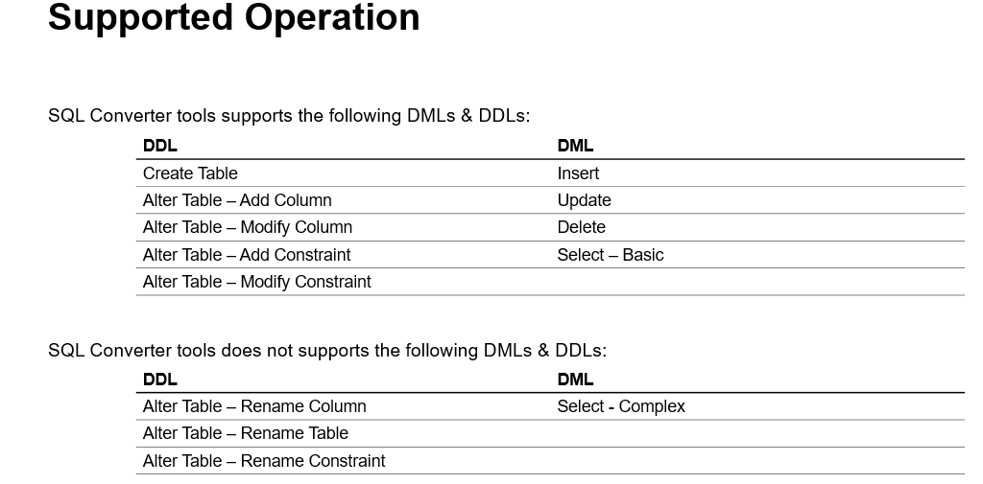

1. **Localized features available in tool.**

The tool will suppress commit in SQL statement and support variables.

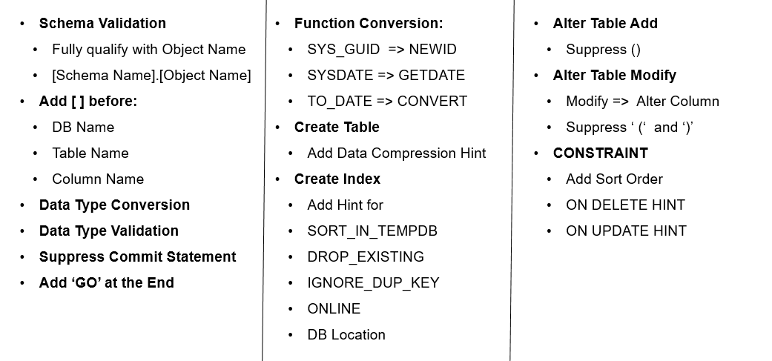

1. **Tool Input**
2. In the left tab, paste the Oracle DML or DDL statements.
3. Click the <Convert> button.

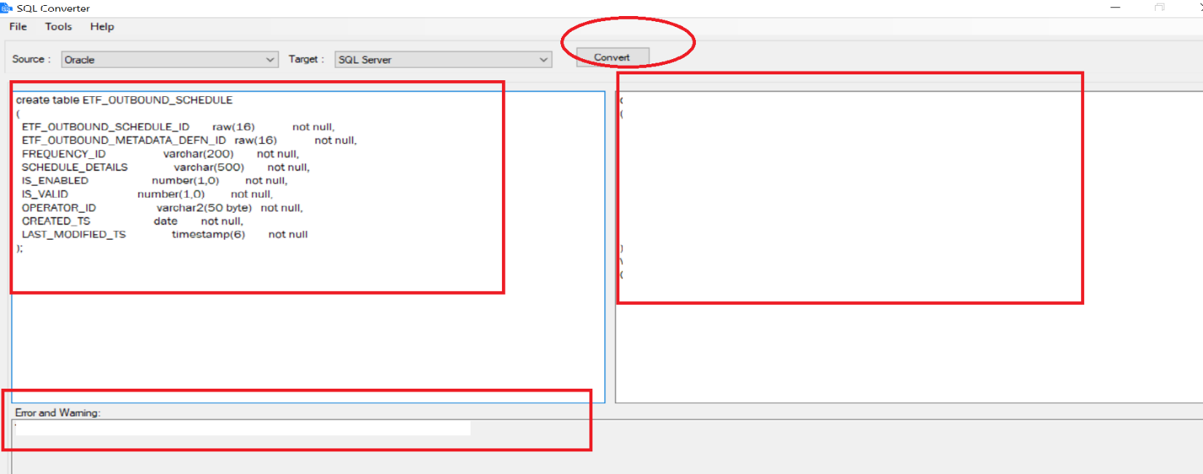

1. The Oracle equivalent SQL script is generated and copied in the right tab.
2. Refer for Error and Warnings tab, in case if any errors or warnings is found.

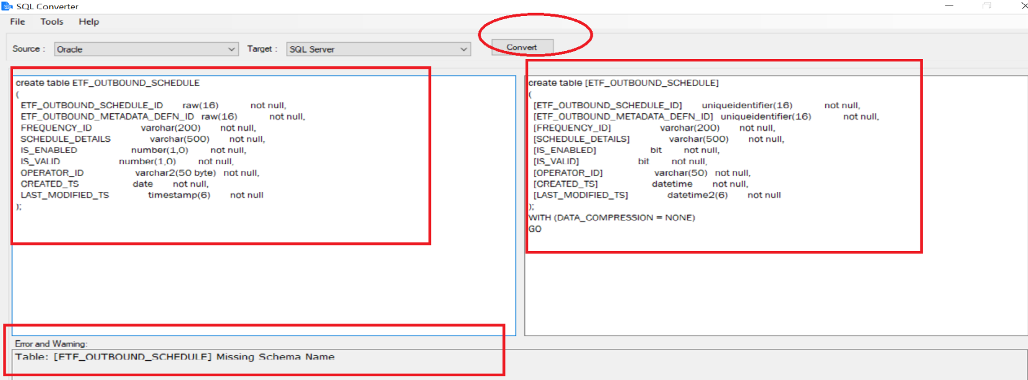

1. **SQL Convertor errors and warnings.**

The tool will validate the input Oracle statements and generate the SQL statements in right pane with if any errors found in separate section. Rewrite the Oracle statements based on the error found given by the tool.

The errors and warnings are captured and shown in the separate section.

The errors are categorized as (Naming Standard Error, Unsupported datatype, Missing Schema Name).

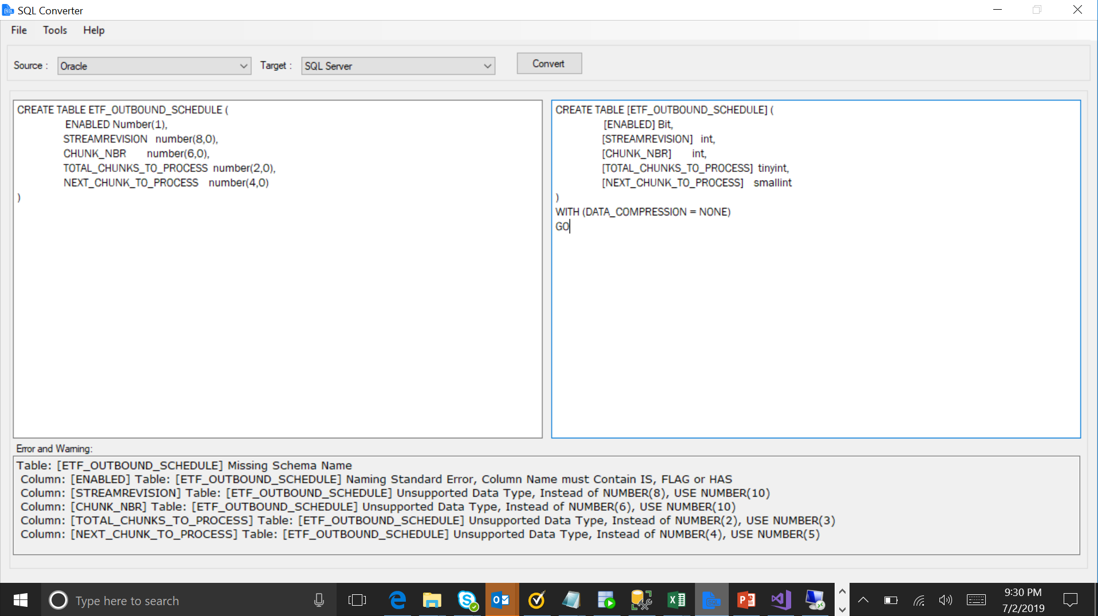

6

5

4

3

2

1

The Error and Warnings are captured in separate section, refer above image.

1. Table Schema name is missing.

**Missing Schema Name:** Table: [ETF_OUTBOUND_SCHEDULE] Missing Schema Name

**Action:** Add schema name.

1. Boolean type column should prefix or suffix with IS_ or _FLAG or _HAS.

**Naming Standard Error:** Column: [ENABLED] Table: [ETF_OUTBOUND_SCHEDULE] Naming Standard Error, Column Name must Contain IS, FLAG or HAS.

**Action:** Add column name with prefix or suffix with IS_ or _FLAG or _HAS.

1. NUMBER (8) is not a supported datatype.

**Unsupported datatype:** Column: [STREAMREVISION] Table: [ETF_OUTBOUND_SCHEDULE] Unsupported Data Type, Instead of NUMBER (8), USE NUMBER (10).

**Action:** Change the datatype to NUMBER (10).

1. NUMBER (6) is not a supported datatype.

**Unsupported datatype:** Column: [CHUNK_NBR] Table: [ETF_OUTBOUND_SCHEDULE] Unsupported Data Type, Instead of NUMBER(6), USE NUMBER(10).

**Action:** Change the datatype to NUMBER (10).

1. NUMBER (2) is not a supported datatype.

**Unsupported datatype:** Column: [TOTAL_CHUNKS_TO_PROCESS] Table: [ETF_OUTBOUND_SCHEDULE] Unsupported Data Type, Instead of NUMBER(2), USE NUMBER(3)

**Action:** Change the datatype to NUMBER (3).

1. NUMBER (4) is not a supported datatype.

**Unsupported datatype:** Column: [NEXT_CHUNK_TO_PROCESS] Table: [ETF_OUTBOUND_SCHEDULE] Unsupported Data Type, Instead of NUMBER (4), USE NUMBER (5)

**Action:** Change the datatype to NUMBER (5).