1. **The SQL Converter will convert the Oracle DDL and DML as SQL Server scripts.**

This tool will help the developer to migrate ORACLE DDL and DML statements to SQL statements.

The Oracle DDL and DML syntax should be verified before processing the statements in this tool.

The tool can process multiple statements in a single go.

The generated SQL output should be tested and validated in SQL Server environment before check-in.

**Refer the documents before using this tool.**

a) Oracle to SQL Comparison.xslx 🡪 Sample Oracle statement and its equivalent SQL statements.

\Documentation\Architecture\Info Arch\DBA\Reference\Oracle to SQL Comparison.xslx

b) Oracle to SQL DDL scripts conversion guidance 🡪 Coding guidance to convert Oracle to SQL scripts.

\Documentation\Architecture\Info Arch\DBA\Reference\Oracle to SQL DDL scripts coding guidance.docx

c) Oracle to SQL Migration Checklists.xslx 🡪 Links to SQL Server documentation.

\Documentation\Architecture\Info Arch\DBA\Reference\ Oracle to SQL Migration Checklists.xslx

1. **The SQL Converter Datatype mapping guideline.**

|  |  |  |  |  |
| --- | --- | --- | --- | --- |
| **.NET Type** | **SQL Server Type** | **Oracle Type** | **Min & Max Value** | Recommended, based on Max Value |
| Boolean | BIT | Number (1,0) | False and True | 0 and 1 | Oracle does not have a Boolean data type Number(1,0) is used.  Columns naming should clearly identify by using IS_ HAS_ prefixs or _IND or _FLAG suffix naming. |
| System.Byte | TINYINT | Number(3,0) | 0 to 255  If you expect the data value to exceed 255 or storing values <0,  modify the mapping to a larger numeric data type such Int16. | Oracle NUMBER(3,0) has a default mapping to .NET Byte. Oracle NUMBER(3,0) can store a value up to 999, while a .NET Byte can store up to the value of 255. If you expect the data value to exceed 255 or storing values <0, modify the mapping to a larger numeric data type such Int16. |
| Short/System.Int16 | SMALLINT | Number(5,0) | -32,768 to 32,767 | NUMBER(5,0) can store a value up to 99,999, while a .NET Int16 can store up to the value of 32,767. If you expect the data value to exceed 32,767, modify the mapping to a larger numeric data type such Int32. ​ |
| Int/System.Int32 | INT | Number(10,0) | -2,147,483,648 to -2,147,483,647 | Oracle NUMBER(8,0) can store a value up to 9,999,999,999, while a .NET Int32 can store up to the value of 255. If you expect the data value to exceed 2,147,483,647, modify the mapping to a larger numeric data type such Int64. |
| Long/System.Int64 | BIGINT | Number(19,0) | -9,223,372,036,854,775,808 to 9,223,372,036,854,770,000 | Oracle NUMBER(19,0) can store a value up to 9,999,999,999,999,999,999, while a .NET Int64 can store up to the value of 9,223,372,036,854,775,807. If you expect the Oracle data to exceed 9,223,372,036,854,775,807, modify the mapping to a larger numeric data type Decimal. |
| Float/Double/Decimal | Numeric(p,q) | Number(p,q) |  | NUMBER(p,q), where q > 0. |
| GUID | UNIQUEIDENTIFIER |  | GUID | Use rawToGuid transform in Oracle |
| String | Varchar/Char | Varchar2/Char | String | When sizing do not assume byte and character are the same. Consider mutli byte Unicode character encoding. 40 bytes may only store 10 characters in some cases. |
| Datetime | Datetime2(0) | Date | Date |  |
| Datetime | Datetime2(6) | Timestamp(6) | Date |

1. **SQL Convertor tool.**

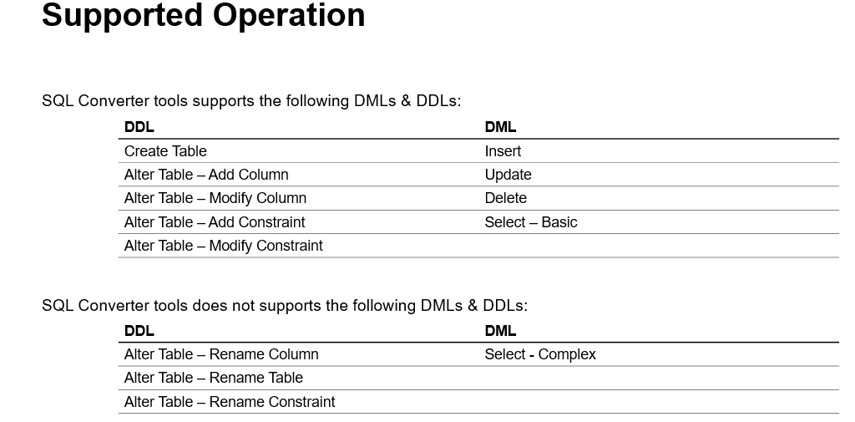

1. **Localized features available in tool.**

The tool will suppress commit in SQL statement and support variables.

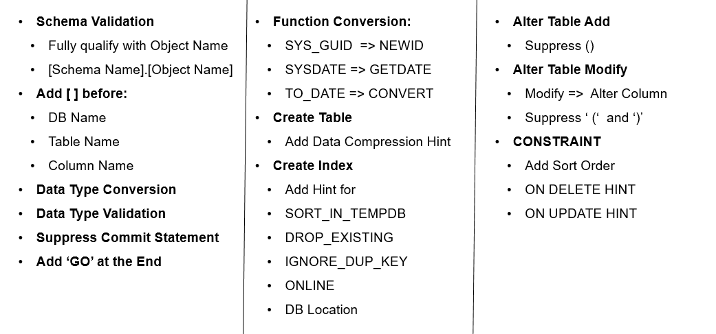

1. **Tool Input**
2. In the left tab, paste the Oracle DML or DDL statements.
3. Click the <Convert> button.

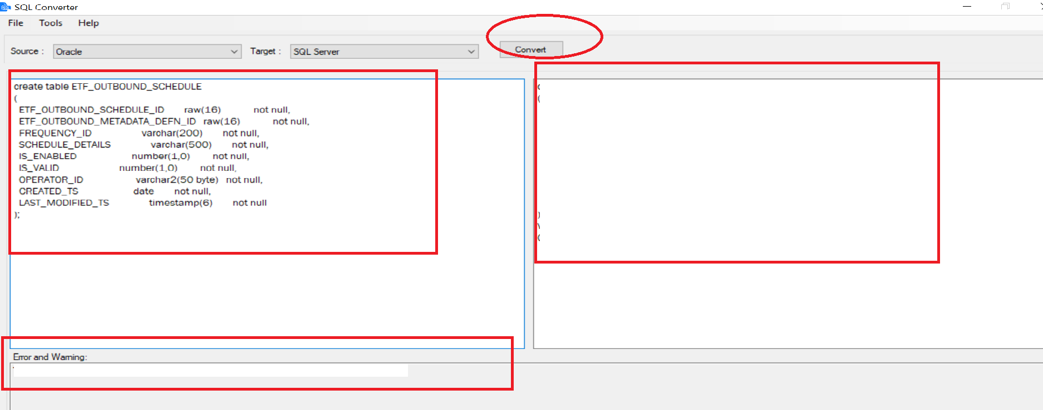

1. The Oracle equivalent SQL script is generated and copied in the right tab.
2. Refer for Error and Warnings tab, in case if any errors or warnings is found.

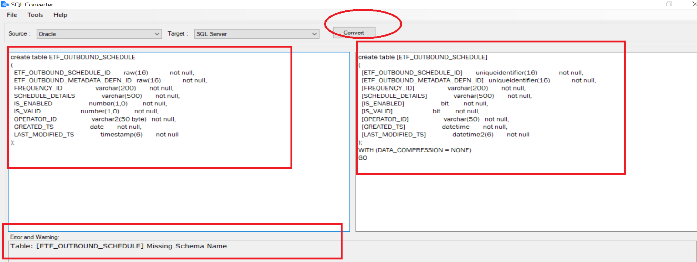

1. **SQL Convertor errors and warnings.**

The tool will validate the input Oracle statements and generate the SQL statements in right pane with if any errors found in separate section. Rewrite the Oracle statements based on the error found given by the tool.

The errors and warnings are captured and shown in the separate section.

The errors are categorized as (Naming Standard Error, Unsupported datatype, Missing Schema Name).

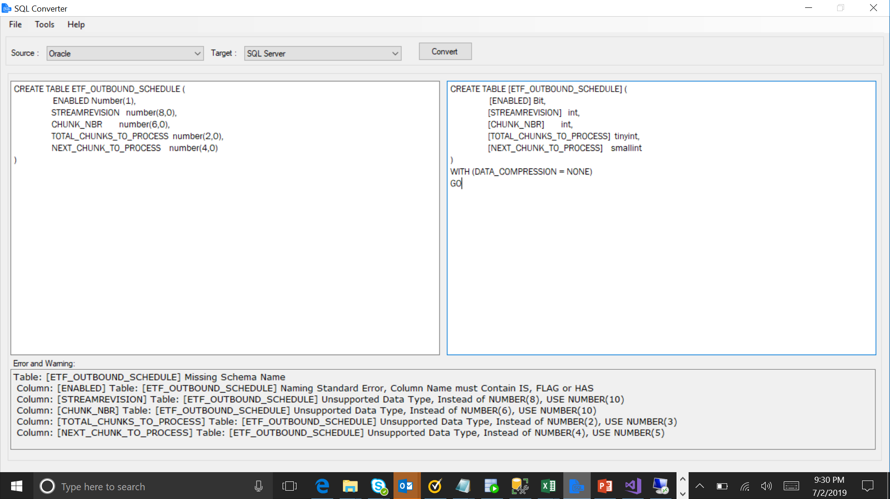

6

5

4

3

2

1

The Error and Warnings are captured in separate section, refer above image.

1. Table Schema name is missing.

**Missing Schema Name:** Table: [ETF_OUTBOUND_SCHEDULE] Missing Schema Name

**Action:** Add schema name.

1. Boolean type column should prefix or suffix with IS_ or _FLAG or _HAS.

**Naming Standard Error:** Column: [ENABLED] Table: [ETF_OUTBOUND_SCHEDULE] Naming Standard Error, Column Name must Contain IS, FLAG or HAS.

**Action:** Add column name with prefix or suffix with IS_ or _FLAG or _HAS.

1. NUMBER (8) is not a supported datatype.

**Unsupported datatype:** Column: [STREAMREVISION] Table: [ETF_OUTBOUND_SCHEDULE] Unsupported Data Type, Instead of NUMBER (8), USE NUMBER (10).

**Action:** Change the datatype to NUMBER (10).

1. NUMBER (6) is not a supported datatype.

**Unsupported datatype:** Column: [CHUNK_NBR] Table: [ETF_OUTBOUND_SCHEDULE] Unsupported Data Type, Instead of NUMBER(6), USE NUMBER(10).

**Action:** Change the datatype to NUMBER (10).

1. NUMBER (2) is not a supported datatype.

**Unsupported datatype:** Column: [TOTAL_CHUNKS_TO_PROCESS] Table: [ETF_OUTBOUND_SCHEDULE] Unsupported Data Type, Instead of NUMBER(2), USE NUMBER(3)

**Action:** Change the datatype to NUMBER (3).

1. NUMBER (4) is not a supported datatype.

**Unsupported datatype:** Column: [NEXT_CHUNK_TO_PROCESS] Table: [ETF_OUTBOUND_SCHEDULE] Unsupported Data Type, Instead of NUMBER (4), USE NUMBER (5)

**Action:** Change the datatype to NUMBER (5).

1. **Sample tested scripts are copied in below folder.**

\Documentation\Architecture\Info Arch\DBA\Reference\SQLConvertorsamplescripts.zip

Oracle Statement to be copied in left pane will be ######-In.txt

The expected SQL statement output will be ######-Out.txt

The error file will be ######-Error.txt