SIMATS ENGINEERING (SAVEETHA SCHOOL OF ENGINEERING)
Department of Computer Science and Engineering

ASSESSMENT TOOL 2 – CASE STUDY

Course Code: | CSA0612 | Course Title: | Design and Analysis of Algorithms
CO Assessed: | CO3: Articulation (BL4, BL5) | Assessment: | Assessment Tool 2 – Case Study
Weightage: | 20% of CIA | Total Marks: | 100
CO3 Statement: | Design Divide and Conquer algorithms for Merge Sort, Quick Sort, Binary Search and Matrix Multiplication
Student Name: | SRINIVASAN A | Reg. No.: | 192411025
Section / Batch: | 2024,CSE | Date: | 10.08.26

Instructions to Students
- Answer the following question. Total Marks: 100.
- Carefully analyze the given case study questions.
- Explain in detail with sample code if needed.
- Clearly identify all key issues, provide an in-depth analysis, and propose innovative, feasible solutions with strong justification.

Question Type | Focus Area | Questions
Case Study | Focus on Design Divide and Conquer algorithms: Merge Sort, Quick Sort, Binary Search and Matrix Multiplication | Q1

SECTION A – CASE STUDY

Code of Conduct
I SRINIVASAN A/192411025__ (Name / Reg No) certify that this submission is my original work and that I have adhered to the guidelines specified for this assessment. I understand that any violation of academic integrity rules will result in disciplinary action.
Signature of the Student: _________________________

RUBRICS FOR CALCULATION

 |  | Case Study
Criteria | Weightage | Level 4 –  Exemplary | Level 3 –  Proficient | Level 2 –  Developing | Level 1 –  Beginning
Understanding of Case | 25% | Thorough understanding; clearly  identifies all key issues | Good understanding with most issues identified | Basic understanding;  some issues missed | Poor understanding;  problem not  identified correctly
Application of Concepts | 25% | Effectively applies relevant concepts to  analyze the case deeply | Applies appropriate  concepts with minor gaps | Limited application of concepts | Fails to apply relevant concepts
Analysis | 20% | In-depth analysis with strong  reasoning and insights | Good analysis with logical reasoning | Basic analysis with limited depth | Weak or no analysis; lacks reasoning
Solution Design | 20% | Innovative, feasible  solutions with strong justification | Logical solutions with adequate justification | Basic solutions with weak  justification | Incorrect or no solution provided
Clarity | 10% | Clear, wellstructured, and easy to understand | Organized and understandable presentation | Limited clarity and structure | Poor clarity; difficult to understand

Marks Evaluation:
Criteria | Wt. | Level 4 –  Exemplary | Level 3 –  Proficient | Level 2 –  Developing | Level 1 –  Beginning
Understanding of Case | 25%
Application of Concepts | 25%
Analysis | 20%
Solution Design | 20%
Clarity | 10%
Total Marks (100):

Faculty In-charge | Course Coordinator | Head of Department
Name: | Name: | Name:
Signature: _______________ | Signature: _______________ | Signature: _______________
Date: ___________________ | Date: ___________________ | Date: ___________________

QUESTION:

Online Gaming Leaderboard (Quick Sort) An online gaming system dynamically updates player rankings based on scores and requires fast sorting for real-time leaderboard.Analyze how Quick Sort can be utilized in this scenario. Identify issues such as pivot selection and worst-case performance. Apply divide ant conquer concepts to explain its working. Analyze efficiency and propose optimizations such as randomized pivot selection with justification.

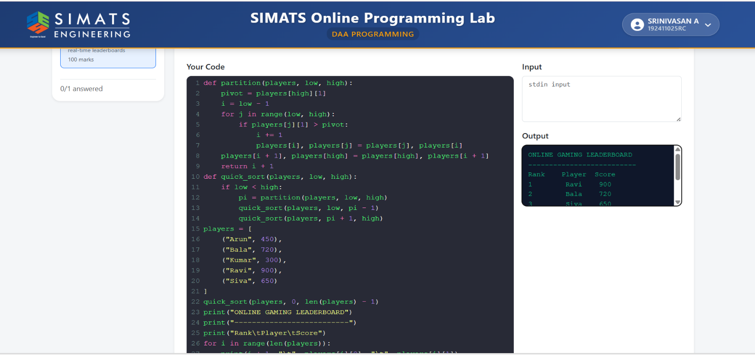

Algorithm: Online Gaming Leaderboard Using Quick Sort

- Start
- Store the player names and their scores in an array.
- Set low = 0 and high = n - 1.
- Call the Quick Sort function.
- In Quick Sort:
  - Select the last element as the pivot.
  - Set i = low - 1.
  - Compare each score with the pivot.
  - If the current score is greater than the pivot, increment i and swap the players.
- Place the pivot in its correct position.
- The array is divided into two parts:
  - Scores greater than the pivot.
  - Scores smaller than the pivot.
- Recursively apply Quick Sort to the left and right parts.
- Continue until low >= high.
- Display the sorted players as the leaderboard.
- Assign ranks from 1 to n.
- Stop

