**Step by Step Guidance:**

**1st:**

Just create an account in firebase

**2nd:**

Click on create new project

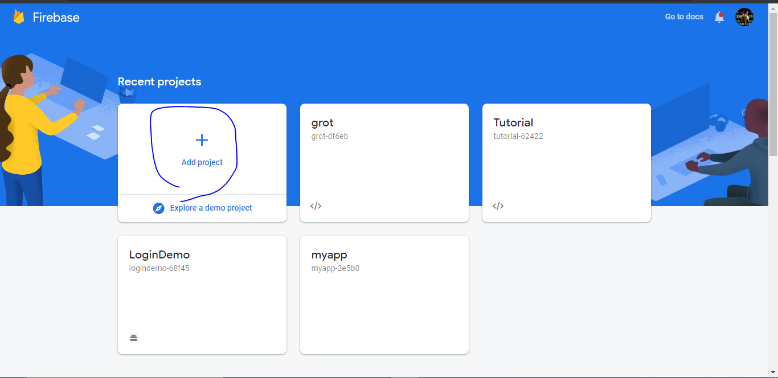

**3rd :**

Enter the project name.

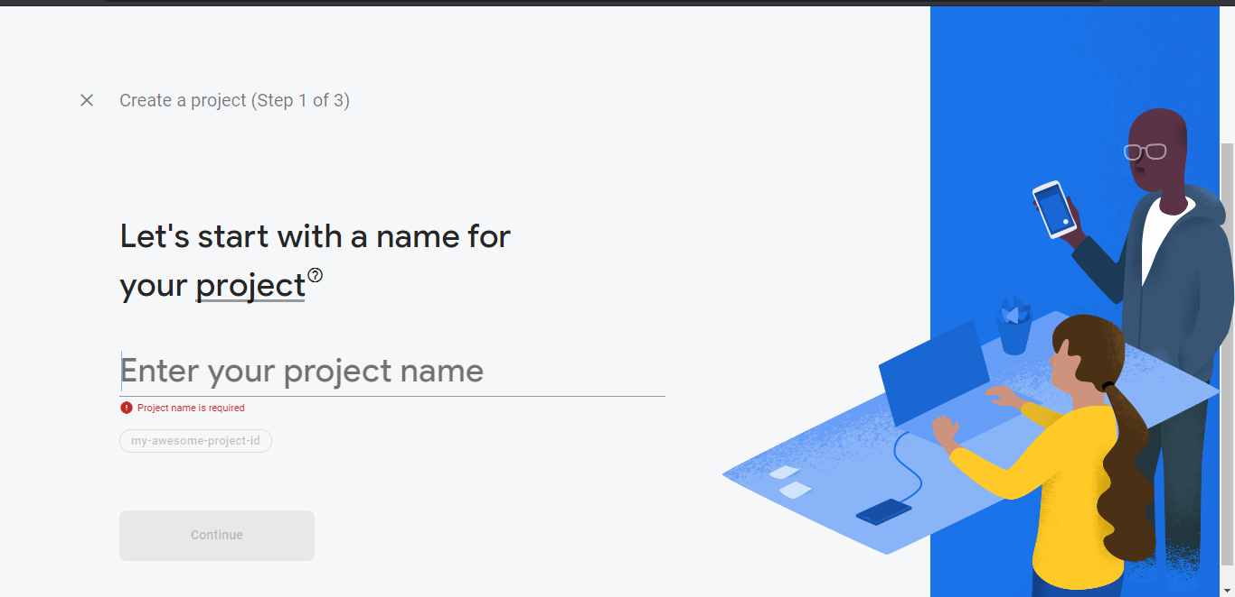

**4th:**

After enter into project they will ask us to choose any one technology from the 3 options

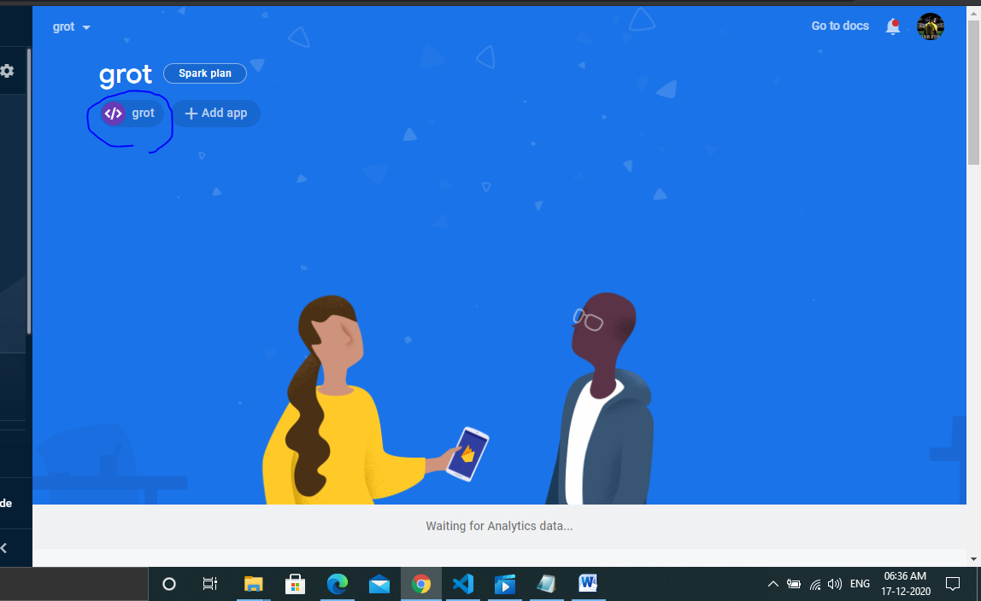

1)Android

2)Mac

3)Web

Here we need to choose the web option after click on to the web option they will give some small code snippet.

We should need to copy that snippet & we need to paste that snippet at the bottom of our body tag.

**5th:**

next on the left side there will be a option called storage & click on

that storage & just create a new storage.

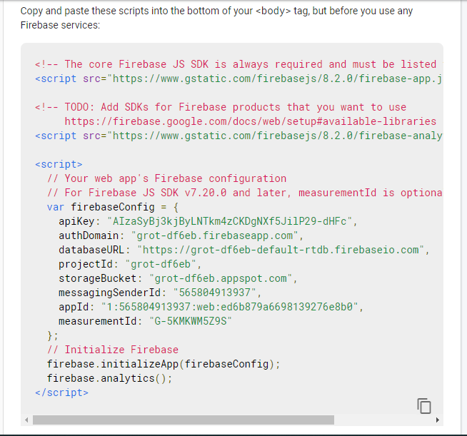

**6th:**

next connect our webpage to firebase storage.

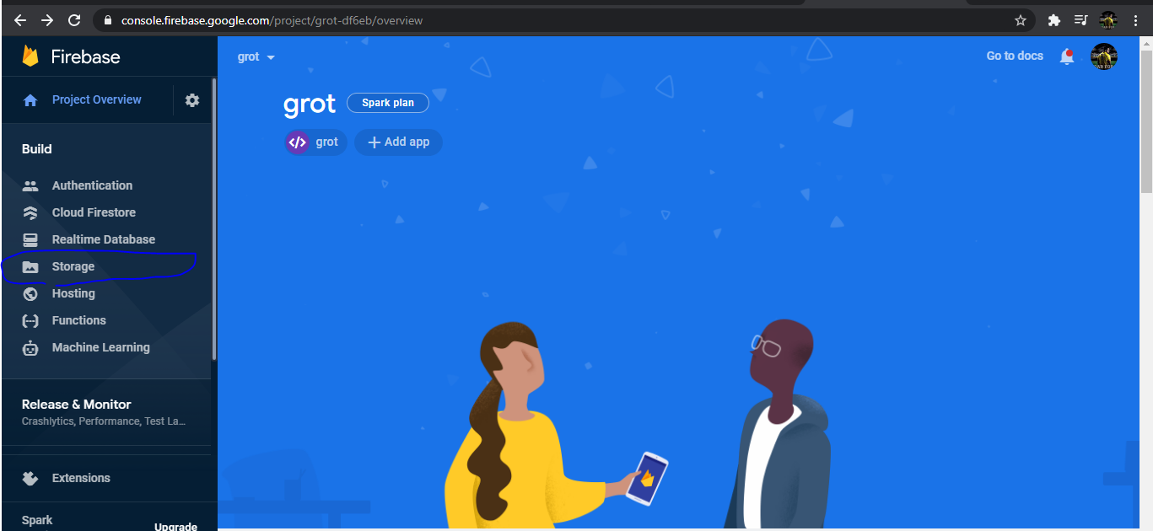

**7th:**

Firebase storage is not a real-time storage so after uploading just refresh the firebase to see the updated changes.

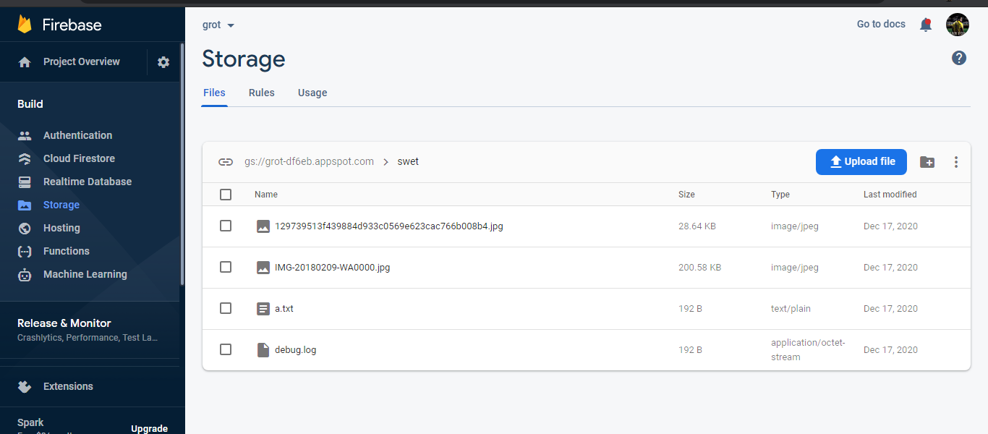

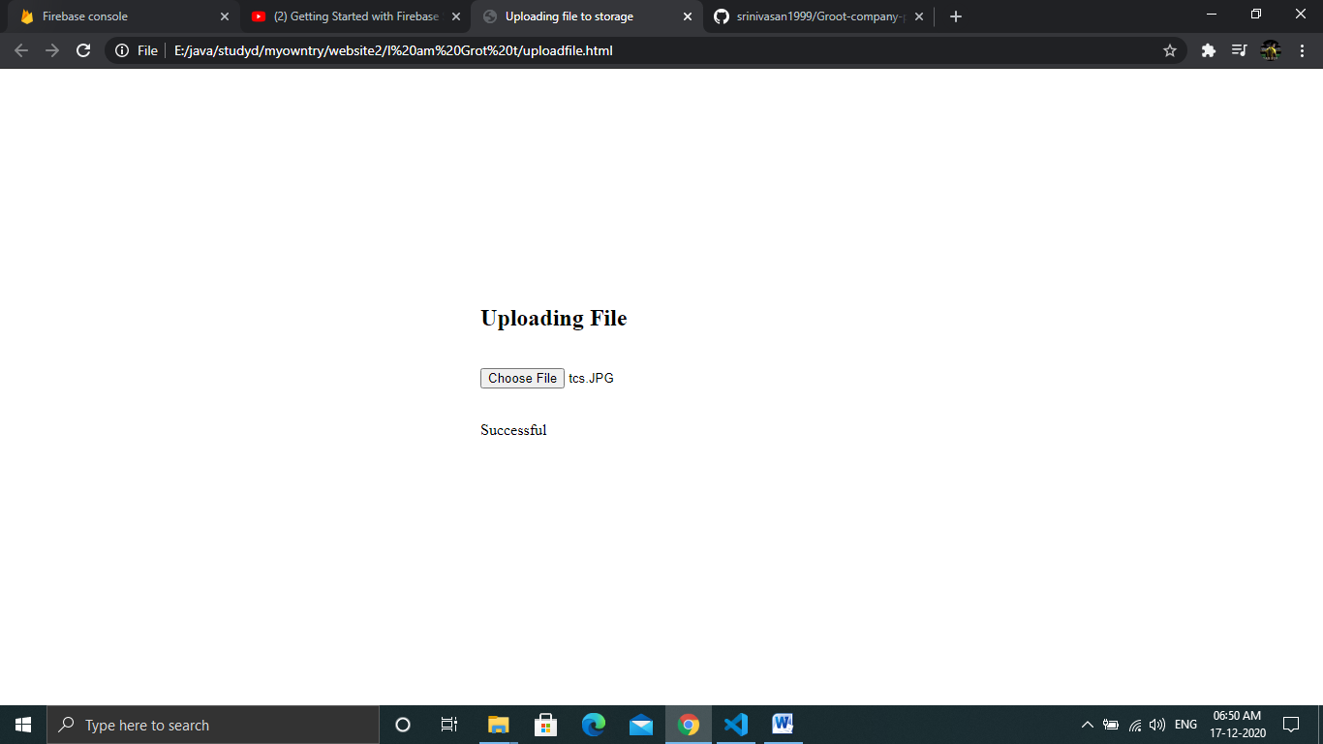

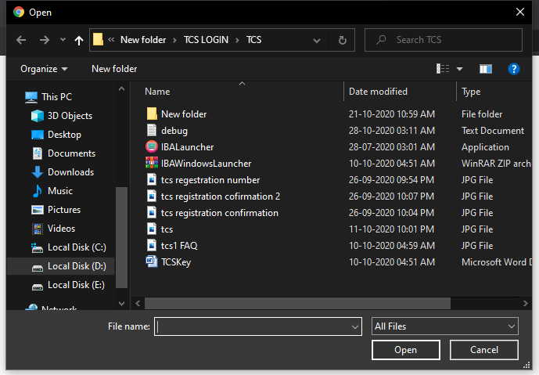

Choose any file from the system it can be text file, mp3 file, video file,etc.

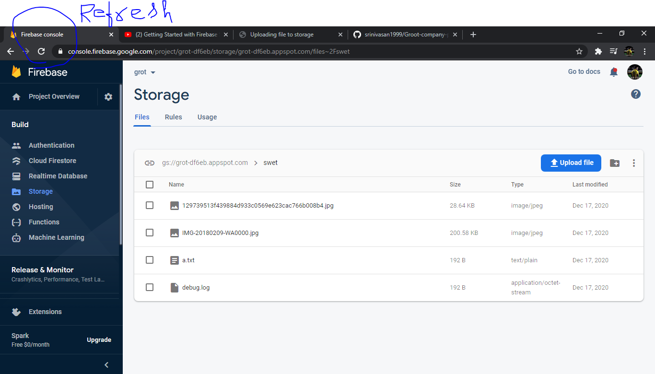

Refresh the firebase to see the changes.