There are two types of polymorphism
- Method overloading
- Method overriding

Method definition

Public static void add()
{ method signture
System.out.println()
}
Method body

Public class Demo{
Public static void add(int a, int b){
System.out.println(A+b);
}
Public static void add(int a, int b,int c){
System.out.println(A+b+c);
}
Public static void add(){
System.out.println(10+20+30+40);
}
Public static void main(String[]args)
{
Add();
Add(10,20);
Add(10,20,30);
}
}

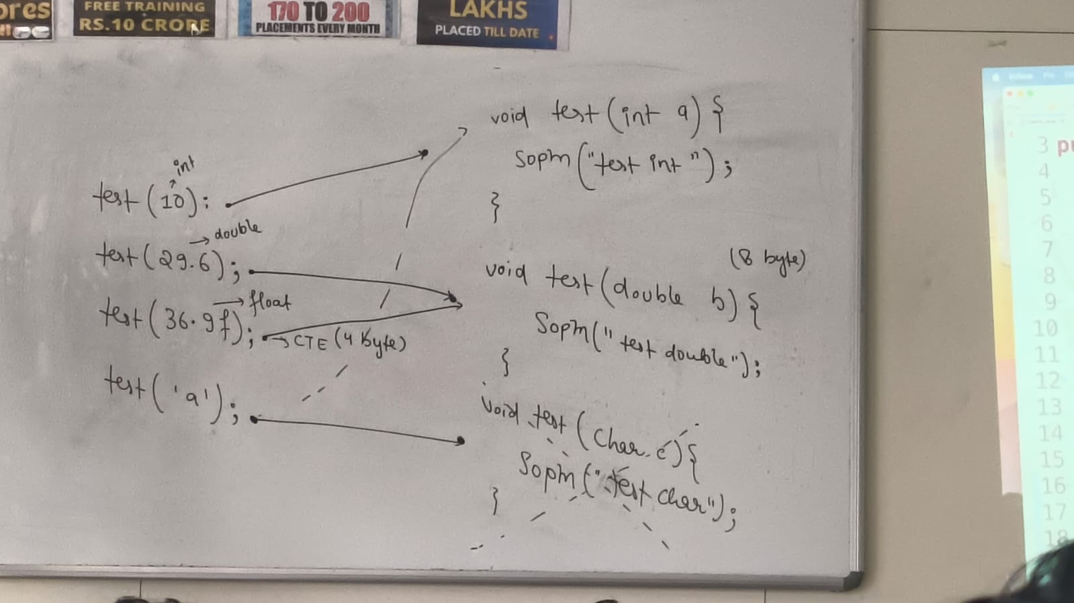
METHOD OVERRIDING
Changing the implementation of super class method into the child class in know has method overriding
RUN TIME POLYMORPHISM
The method decleartion should be same
While overwriting the scope of the parent class method into child class should equal (or) higher

RUN TIME BINDING
Run time binding is also know has dynamic binding or late binding
Which means the execution of a method depends on what object we are creating not on what reference variable

If the parent and child both having same method them it will perform method shadowing.
Note: for method shadowing both the method should be static method shadowing is also called as method hiding

METHOD OVERRIDING
If parent and child class having same method declarion but different implementation that is called method overriding
For method overriding there should be is a relationship
The method should be nonstatic 5

