# Smart Parking System phase 1

**Problem Definition**

Now days finding parking in busy areas is very hard and there is no system to get the details of parking availability online. Imagine if you can get the parking slot availability information on your phone and you don’t have roaming around to check the availability. This problem can be solved by the **IoT based smart parking system**. Using the IoT based parking system you can easily access the parking slot availability over the internet. This system can complet ely automate the car parking system. From your entry to the payment and exit all can be done automatically.

**Design thinking**

So here we are building an **IOT based Car Parking System** using Node MCU, five IR sensors, and two servo motors. Two IR sensors are used at entry and exit gate to detect the car while three IR sensors are used to detect the parking slot availability. Servo motors are used to open and close the gates according to the sensor value. Here we are using the Io platform to show publish the data on cloud which can be monitored from anywhere in the world.

# Components Required

**Hardware**

* Node mcu
* IR sensors
* Servo motor
* Breadboard

IoT Based Smart Parking System

Now days finding parking in busy areas is very hard and there is no system to get the details of parking availability online. Imagine if you can get the parking slot availability information on your phone and you don’t have roaming around to check the availability. This problem can be solved by the IoT based smart parking system. Using the IoT based parking system you can easily access the parking slot availability over the internet. This system can completely automate the car parking system. From your entry to the payment and exit all can be done automatically.

So here we are building an IOT based Car Parking System using NodeMCU, five IR sensors, and two servo motors. Two IR sensors are used at entry and exit gate to detect the car while three IR sensors are used to detect the parking slot availability. Servo motors are used to open and close the gates according to the sensor value. Here we are using the Adafruit IO platform to show publish the data on cloud which can be monitored from anywhere in the world.

Circuit Diagram

The circuit diagram for this IoT based smart parking system project is given below.

# Circuit Diagram

The circuit diagram for this **IoT based smart parking system project** is given below.

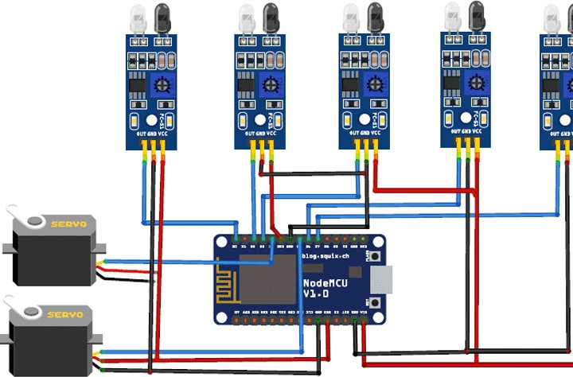

In this Smart Parking System using IOT, we are using five IR Sensors and two servo motors. IR sensors and Servo motors are connected to the NodeMCU. NodeMCU controls the complete process and sends the parking availability and parking time information to Adafruit IO so that it can be monitored from anywhere in the world using this platform. Two IR sensors are used at entry and exit gate so that it can detect the cars at entry and exit gate and automatically open and close the gate. We previously used [Adafruit IO cloud i](https://iotdesignpro.com/tags/adafruit-io)n many IoT projects, follow the link to learn more.

Two servo motors are used as entry and exit gate, so whenever the IR sensor detects a car, the servo motor automatically rotates from 45° to 140°, and after a delay, it will return to its initial position. Another three IR sensors are used to detect if the parking slot is available or occupied

and send the data to NodeMCU. Adafruit IO dashboard also has two buttons to manually operate the entry and exit gate.

This is how this complete setup for **Smart Parking System using IOT** will look:

IoT Based Smart Parking System Circuit Diagram

In this Smart Parking System using IOT, we are using five IR Sensors and two servo motors. IR sensors and Servo motors are connected to the NodeMCU. NodeMCU controls the complete process and sends the parking availability and parking time information to Adafruit IO so that it can be monitored from anywhere in the world using this platform. Two IR sensors are used at entry and exit gate so that it can detect the cars at entry and exit gate and automatically open and close the gate. We previously used Adafruit IO cloud in many IoT projects, follow the link to learn more.

Two servo motors are used as entry and exit gate, so whenever the IR sensor detects a car, the servo motor automatically rotates from 45° to 140°, and after a delay, it will return to its initial position.

Another three IR sensors are used to detect if the parking slot is available or occupied and send the data to NodeMCU. Adafruit IO dashboard also has two buttons to manually operate the entry and exit gate.

This is how this complete setup for Smart Parking System using IOT will look:

## COMPONENT DESCRIPTION:

**NodeMCU:-**

NodeMCU is an open source IoT platform. It includes firmware which runs on the ESP8266 WiFi SoC from Espressif Systems, and hardware which is based on the ESP-12 module. The term “NodeMCU” by default refers to the firmware rather than the development kits. The firmware uses the Lua scripting language. It is based on the eLua project, and built on the Espressif NonOS SDK for ESP8266.

## IR SENSOR

IR (Infrared) sensors are versatile devices that detect and measure infrared radiation, making them invaluable in a wide range of applications. They work by emitting infrared light and then measuring the intensity of the reflected or emitted infrared radiation from objects. This technology finds extensive use in motion detection for security and lighting, proximity sensing for touchless applications, object counting in various industries, and even non-contact temperature measurement. IR sensors come in different types, including passive infrared (PIR) sensors for motion detection and active infrared (AIR) sensors for proximity and object detection. Their sensitivity and range can be tailored to suit specific requirements, making IR sensors a fundamental component in many modern technologies, from smart home systems to robotics and automotive safety features.

## SERVO MOTOR

A servo motor is a highly specialized electric motor designed for precise and controlled motion in various applications. It stands out for its exceptional precision and accuracy in controlling position, speed, and acceleration, making it an indispensable component in fields like robotics, manufacturing, aerospace, and automation. What sets servo motors apart is their ability to maintain and adjust their position according to a control signal, often using a feedback mechanism like an encoder or potentiometer. This feedback loop ensures that the motor moves with pinpoint accuracy, even in response to external disturbances. Servo motors are revered for their versatility, reliability, and the ability to provide consistent and repeatable motion, making them a cornerstone in industries where precise control and automation are paramount.