LOW COST RTU (LCR)

ConnectM Technologies Pvt Ltd

Date : 17 October 2019

Firmware flow

Start DIO

thread

Start Rs485 thread

Start the Event Manager thread

Start TCP backup timer

Stop the execution

No

Is

Initialization done

Properly

?

* Initializing SD Card
* Checking Modem Communication
* Configuring the modem
* Reading configuration file

Yes

Description

Event manger is a thread which initiates all the other threads like rs485, dio and tcpbackup. This thread works on events. So whenever event is received based on the LCR state corresponding tasks are done.

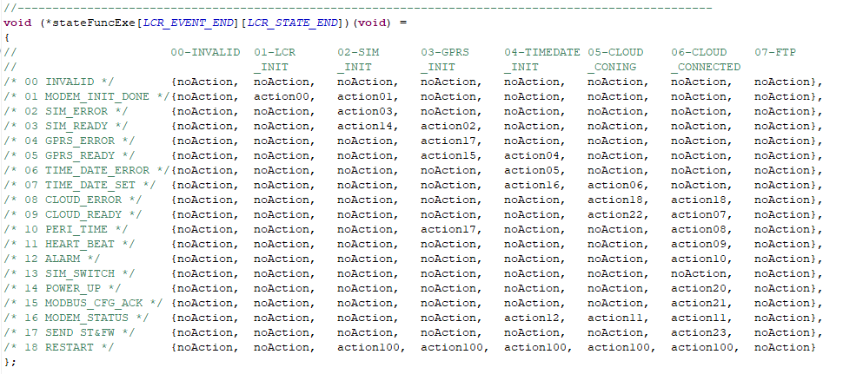

As shown in the above diagram event manager contains a 2D array of function pointers. Each column defines the state of the device and each row depicts the events. So corresponding to state and events functions are defined.

ChibiOs is used for the RTOS implementation. So in this firmware events are pushed to ‘chibios mailbox’.

This RTOS features virtual/software timers which is used to send data to server, check modem’s health periodically.

TcpBackup thread also works based on events. But Rs485 and Dio threads runs continuously.

Pending works / implementation

1. Store and forward feature for multiple tcp packets.
2. DOTA.
3. SMS to clear particular Modbus configuration.
4. SMS to delete tcp backcup file.
5. Retry connecting server in case of server connection error.
6. Addition of logical/communication status alarm in the single frame tcp packet.
7. Reading the analog data.
8. Restart of the device for every 6 hours.
9. Resynch with the time server for half an hour to update the time in modem.
10. Adding the time stamp to the debug logs.

Bugs

1. Modem band selection error which leads to end of the program.
2. Change in offset of the modbus data.
3. PDP contex error and mobile class error while GPRS re-initialization.
4. LCRCFG.TXT file getting erased after sending few no of SMS configuration or while sending Modbus configuration over tcp.
5. Endian/mapping issues in the DIO packet.
6. SIM registration problem when SIM is switched.
7. Json parsing error when more no of configurations added to the LCRCFG.TXT.
8. Modem keeping tcp connection for the shorter period.
9. No IMEI no in the received SMS.
10. More than one packet received within a specified peri time.

Future implementation or thoughts

1. When restart happens store the cursor position of the tcpbackup file. So on restart sending backup data will be resumed. Duplicate packets will not be sent.
2. Configure LCRCFG.TXT file such a way that specific data/bit is extracted from the Modbus data.
3. Pushing debug logs to FTP.
4. Using PPP connection over USB. Which provide separate virtual ports and clean communication.