OAKARA — ONLINE FURNITURE MARKETPLACE
A Mini Project Report Submitted in partial fulfillment of the requirements for the award of the degree of

BACHELOR OF TECHNOLOGY

In
DEPARTMENT OF COMPUTER SCIENCE ENGINEERING
Submitted by:
- S. Roshan Sai Krishna – 2420030528
- A. Srinivas – 2420030349
M. Pranay – 2420030562

Under the Esteemed Guidance of:

Dr. Venkateshwari




K L (Deemed to be) University
DEPARTMENT OF COMPUTER SCIENCE ENGINEERING

DECLARATION

We hereby declare that the mini-project report entitled “Oakara — A Scalable Microservices-Based Online Furniture Marketplace” is a bona fide record of original work carried out by S. Roshan Sai Krishna (2420030528), A. Srinivas (2420030349), and M. Pranay (2420030562), in partial fulfillment of the requirements for the award of the degree of Bachelor of Technology in Computer Science and Engineering at K L (Deemed to be) University. The work presented in this report has not been submitted previously to any other institution or university for the award of any degree or diploma.

S. Roshan Sai Krishna – 2420030528
A. Srinivas – 2420030349
M. Pranay – 2420030562

K L (Deemed to be) University
DEPARTMENT OF COMPUTER SCIENCE ENGINEERING

CERTIFICATE

This is to certify that the mini-project report entitled “Oakara — A Scalable Microservices-Based Online Furniture Marketplace” is a bona fide record of work carried out and submitted by S. Roshan Sai Krishna (2420030528), A. Srinivas (2420030349), and M. Pranay (2420030562), in partial fulfillment of the requirements for the award of the degree of Bachelor of Technology in Computer Science Engineering at K L (Deemed to be) University during the academic year 2026–2027.

Signature of the Course Co-ordinator Signature of HOD

ACKNOWLEDGEMENT

The successful completion of this project would not have been possible without the guidance, support, and resources provided by many people. We sincerely thank everyone who assisted us throughout the development of Oakara.

We express our deepest gratitude to our project guide, Dr. Venkateshwari, for her valuable advice, encouragement, and constructive feedback throughout the project.

We also thank the Head of the Department and K L (Deemed to be) University for providing the academic environment and facilities required to complete this mini-project. We are grateful to our faculty members and technical staff for their support.

Finally, we thank our parents, classmates, and friends for their encouragement and cooperation during the completion of this project.

S. Roshan Sai Krishna – 2420030528
A. Srinivas – 2420030349
M. Pranay – 2420030562

TABLE OF CONTENTS

S.No. | Contents | Page no.
1. | Abstract
2. | Introduction
3. | Literature survey
4. | Problem Statement and Objectives
5. | Hardware and Software requirements
6. | Implementation
7. | Results & Discussion
8. | Conclusion & Future Scope
9. | References

1.ABSTRACT

Oakara is a web-based furniture marketplace designed to make buying and selling new and pre-owned furniture more convenient, transparent, and sustainable. The platform addresses challenges faced by people relocating between cities, including the cost of transporting furniture, the difficulty of finding reliable second-hand products, and the high price of new furniture. Oakara brings new furniture and pre-owned listings together in one marketplace. Pre-owned listings include condition grades, usage details, seller information, and a proposed 25-point inspection report to support informed purchasing decisions. The frontend uses React 19, Vite, React Router v7, and Tailwind CSS. The backend follows a microservices architecture using Spring Cloud Gateway, Eureka service discovery, and separate User, Product, Order, and Payment services. MySQL supports service-specific data, while JWT-based authentication and role-based access control provide a foundation for secure access. The prototype includes catalogue search, filters, product details, seller dashboards, wishlist, checkout flows, order history, and an admin dashboard. External payment, inspection, escrow, and delivery services require live integration before production deployment.
Team Name: Oakara

Team Logo: Insert the Oakara logo if available.

Team Members:
- 1. S. Roshan Sai Krishna – Project Coordination / Frontend (2420030528)
- 2. A. Srinivas – Backend / API Integration (2420030349)
- 3. M. Pranay – Database / Testing (2420030562)

2.INTRODUCTION

Urban professionals, university students, and families in India frequently relocate across major metropolitan hubs. Moving bulky furniture can be expensive, while informal resale platforms may provide limited information about condition, seller reliability, and delivery. At the same time, quality new furniture can be costly for budget-conscious buyers. These challenges contribute to premature disposal of usable furniture and make it harder for buyers to find affordable, dependable options.
Oakara addresses these issues through a dual marketplace for new and pre-owned furniture. Product pages provide relevant specifications and, for pre-owned items, condition grades and seller-provided usage information. The application supports product discovery, seller listing workflows, cart and checkout screens, order tracking, customer accounts, and administration. Its architecture uses a React frontend connected through a central Spring Cloud API Gateway to backend microservices, with Eureka service discovery and service-specific MySQL data. This report presents the related platforms, project objectives, system requirements, implementation approach, prototype results, and future improvements.

3.LITERATURE SURVEY
1. IKEA India (https://www.ikea.com/in/en/): IKEA provides an organized furniture catalogue, product specifications, category navigation, and online shopping features. Its structured browsing is a useful reference for Oakara’s product discovery and presentation. IKEA primarily focuses on new products, while Oakara also includes pre-owned listings.
2. Pepperfry (https://www.pepperfry.com/): Pepperfry offers a broad furniture and home décor catalogue with product filters, pricing, and category-based discovery. Its product cards and shopping flow provide useful references for Oakara. Oakara extends this approach with a dedicated pre-owned marketplace.
3. Urban Ladder (https://www.urbanladder.com/): Urban Ladder emphasizes curated furniture collections, product imagery, and detailed specifications. These features inform Oakara’s product-detail pages and presentation of furniture styles, materials, and dimensions.
4. OLX India (https://www.olx.in/furniture-home-decor_c628): OLX supports local listings for used furniture and location-based discovery. Its person-to-person model shows the value of seller listings, but condition verification and delivery coordination may vary. Oakara aims to provide more structured condition information and purchase workflows.
5. Facebook Marketplace (https://www.facebook.com/marketplace/): Facebook Marketplace enables local discovery and direct communication between buyers and sellers. It demonstrates the usefulness of location-aware listings. Oakara specializes in furniture and defines clearer product, order, and role-based workflows.
6. Giveasy (https://www.giveasy.in/): Giveasy focuses on pre-loved goods and managed resale experiences. It provides a relevant comparison for making second-hand purchases more convenient and trustworthy. Oakara similarly emphasizes transparency and a structured resale journey.

4.Problem Statement and Objectives

Problem Statement:
Urban consumers need a dependable marketplace that combines new and pre-owned furniture with transparent listing details and organized buying and selling workflows.

Problem Description:
Buyers often struggle to find affordable furniture with reliable condition information, while sellers face uncertainty and logistical challenges when reselling bulky items through informal channels. Oakara organizes discovery, listings, checkout, and order tracking in one platform.
Objectives:
The project aims to:
1. Develop a responsive furniture catalogue with search, filtering, and sorting.
2. Support seller listings with condition grades and usage details for pre-owned items.
3. Provide product pages, cart, wishlist, checkout, and order-tracking workflows.
4. Create customer, seller, and administrator views with role-based access.
5. Demonstrate a microservices backend with an API gateway and service discovery.
6. Encourage furniture reuse through a more transparent resale experience.

5.HARDWARE AND SOFTWARE REQUIREMENTS
Hardware Requirements:
- • Processor: Intel Core i5 / AMD Ryzen 5 or equivalent and above
- • RAM: 8 GB minimum; 16 GB recommended
- • Storage: At least 10 GB free space; SSD recommended
Software Requirements:
- • Operating System: Windows 10/11, macOS, or Linux
- • Frontend: React 19, Vite, React Router v7, Tailwind CSS
- • Backend: Java JDK, Spring Boot, Spring Cloud Gateway, Eureka, OpenFeign
- • Database and tools: MySQL, Node.js/npm, Git, and a modern browser

6.IMPLEMENTATION
- 1. Frontend: React 19, Vite, React Router v7, Tailwind CSS, and Lucide React.
- 2. Backend: Spring Boot microservices for User, Product, Order, and Payment functions, with MySQL data storage.
- 3. API Integration: Spring Cloud Gateway routes frontend requests, Eureka supports service discovery, and OpenFeign supports synchronous service-to-service communication.

Frontend (React, Vite, Tailwind CSS):
- • React components provide home, shop, product details, pre-owned hub, sell wizard, seller dashboard, cart, checkout, orders, wishlist, account, and admin views.
- • Tailwind CSS provides responsive styling and the Oakara warm-neutral colour palette.
- • React Router manages client-side routes; Axios centralizes HTTP requests and bearer-token attachment.
- Backend and API integration:
• User Service (8081): user accounts and authentication structure.
- • Product Service (8082): catalogue, product details, and listing operations.
• Order Service (8083): order records and order-status workflow.
- • Payment Service (8084): payment workflow integration point; checkout payment options are simulated in the prototype.
• Eureka runs on port 8761 and the API Gateway on port 8080. External payment, escrow, inspection, and delivery providers require live integration for production use.

7.RESULTS & DISCUSSION
The prototype presents a dual-marketplace homepage, searchable catalogue, product details, pre-owned condition tiers, a six-step sell wizard, seller dashboard, cart and checkout flow, order tracking, wishlist, customer account, and admin dashboard. The sample dataset contains 18+ furniture products across eight categories and six metro hubs. Insert actual screenshots of the homepage, catalogue, seller listing wizard, and admin dashboard in the space below, with a short caption for each.

8.CONCLUSION & FUTURE SCOPE
Oakara demonstrates a structured approach to organizing new and pre-owned furniture sales in one web application. The prototype brings together product discovery, seller listing workflows, shopping features, order status views, and administration. Its React frontend and microservices-oriented backend illustrate full-stack and distributed-system concepts. The prototype addresses the core project objectives, while live payment processing, escrow, physical inspection, and managed delivery remain areas for further integration and validation.

Future Scope:
• Integrate a verified payment gateway and secure escrow provider.
• Connect furniture pickup and delivery partners with automated scheduling.
• Add seller verification, ratings, reviews, and dispute resolution.
• Explore image-based search and computer-vision-assisted condition checks.
• Deploy services to cloud infrastructure with monitoring, CI/CD, and automated testing.

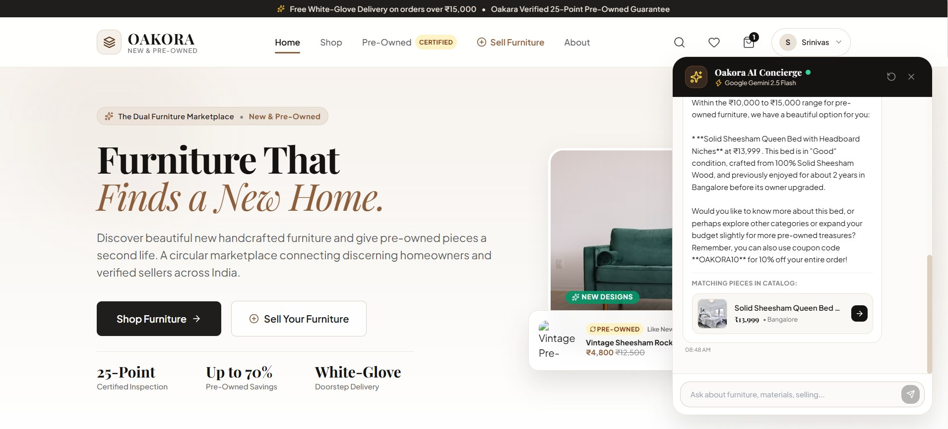

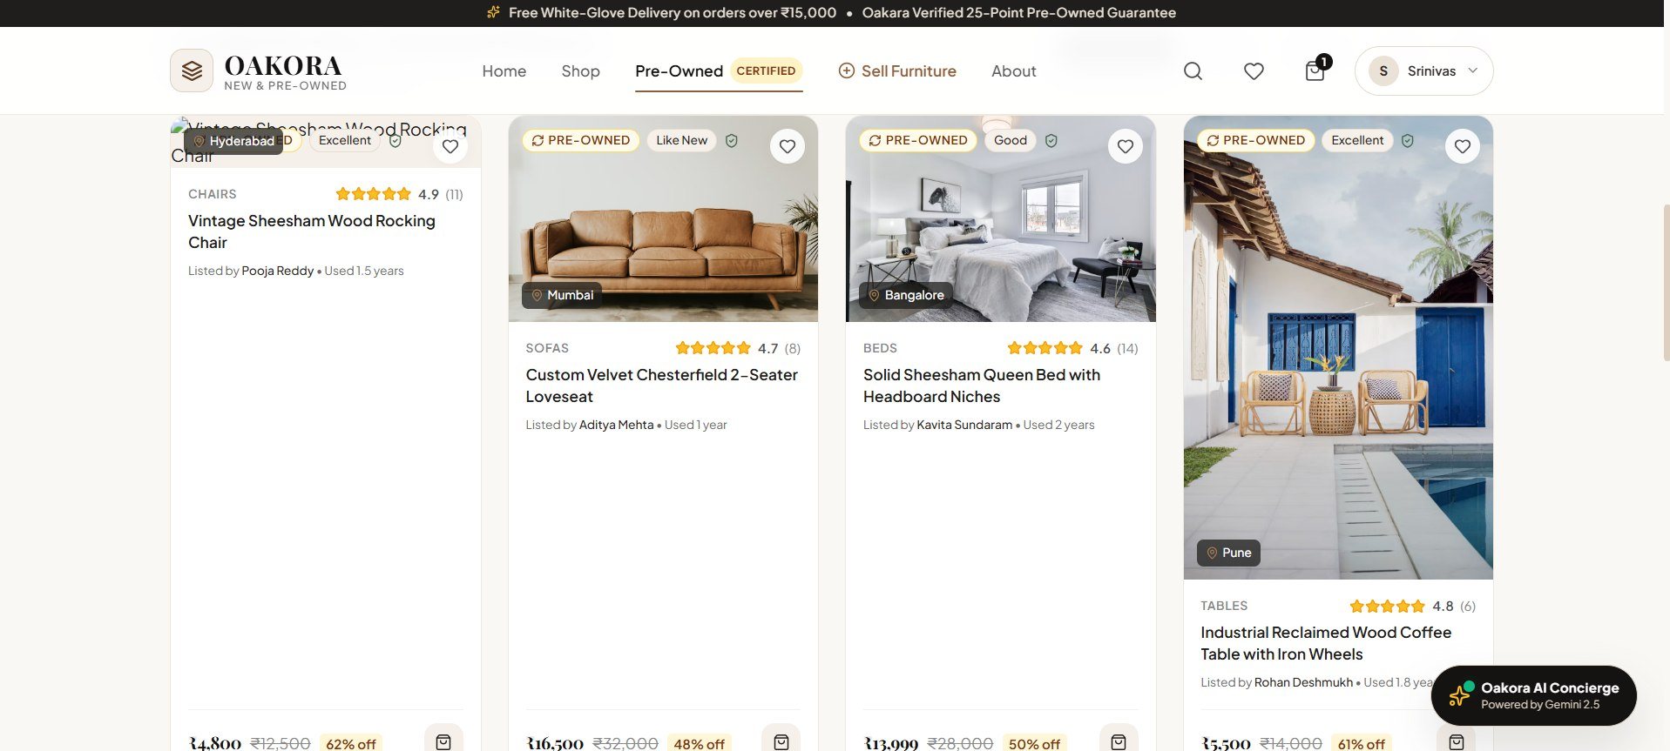

9. REFERENCES

1. IKEA India. Furniture and home furnishing catalogue. https://www.ikea.com/in/en/
2. Pepperfry. Online furniture and home décor marketplace. https://www.pepperfry.com/
3. OLX India. Furniture and home décor listings. https://www.olx.in/furniture-home-decor_c628
4. Urban Ladder. Online furniture catalogue. https://www.urbanladder.com/
5. Giveasy. Pre-loved furniture and appliances marketplace. https://www.giveasy.in/
6. Facebook Marketplace. Local marketplace listings. https://www.facebook.com/marketplace/
7. React. Official documentation. https://react.dev/
8. Spring Boot. Official documentation. https://spring.io/projects/spring-boot
9. Spring Cloud. Official documentation. https://spring.io/projects/spring-cloud
10. MySQL. Official documentation. https://dev.mysql.com/doc/

