AutoLens — Mini CANoe Architecture
Problem & Scope
Replace the 3 most-used CANoe features without requiring a dongle:
Feature | CANoe equivalent | AutoLens module
Live CAN monitor + DBC decode | Trace Window | TraceWindow
Manual + periodic frame sending | IG Block | Generator
Log file replay + DBC linking | Replay Block | Simulation
Read/Write DIDs + DTCs | UDS Diagnostics | Diagnostics

Data Sources
Vector VN Hardware (physical)
└─ vxlapi.dll (Vector XL Driver Library — free download, no licence needed)
└─ VectorXLInterface : ICANInterface
DemoInterface : ICANInterface ← simulated traffic for offline dev/testing
Log Files (.asc, .blf) ← replay input
DBC Files (.dbc) ← signal decode database
Key decision: we talk to the DLL via QLibrary (dynamic load), so the app still starts even if the Vector driver isn't installed — it degrades gracefully to Demo mode.

Module Structure
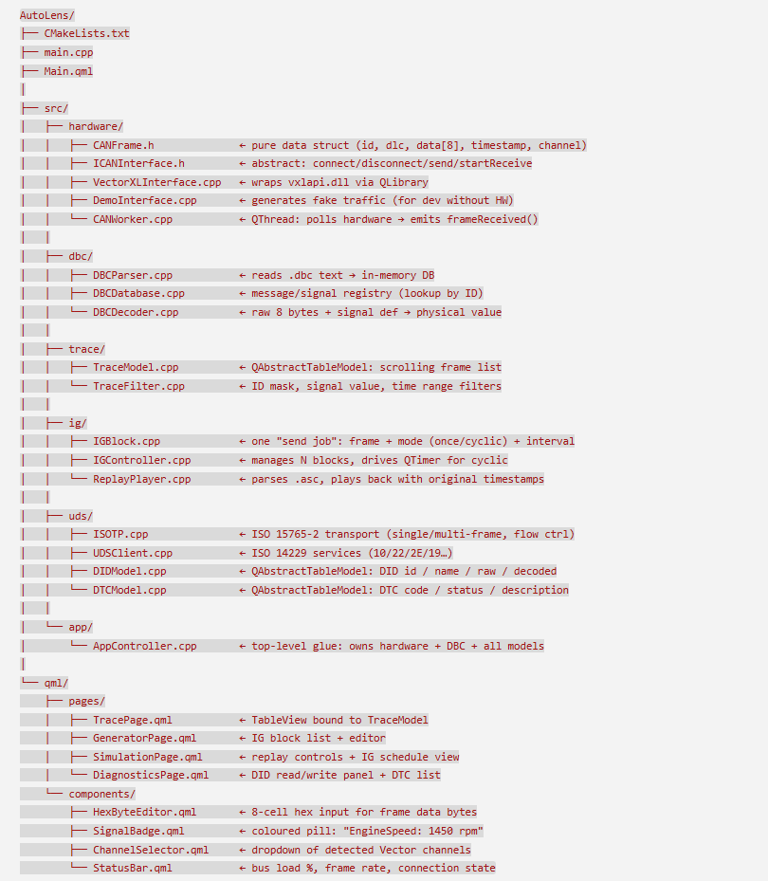
Qt Model Hierarchy
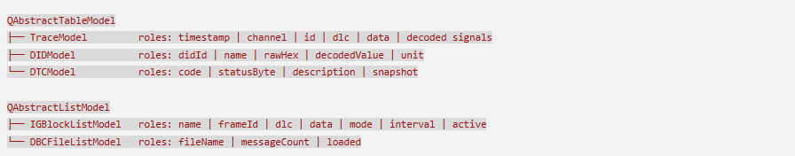
Threading Strategy
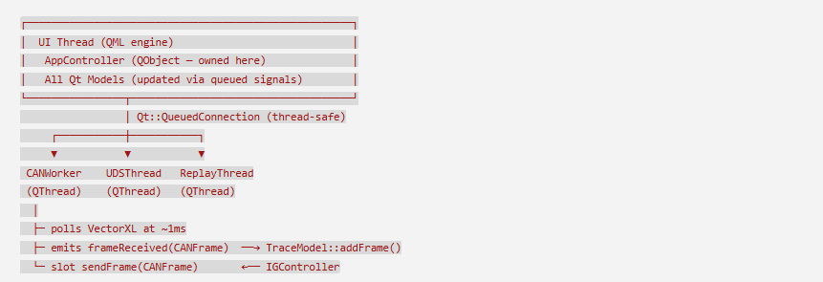
Rules:
- Models only mutate on the UI thread (via Qt::QueuedConnection)
- CANWorker never touches models directly — only emits signals
- ISOTP/UDSClient live on UDSThread — request/response via signals
Navigation Structure
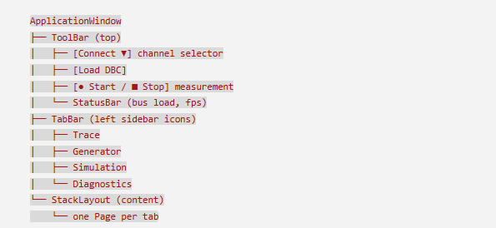
Phased Build Plan
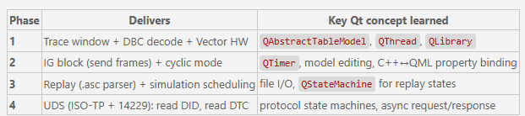

What we build new (AutoLens-specific)
DemoCANDriver — fake traffic generator (dev without HW connected)
AppController — QML-exposed singleton: owns driver + DBC + all models
TraceModel — QAbstractTableModel → bound to QML TableView
IGBlockListModel — QAbstractListModel → IG block list
IGController — cyclic send logic using QTimer
ReplayPlayer — .asc log file parser + playback
UDSClient — ISO 15765-2 CAN-TP + ISO 14229 UDS services
DIDModel — QAbstractTableModel for DID read/write results
DTCModel — QAbstractTableModel for DTC list
All QML pages — TracePage, GeneratorPage, SimulationPage, DiagnosticsPage

Phase 1: Foundation — Trace Window + DBC Decode + Vector HW
Files to create:
- AutoLens/CMakeLists.txt — project setup with CANManager + DBCManager modules
- AutoLens/main.cpp — QML app entry point, register C++ types
- AutoLens/Main.qml — main window with navigation sidebar
- AutoLens/third_party/vector_xl/vxlapi.h — copy from C:/VectorXL/bin/
- AutoLens/src/hardware/CANInterface.h — copy from SPYDER_AutoTrace
- AutoLens/src/hardware/VectorCANDriver.h and .cpp — adapting from the existing driver with updated naming
- AutoLens/src/hardware/DemoCANDriver.h and .cpp — creating a mock driver for testing without hardware
- AutoLens/src/dbc/DBCParser.h — starting the DBC parsing module
- AutoLens/src/dbc/DBCParser.cpp — continuing the parser implementation
- AutoLens/src/trace/TraceModel.h and .cpp — building a table model to display CAN messages
- AutoLens/src/app/AppController.h and .cpp — creating the QML-facing controller that ties everything together
- AutoLens/qml/pages/TracePage.qml, StatusBar.qml, and ChannelSelector.qml — the UI components

