Step 1: creating repo in GitHub  
  
Step2: Clone repo in your local PC

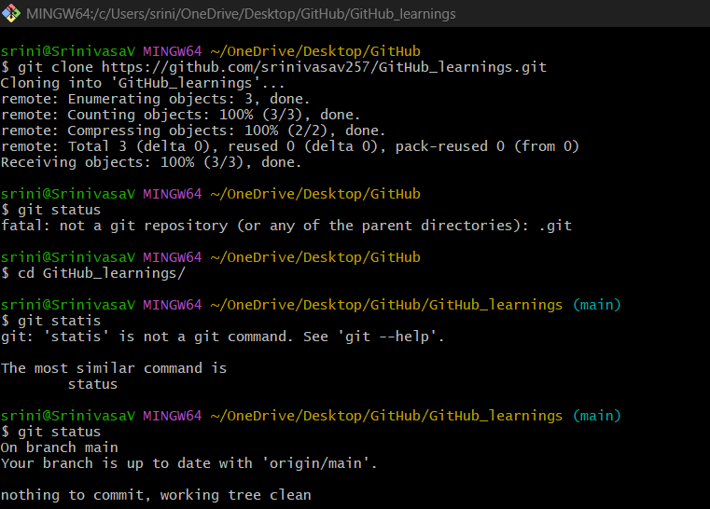

Step3: Do some changes and do commit & push in remote server

