Step1: create local repo

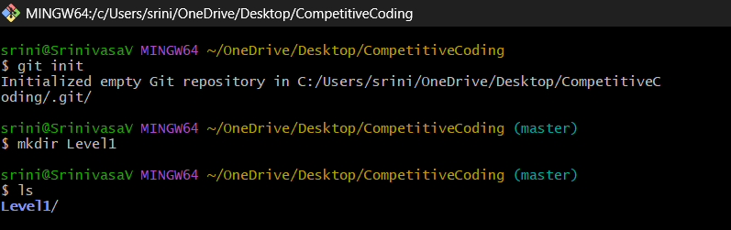

Step2: link the local repo with server

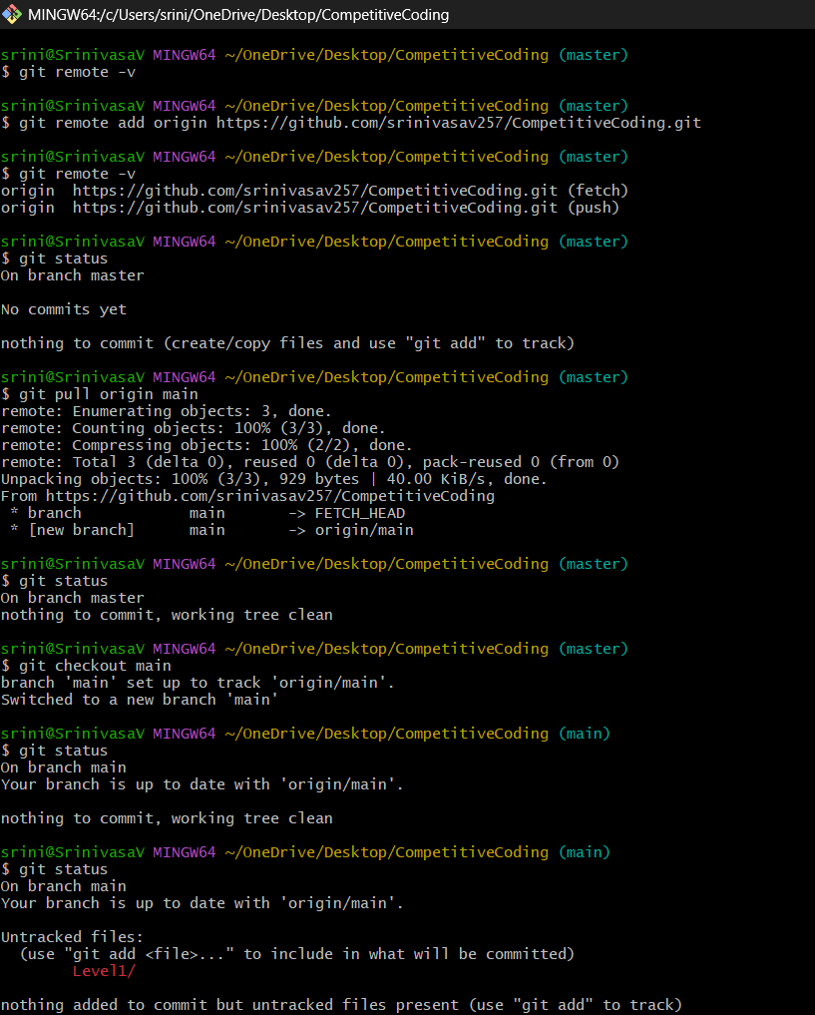

**Note:** git checkout to branch should be done, so that git will start tracking the origin with your local repo if any change is occurred.