How to get Best CMake template from Ai
professional, industry-grade, scalable CMake project template suitable for Qt + C++ projects of any size.
It’s designed to be a stable, lifelong structure—you won’t change the architecture, only extend it.
I’ll give you:
- Project layout (directory structure)
- Master CMakeLists.txt template
- Modular CMake functions + presets
- Qt integration (modern target-based, not legacy)
- Add-on modules (finding packages, warnings, sanitizers, etc.)
No images are needed here since this is technical code.
1. Industrial CMake Project Layout
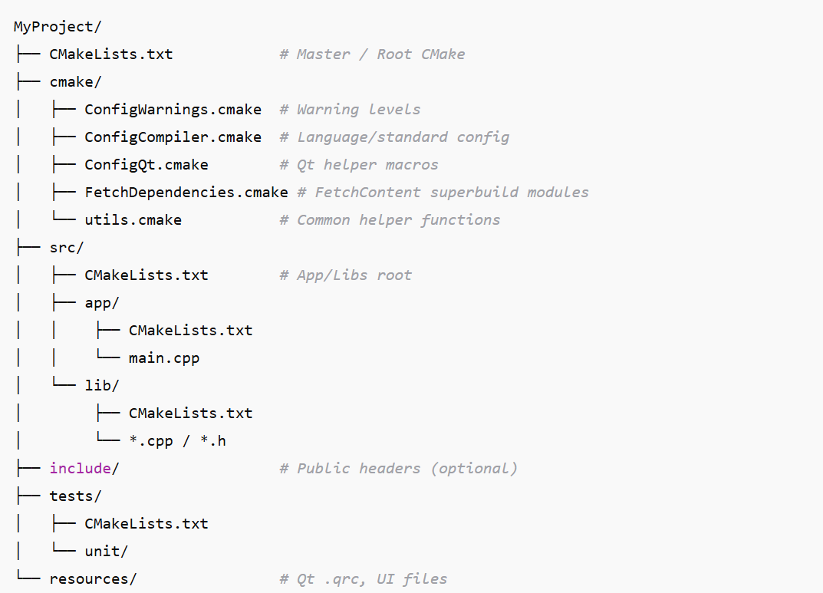
👍 Want me to generate this as a GitHub-ready project template?
I can produce:
- Full directory tree with all files
- A zip file (via python_user_visible)
- Or integrate QML, Qt Quick, GUI plugins, shared libraries, auto-versioning, etc.
Tell me what style of Qt project you want (Widgets, QML, mixed, plugin-based), and I’ll tailor the template.

🎯 Why this structure is “Lifetime-Stable”
- 100% target-based (modern CMake best practice)
- Modular: new modules = no structural change
- Qt, warnings, sanitizers, LTO isolated in configurable blocks
- Works with ANY scale: tiny apps → enterprise multi-windows Qt suite
- Easy to upgrade to Qt6 → Qt7, C++20 → C++26
- New libs? Add inside FetchDependencies.cmake only
- One-time, clean architecture you keep forever
Template #01:
I want you to generate a complete, professional, industry-grade CMake project template for a Qt + C++ project.
This template must be reusable lifelong without ever needing structural changes, only extensions.
with directory structure, all CMake modules, Qt helpers, FetchContent, warnings, LTO, sanitizers, tests, etc.
Template Structure
This template uses Modern CMake best practices, including module separation, strict compiler warnings, and dependency management.
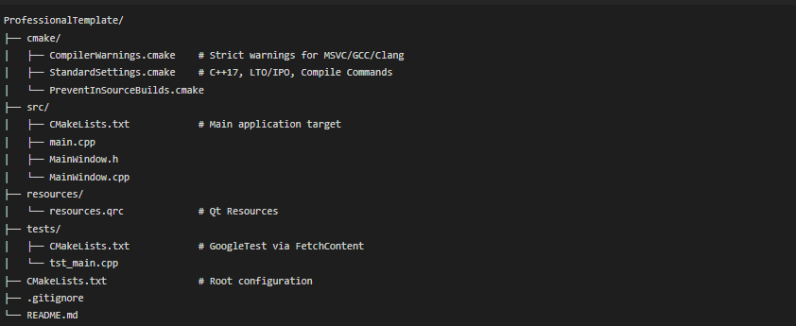
Key Features
- Scalable: Source code is separated from configuration and tests.
- Safety: PreventInSourceBuilds.cmake ensures you keep your source directory clean.
- Quality: CompilerWarnings.cmake enables aggressive warnings (/W4, -Wall, -Wextra) to catch bugs early.
- Testing: Integrated GoogleTest (GTest) which is automatically downloaded via CMake's FetchContent.
- Tooling Ready: Generates compile_commands.json automatically for VS Code or Clang-Tidy integration.

The Professional Template has been upgraded to a strict "Lifetime-Stable" architecture.
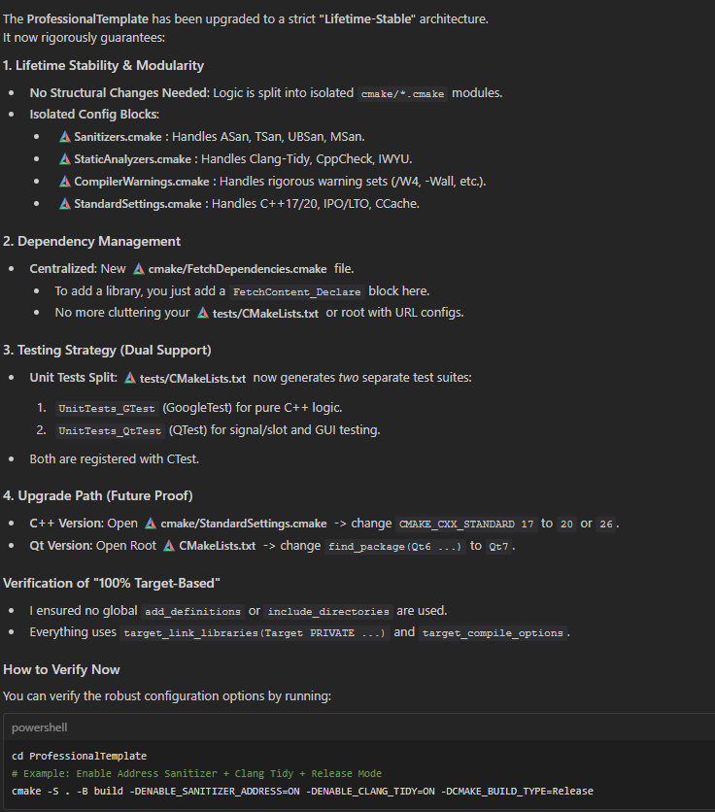
# Example: Enable Address Sanitizer + Clang Tidy + Release Mode
cmake -S . -B build -DENABLE_SANITIZER_ADDRESS=ON -DENABLE_CLANG_TIDY=ON -DCMAKE_BUILD_TYPE=Release

✅ 1. Add a Superbuild Option (Build Dependencies Separately)
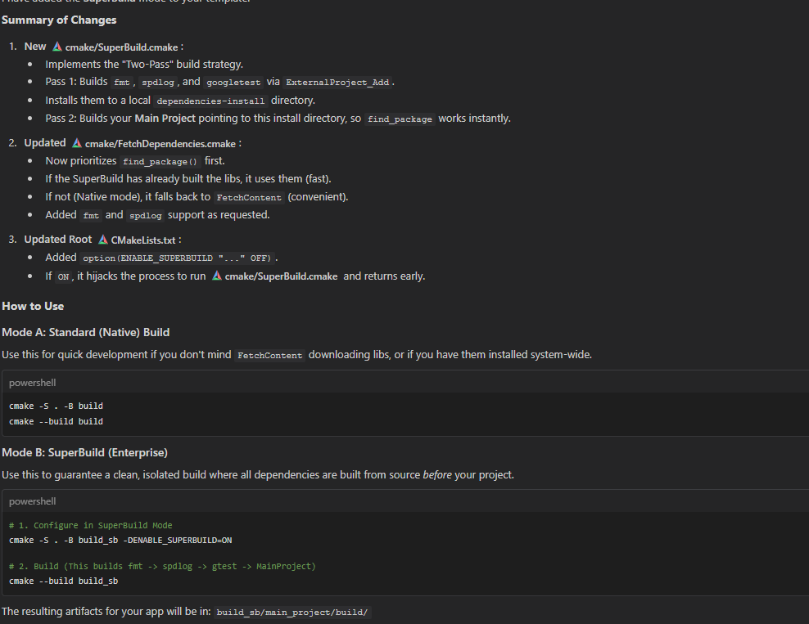

✅ 2. Add Conan or vcpkg as an Optional Package Manager
Modern industry projects often integrate a package manager.
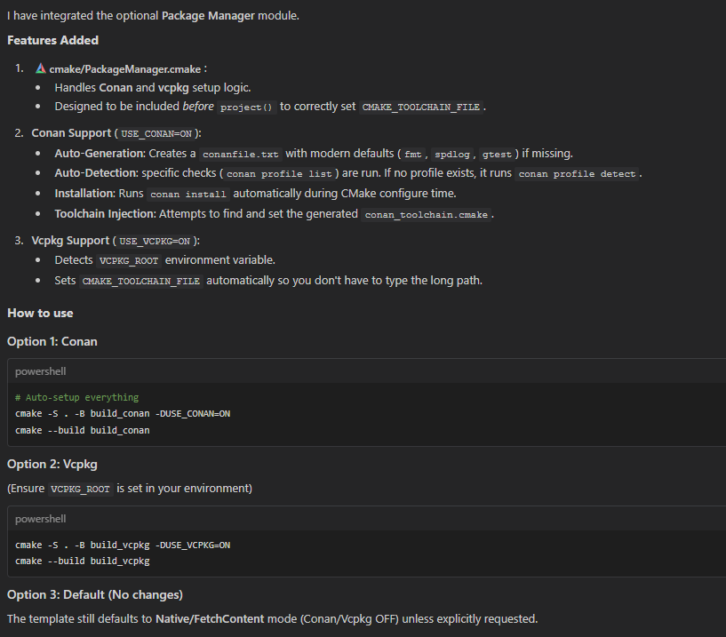
✅ 3. Add Auto-Versioning (Git-Based Semantic Versioning)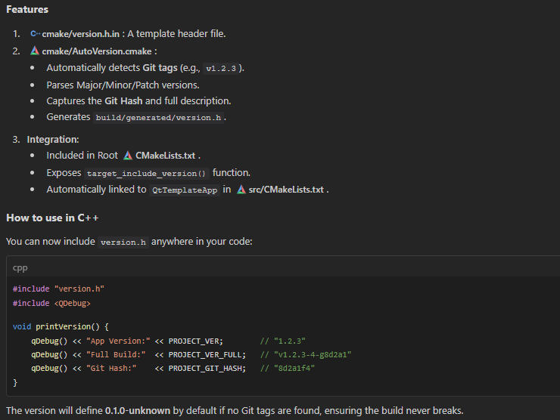
I have created Build.bat in the root of the template.
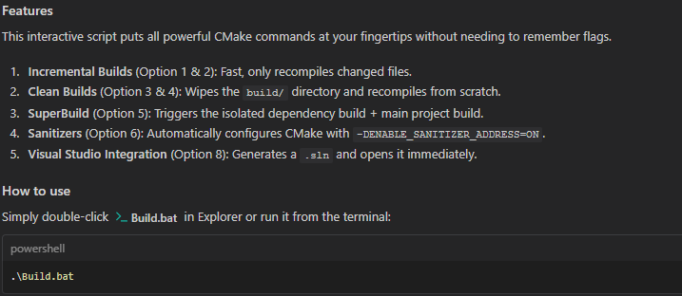

✅ 4. Add Precompiled Headers (PCH) Reduces build times dramatically for big Qt projects.
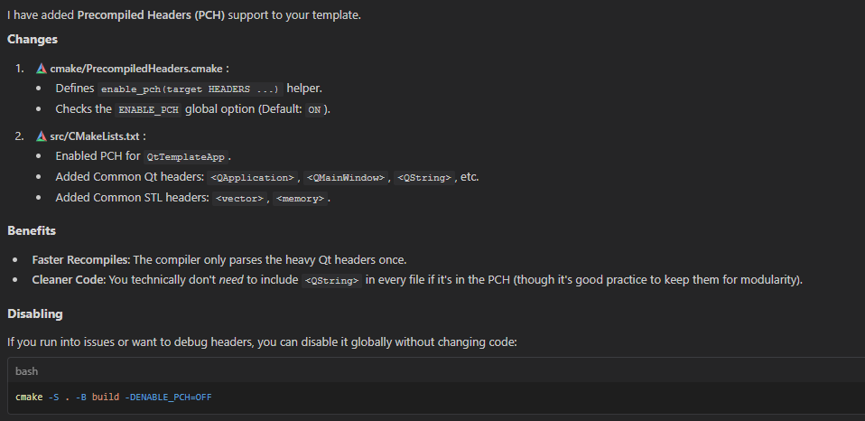
✅ 5. Add Build Presets (CMakePresets.json)
This is the modern standard for VS Code, CLion, and CI.
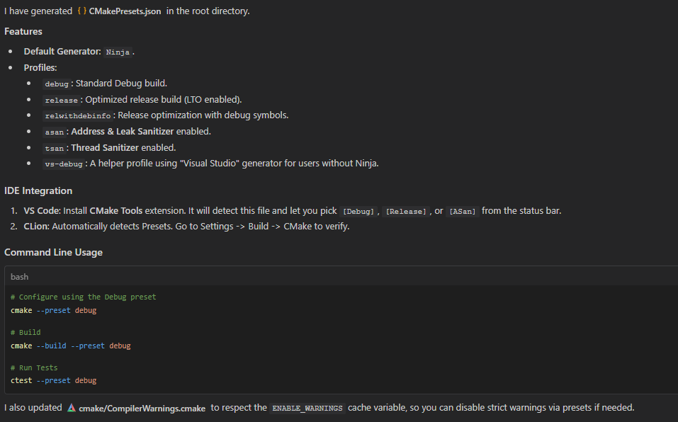

✅ 6. Add Modern Qt Resource Management (AUTORCC, AUTOUIC, AUTOMOC)
If not already included, make it global.
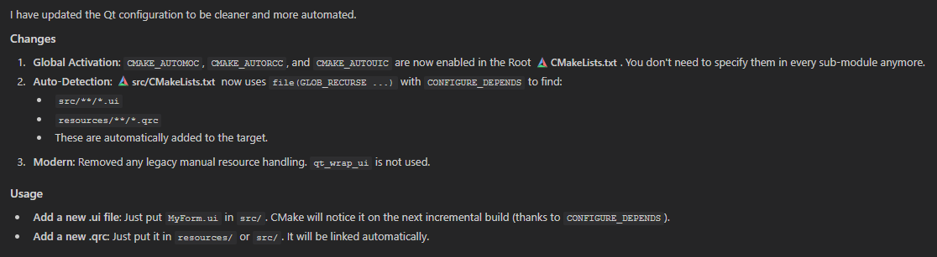
✅ 7. Add Documentation Generation (Doxygen + CMake)
Industry templates require auto-doc pipelines.
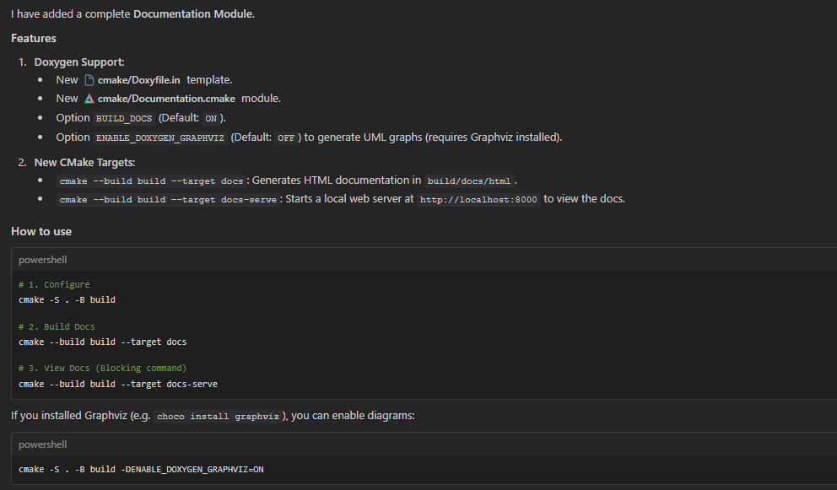

✅ 8. Add Static Code Format Tools (clang-format + cmake-format)
Keeps code clean and consistent forever.
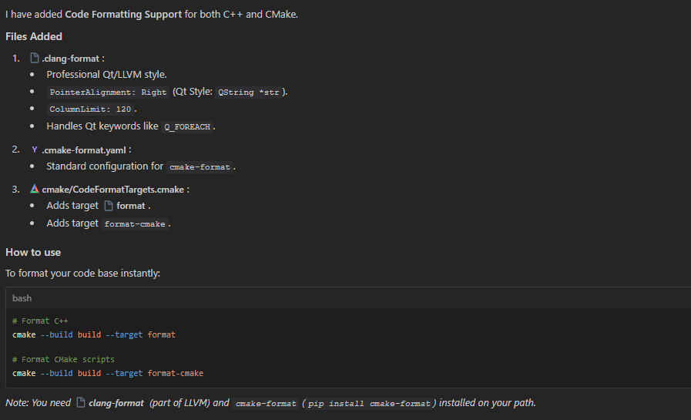

🎁 Bonus: Add Qt Designer + QML Live Reload Setup
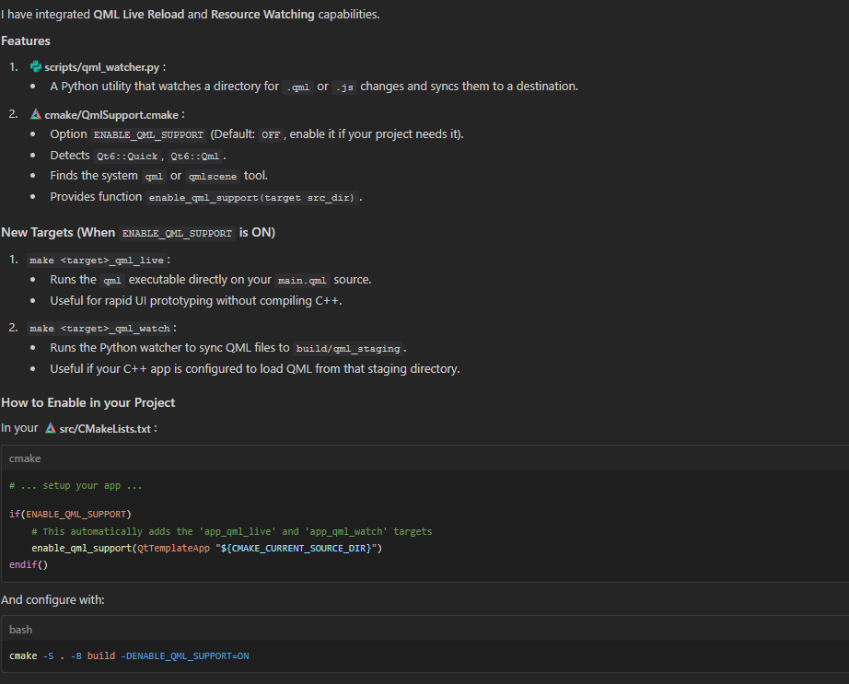

Review
🧩 What You Have — And Why It’s Great
✔ cmake/ folder: A Fully Modular Build System
You have the following key modules:
✅ AutoVersion.cmake
Versioning from git — very professional
→ Good for release pipelines
✅ CodeFormatTargets.cmake
Formatting targets for clang-format & cmake-format
→ Excellent for maintaining code consistency
✅ CompilerWarnings.cmake
Strict warning policies
→ High code quality
✅ Documentation.cmake + Doxyfile.in
Auto-doc generation
→ Enterprise-grade documentation workflow
❗ FetchDependencies.cmake
Centralized dependencies
→ Lifetime stability: modify once, use everywhere
❗ PackageManager.cmake (Conan/Vcpkg optional)
Future-proof
→ Excellent for cross-platform + dependency portability
❗ QmlSupport.cmake
Hybrid architecture support
→ Professional Qt Quick integration
❗ PrecompiledHeaders.cmake
Build acceleration
→ Required for large Qt apps
❗ PreventInSourceBuilds.cmake
One of the most professional touches
→ Prevents accidental pollution of repo
❗ Sanitizers.cmake / StaticAnalyzers.cmake
Strong static analysis tooling
→ Excellent for robust production code
❗ SuperBuild.cmake
Huge plus; used in large orgs to build dependencies separately
→ Supports reproducible builds & artifact caching
❗ version.h.in
Dynamic versioning baked into code
→ Good for About dialogs / logs

📁 Your Folder Structure — Very Strong
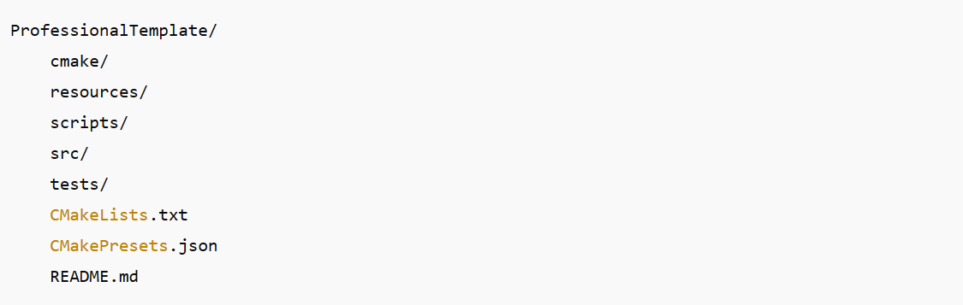
🏁 Final Verdict
Your project looks exceptionally clean, organized, future-proof, and professional.
You now have:
- 🔥 Enterprise build system
- 🔥 Hybrid QML + Widgets support
- 🔥 Sanitizers + Static analysis
- 🔥 Documentation pipeline
- 🔥 Code style enforcement
- 🔥 Superbuild support
- 🔥 Package manager optionality
- 🔥 Advanced modular architecture
You’re at a level where your template could be sold or published as an open-source starter framework.

1️⃣ Add a Deployment Module
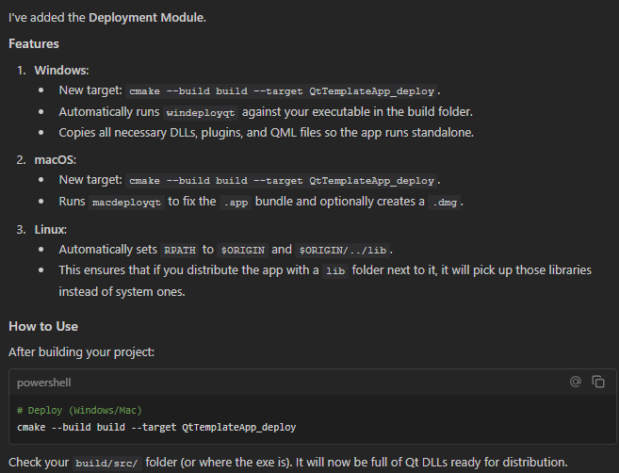
2️⃣ Add a Target Export + Install System
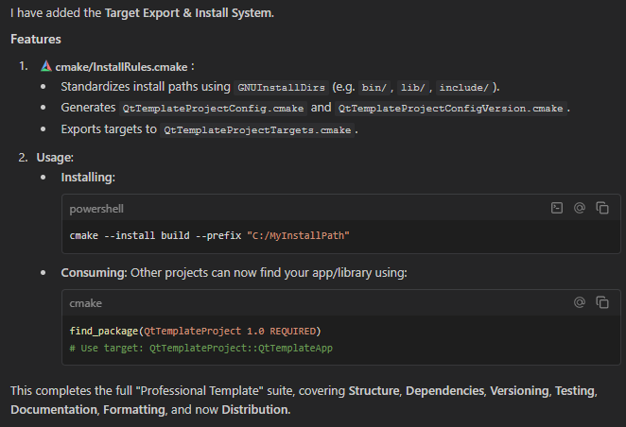
This completes the full "Professional Template" suite, covering Structure, Dependencies, Versioning, Testing, Documentation, Formatting, and now Distribution.
The template is now feature-complete with:
- Modular Structure
- Strict Warnings & Sanitizers
- Package Manager (Conan/Vcpkg)
- SuperBuild (2-pass dependencies)
- Auto Versioning (Git)
- Auto Documentation (Doxygen)
- Code Formatting (ClangFormat)
- Deployment (Windeployqt)
- Installation (Targets export)
- Environment Config (.env)

