Detection of Roads and Boundaries

by

Jibril Moalim,

Kare Sindhu Gonda,

Pendotagaya Srinivas

Project

Submitted to the Department of Computer Sciences and Engineering, University of North Texas.

**Professor: Xiaohui Yuan**

**Abstract**

The purpose of this project is to detect the roads, and the field boundaries for which we used combination of distinct methods such as first part of the SIFT technique that is subtracting the same image of different scales by which we obtain the fine features, and then we used K-Means clusters to get rid of bushes and the levees, using cluster-8 we can get fine tuned roads, and using the cluster-5 we can get rid of bushes. We used distinct methods such as Sobel, canny, Wavelet Transform, Hough Transform, K-Means, and then we come with our own method which is a combination of distinct techniques. The purpose of road detection and the boundary are, there is no denying the significance of land-use statistics in contemporary agriculture and commerce. Precision in land classification is necessary for accurate and current mapping of land use, but this process is difficult without the ability to detect field boundaries.

**Table of Contents**

Introduction 5

Background And Motivation 5

Dataset 6

Methodology 6

Experimental Results 11

Evaluation procedure 13

Discussion 15

Conclusion 16

References 17

**List of Figures**

Fig1: Gradient change 6

Fig 2: X-Derivative 6

Fig 3:Y-Derivative 7

Fig 4: Wavelet Transform Decomposition 8

Fig 5: Wavelet Decomposition 8

Fig 6: Hough Space 9

Fig 7 : Mixture of different techniques flow 10

Fig 8: Update method flow 10

Fig 9: Sobel edge detection result 11

Fig 10: Canny edge detection result 11

Fig 11: Wavelet Transform output 12

Fig 12: K-Means clustering output 12

Fig 13: Hough Transform outcome 12

Fig 14: outcome of mixture of different techniques 13

Fig 15: Updated method outcome(Final Output) 13

**List of Tables**

Table 1: Accuracies of distinct models 14

Table 2: Accuracies of 9 images 15

**Introduction**

The purpose of this project is to detect the roads and the boundaries of the given fields. In this project we come across various techniques, we started with the first technique Sobel, canny edge detector but the results were not up to the mark, then we moved on to the second technique that is Wavelet Transform in which we detect the features at distinct scales and at the end we add them, yet this technique didn’t provide the required results. The third technique is Hough Transform although this method failed at curved borders, it was not able to detect the curves since Wavelet Transform is designed to detect the straight lines.

The Fourth Technique is K-Means, where the image is classified into distinct groups using Image segmentation. The fifth technique is a mixture of distinct methods, these methods are considered in such a way that fine-tuned boundaries, and roads are detected, the methods that we considered are the first step of the Scale-Invariant Feature Transform(SIFT) where we subtract two images that is the original image with its blurred image which provides fine detailed edges and boundaries, and then imbinarize, Imclose, bwboundaries. The fifth technique gave us fine detailed boundaries and edges but failed to get rid of bushes.

Finally, we applied two techniques to get rid of bushes one of the methods we used is the cluster and merge method, where the image will be divided into 32x32, and using each specimen we find the total count of ones and if it is greater than the certain threshold then it will make zero else it will remain the same. Yet this method didn’t perform well since it even made the edges too black to overcome this problem, we used the final method which is we subtracted the fifth and eighth clusters of K-Means so that image become smoother, and also, we got rid of the bushes. In this report, we will provide detailed information on how we were able to detect the roads, and boundaries, and how we were able to overcome distinct challenges.

**Background And Motivation**

There is no denying the significance of land-use statistics in contemporary agriculture and commerce. Precision in land classification is necessary for accurate and current mapping of land use, but this process is difficult without the ability to detect field boundaries.

Existing maps are frequently manually created using observational data or based on old administrative maps. The first ones cannot be highly accurate. The second one requires a lot of manual labor, which increases with the quantity of maps that need to be made or updated. Both of these fail under the test of variability over time. In such cases, yield projections won't result in precise estimations, which could cause shortages

Another area of interest in agricultural management that gains a lot from these maps is crop area protection. Protection ensures agricultural yields and maintains soil fertility in light of the rising consumption trend experienced by cropland in both industrialized and still developing countries.

**Dataset**

These images are aerial imagery acquired by the U.S. Department of Agriculture (USDA) during agricultural growing seasons in the conterminous United States. They are cropped from image tiles that has a 1-meter ground sample distance (GSD), around 9 images are provided.

**Methodology**

We tried distinct methods to get the accurate, detailed roads, and boundaries which are as follows:

**Phase-1**

**Canny and Sobel Edge detection**

A method that we'll utilize to create a program that can identify edges in pictures. We therefore look for regions in an image where there is a sharp change in hue and intensity.

Fig1: Gradient change

It's crucial to remember that a picture can be understood as a matrix (an array of pixels). Light levels at specific points in the image are contained in each pixel. The intensity of each pixel is represented by numerical values, ranging from 0 to 255. Black represents no intensity (0), and 255 represents the highest intensity (white). The Sobel method calculates the approximate gradient of the image intensity at each point of an image by convolution with an integer value filter.Diagram

Fig 2: X-Derivative

The Canny edge detection is essentially taking a Sobel operator and makes it just a step better, a step more useful. For analysis which is to get rid of the edge that we are not interested in and only keep relevant information. The Canny operator is simply the output of Sobel. We take an image and convert to grayscale and run our Sobel operator in both X and Y directions.

Fig 3:Y-Derivative

**Phase-2**

**Wavelet Transform**

In this project we use a scale multiplication-based edge detection scheme. Two DWT sub bands are multiplied as a product function and edges are determined based on this product function. Edges are determined as local maxima in the product function after thresholding.

1. For an image, we first calculate its sub bands (LL, LH, HL, HH) using wavelet decomposition as shown in the fig.1. If the original dimensions of the image were m*n, then each of these sub band will be of the size m / 2 * n / 2 These contain the high frequency components of the image which is our required edge information. The LL sub band is essentially a smaller blurred version of the original image.
2. Wavelet decomposition is now performed on the LL sub band image to further obtain 4 sub bands of size m / 4 * n / 4 We threshold this image to black and white to get the edge information
3. We repeat step 2 twice to get to the m/16 x n/16 level.
4. Now that we have the edge information (LH, HL, HH) at 4 different scales, we have to combine them to get the final edges. Scale Multiplication: This is done by upscaling one sub band image at the lowest scale (m/16Xn/16) twice to its size and then multiplying (element wise) it to the corresponding sub band image at that scale (m/8 x n/8).
5. Step 4 is done all the way up to mxn for all the three sub bands individually.

Fig 4: Wavelet Transform Decomposition

1. Now we calculate the magnitude of the LH, HL and HH to obtain our final edges.
2. Performing the segmentation, according to the requirement.

Fig 5: Wavelet Decomposition

**Phase-3**

**Hough Transform**

When given a binary edge map as input, the Hough transform looks for edges that have been drawn as straight lines. Every edge point in the edge map is transformed using the Hough transform into every conceivable line that could pass through that point.

The Hough Space is a 2D plane with a vertical axis that represents a line's intercept on the edge picture and a horizontal axis that represents the slope. The formula y = ax + b is used to depict a line on an edge picture. Since a line is defined by its slope a and intercept b, one line on the edge picture results in a point on the Hough Space. On the other hand, there are an endless number of lines that can pass through an edge point (xi, yi) on the edge image. As a result, an edge point generates a line with the formula b = axi + yi in the Hough Space.

Fig 6: Hough Space

**Phase-4**

**K-means segmentation**

The idea of the k-means segmentation is that we are looking for K segments in the image. We take our image, here we have field/land in jpg format and map it to feature space. In this feature space we want to find K clusters. Find K clusters by finding the means of K clusters.

A Clustering algorithm is K Means because clustering methods are unsupervised algorithms, no tagged data are available. Based on how similar the data is, it is used to identify several classes or clusters within the given data. Data points within the same group are more comparable to one another than they are to data point with in the same groups.

1. Select k as the desired number of clusters to be discovered.
2. Place the data points into any k clusters at random then determine the clusters' centers.
3. Determine the separation between the data points and the clusters' centers.
4. Reassign the data points to the closest clusters based on the separation between each data point and the cluster.
5. Calculate the new cluster center once more.

Repeat steps 4,5 and 6 as necessary to reach the specified number of iterations or until the data points don't change the clusters.

**Phase-5**

**5.1 Mixture of different Techniques**

After going through distinct techniques, we finally came across Scale Invariant Feature Transform (SIFT). We used the first part of the SIFT technique which is finding scale-space extrema detection. To find the edges we used a Gaussian filter by which we blur the image and subtract the same from the original image by which we were able to find fine edges, and then we multiplied by 4 to improve the intensity of the edges. We then used imbinarize which converts into binary data that is zeros and ones.

Use the structuring element SE to conduct morphological closing on the grayscale or binary image. The dilatation and erosion that make up the morphological close operation both use the same structuring element. The binary image BW's outside object borders and interior hole boundaries can be traced using the function bwboundaries(BW). Additionally, bwboundaries tracks the offspring of the outermost objects (parents) (objects completely enclosed by the parents).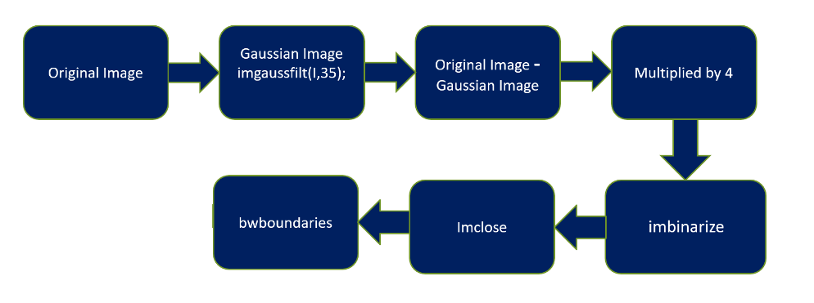

Fig 7 : Mixture of different techniques flow

**5.1.1 Updated method**

Using the above mixture of methods, we were not able to get rid of bushes, then we changed some changes in the flow as shown in the below figure`

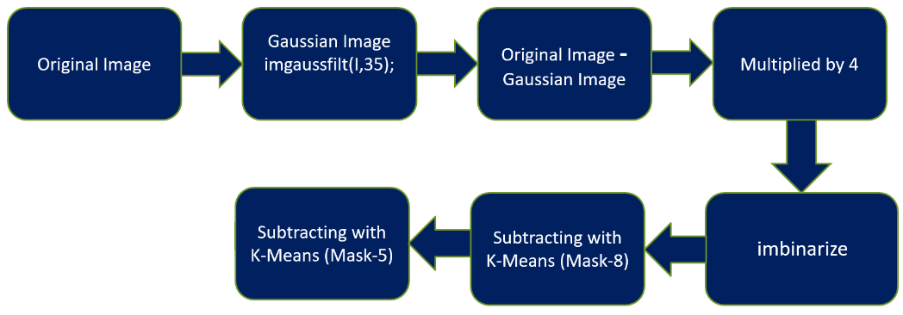

Fig 8: Update method flow

**Experimental Results**

1. **Output of Sobel and canny edge detection**

Initially, we applied Sobel and canny edge detection, the output of both the outcomes can be shown as follows

Fig 10: Canny edge detection result

We can see that the detection of boundaries and roads is not at all accurate. Since we are looking for only boundaries and roads many unwanted regions are appearing in the outcome. Presumably, levees and bushes are affecting the outcome because of which we are getting the noisy outcome. Even the accuracy of the Sobel is only 88.8% while the canny is 89.3%. Here the prominent thing to be considered is **True Positive,**True positive count for the Sobel is 2856 while 3567 for Canny, it indicates that these edge detections are not performing at the best.

1. **Wavelet Transform and K-Means Clustering**

Wavelet Transform is another prominent technique that we opted for edge detection, although it has detected the edges, but not able to get rid of bushes, and there are so many discontinuities along the roads, and even the outcome is not that fine-tuned that we can only see the roads and boundaries, yet there are so many unwanted outcomes such as bushes, levees. On the other hand, K-Means clustering performed well in detecting certain parts of the roads, yet it failed at many other parts, the prominent thing is that we were able to get rid of bushes although it fails to provide the fined tuned roads and the boundaries there were many discontinuities along the roads, some part of the areas were missing. The accuracy that we got for wavelet transform is 89.4% while it is 87.32% for K-Means Clustering, again the True positive count is less for wavelet transform which is 3625, and K-Means 4523.

Fig 11: Wavelet Transform output Fig 12: K-Means clustering output

**III. Hough Transform**

Hough Transform failed in detecting the corners, as the method performs well, only when there are straight discontinuity lines, on the other hand, due to the presence of bushes, and levees, the method is producing a lot of unwanted straight lines. Even after fine-tuning, it could provide straight lines for only the roads but it fails to detect the boundaries of the fields. The accuracy that we got using hough transform is 87.5, and the True positives are 3514.

Fig 13: Hough Transform outcome

As shown in the above figure we added two other steps to have finely detailed edges along with the removal of bushes. To have fine-tuned roads and remove other noisy lines we subtracted the image with K-means mask-8, and to get rid of bushes we used K-Means mask-5.

1. **Mixture of different Techniques and Updated method**

Finally, we used a mixture of different techniques, and it produced fine details of roads, and the boundaries and the accuracy is 93.10%, and the prominent point is that the True Positive count increased drastically which is 42832, which means the model perform well and it produced detailed outcome although we were still facing the issue of bushes, and finally we were able to get rid of bushes, the accuracy increased to 94.07 while the True positive count is 37647.

Fig 14: outcome of mixture of different Fig 15: Updated method outcome(Final Output)

techniques

**Evaluation procedure**

For the evaluation procedure we used a confusion matrix, and to find the True Positive, True Negative, False Positive, and False Negative we found a technique which is as follows.

**True Positive:**

To find the True positive we just multiply the Ground truth with the system outcome and then find the total count of the number of ones, which becomes the True Positive

**True Negative**

To find the True Negative, we just need to invert both images, and then multiply the Ground truth with the system outcome and then find the total count of the number of ones, which becomes the True Negative

**False Positive:**

To find the False positive we multiply Ground_Truth with the inverted system outcome, which means we only invert the system outcome and then find the total count of the number of ones, which becomes the False Positive.

**False Negative:**

To find the False Negative we multiply with the inverted Ground Truth with the system outcome, which means we only invert the Ground Truth and then find the total count of the number of ones, which becomes the False Negative

The following is the table that provides information on the Accuracy of different techniques. From the below data, it can be inferred that K-Means has the least accuracy at 87.32% while the top accuracy is by Updated Technique which is 94.07%

|  |  |  |  |  |  |
| --- | --- | --- | --- | --- | --- |
| **Edge detection Methods** | **True Positive** | **True Negative** | **False Positive** | **False Negative** | **Accuracy** |
| **Sobel** | 2856 | 1723121 | 55155 | 160420 | 0.888968 |
| **Canny** | 3567 | 1806232 | 65215 | 150560 | 0.893475 |
| **Wavelet Transform** | 3625 | 1832453 | 54234 | 162423 | 0.894454 |
| **Hough Transform** | 3514 | 1625365 | 57204 | 175023 | 0.875221 |
| **K-Means Clustering** | 4523 | 1724689 | 56023 | 195054 | 0.873212 |
| **Mixture of different techniques** | 42832 | 3862370 | 62947 | 226155 | 0.931073 |
| **Updated technique** | 37647 | 3908155 | 68132 | 180370 | 0.9407 |

Table 1: Accuracies of distinct models

The following table provides the accuracy of entire data set that is 9 images using **Updated Technique method.**

|  |  |  |  |  |  |
| --- | --- | --- | --- | --- | --- |
| **Images** | **True Positive** | **True Negative** | **False Positive** | **False Negative** | **Accuracy** |
| **Image-1** | 37647 | 3908155 | 68132 | 180370 | 94.07 |
| **Image-2** | 27046 | 3901271 | 50576 | 215411 | 93.65 |
| **Image-3** | 40984 | 3942628 | 78215 | 132477 | 94.97 |
| **Image-4** | 30724 | 3926081 | 53336 | 184163 | 94.33 |
| **Image-5** | 32563 | 3946528 | 53002 | 156723 | 94.99 |
| **Image-6** | 45234 | 3956423 | 60245 | 165321 | 94.66 |
| **Image-7** | 46194 | 3824791 | 45001 | 278318 | 92.29 |
| **Image-8** | 21364 | 3976920 | 37469 | 158551 | 95.32 |
| **Image-9** | 12227 | 4044792 | 90933 | 46352 | 96.72 |

Table 2: Accuracies of 9 images

**Discussion**

To find fine detailed boundaries and the roads, our method found the following prominent points.

* The first part of the Scale Invariant Feature Transform (SIFT) that is subtracting the image with a blurred image of itself producing a detailed feature.
* To get rid of Levees, and to produce a clear output we need to subtract the image with mask-8
* Finally, our method was able to remove the bushes, that is we need to subtract the original image with mask 5,
* Although mask-5 detects only bushes, we cannot subtract the image directly from the original image, since the pixel values at the same instant may not match and hence there will be no use in subtracting the images directly.
* So mask-5 should be undergone through an average filter which smooths the values of the entire region of bushes, and then we can subtract the from the original image, and then we can get rid of the bushes
* The following prominent outcomes can be expected from the project
* Not labor-intensive - eliminate labor inefficiencies related to manually recording field boundaries.
* Obtain high-quality field boundaries for the entire nation with a consistent level of accuracy. Consistent and widespread access.
* Scalable—our system can be trained to recognize borders across a wide range of image resolutions and geographic areas.

**Conclusion:**

In a nutshell, our method outperformed all the existing methods which were Sobel, Canny, Hough Transform, Wavelet Transform, and K-Means. We got the fine detailed roads and boundaries. We were successfully get rid of bushes, and levees.

In the future, the method can be yet updated, as we can see in the outcome that there are still certain positions where there are discontinued roads, and this happened due to the trees that were covering the road, to deal with this problem, after processing through our model, in the next step we can use Hough transform since Hough transform can detect the straight discrete lines, and thereby we can get rid of the issue of discontinuity of roads.

**References**

1. T.J. Yen, A qualitative profile-based approach to edge detection, PhD Thesis, New York University, 2003.
2. J. Canny, A computational approach to edge detection, IEEE Transactions on Pattern Analysis and Machine Intelligence 8 (6) (1986) 679–698.
3. L. Zhang and P. Bao, Edge detection by scale multiplication in wavelet domain, Pattern Recognition Letters 23 (14) (2002), pp. 1771–1784. [6] T. Aydin, Y. Yemez, E. Anarim and B. Sankur, Multidirectional and multiscale edge detection via M-band wavelet transform, IEEE Trans. Image Process. 5 (1996) (9), pp. 1370–1377.
4. S. C. Zhu and A. L. Yuille, "Region competition: Unifying snakes region growing and Bayes/MDL for multiband image segmentation", *IEEE Trans. Pattern Anal. Mach. Intell.*, vol. 18, no. 9, pp. 884-900, Sep. 1996.
5. T. Kanungo, B. Dom, W. Niblack and D. Steele, *A fast algorithm for MDL-based multi-band image segmentation IBM Res. Div.*, 1994