1. **What are the different margins options and do we adjust the margins of the excel worksheet?**

**Answer :**

By default, the margins are 0.75 inches at the top and bottom, and 0.70 inches to the left and right.

1. Click the Page Layout tab.
2. Click the Margins button.
3. Select the margin size you want to use from the list.

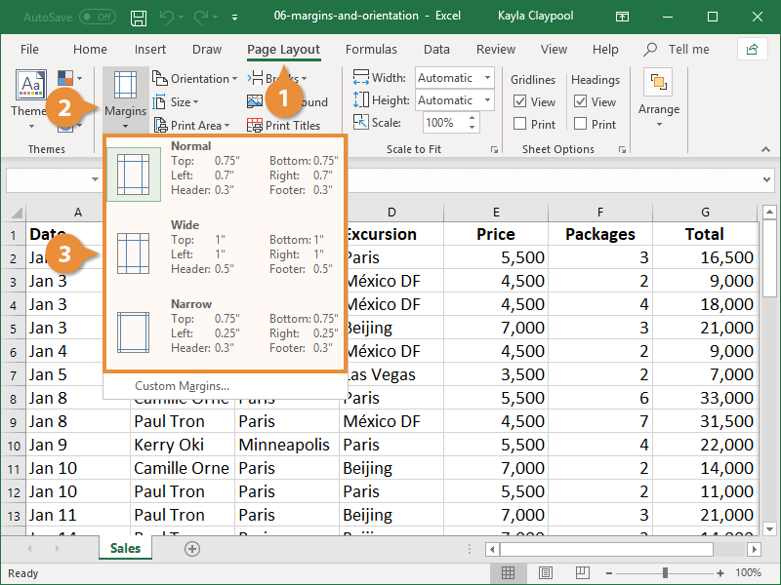

If you don’t see a margin size that works, select Custom Margins to display the Page Setup dialog box. Here you can set your own custom margins.

**Set Page Orientation**

Portrait orientation is the default setting for printing worksheets, but you may want to use landscape orientation instead.

1. Click the Page Layout tab.
2. Click the Orientation button.
3. Select an orientation option:

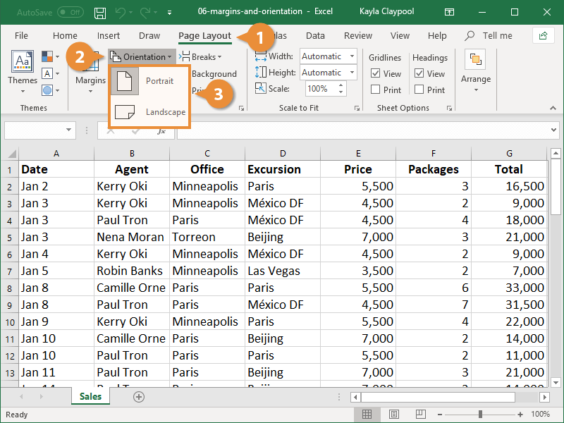

* + Portrait: In Portrait orientation, the paper is taller than it is wide—like a portrait painting.
  + Landscape: In Landscape orientation, the paper is wider than it is tall—like a landscape painting.

1. **Set a background for your table created.**

**Answer :**

* Select the entire table: Click and drag to select all the cells that form your table.
* Go to the "Home" tab in the Excel ribbon.
* Locate the "Cells" group, and click on the "Format" button. A drop-down menu will appear.
* From the drop-down menu, select "Format Cells." The Format Cells dialog box will open.
* In the Format Cells dialog box, navigate to the "Fill" tab.
* Choose a background color for your table by selecting one of the available options or defining a custom color.
* Click on the "OK" button to apply the background color to your table.

1. What is freeze panes and why do we use freeze panes? Give examples.

**Answer :**

Freeze Panes is a feature in Excel that allows you to lock specific rows or columns in place while scrolling through a worksheet. When you freeze panes, the frozen rows or columns remain visible on the screen while the rest of the worksheet scrolls, providing a reference point for data analysis and comparison. This feature is particularly useful when working with large datasets or complex spreadsheets.

Examples of Freeze Panes usage:

a. **Freeze Top Row:** If you have a worksheet with a header row at the top, you can freeze the top row to keep the column labels visible while scrolling through the data.

b. **Freeze First Column:** If you have a worksheet with a table where the first column contains important identifiers or names, you can freeze the first column to maintain visibility as you scroll horizontally.

c. **Freeze Rows and Columns:** In a large dataset where both row and column labels are important, you can freeze both rows and columns simultaneously to create a fixed reference point while navigating through the worksheet.

1. **What are the different features available within the Freeze Panes command?**

**Answer :**

The Freeze Panes command in Excel offers different options to freeze specific rows or columns, allowing you to control what remains visible on the screen while scrolling through a worksheet. Here are the different features available within the Freeze Panes command:

* **Freeze Top Row:** This option freezes the top row of the worksheet, so it remains visible while scrolling vertically. To use this feature, select the row below the row you want to freeze and choose "Freeze Panes" > "Freeze Top Row."
* **Freeze First Column:** This option freezes the leftmost column of the worksheet, keeping it visible while scrolling horizontally. To freeze the first column, select the column to the right of the column you want to freeze, and choose "Freeze Panes" > "Freeze First Column."
* **Freeze Panes:** This option allows you to freeze both rows and columns simultaneously. It keeps the selected rows and columns visible while scrolling vertically and horizontally. To freeze panes, select the cell below the row and to the right of the column you want to freeze, and choose "Freeze Panes" > "Freeze Panes."
* **Unfreeze Panes:** If you have already frozen rows or columns and want to remove the freezing, you can use the "Unfreeze Panes" option. This option unfreezes any frozen rows or columns and restores the normal scrolling behavior. To unfreeze panes, go to "Freeze Panes" > "Unfreeze Panes."

5.Explain what the different sheet options present in excel are and what they do?

* Right-click Sheet Options

Let us discuss each in detail:

Ribbon Sheet Options

Excel has all the basic and advanced options present on its ribbon. Likewise, some quick sheet options are also present on the Excel ribbon and can be accessed by going to Page Layout > Sheet Options. It mainly has four toggle options: two for Gridlines and two for Headings, and they can be turned on and off by selecting and deselecting the checkboxes.

* Gridlines:
  + View: This option allows users to show/ hide gridlines within the active worksheet. Turning off this option removes the gridlines from the sheet and displays a blank Excel sheet.
  + Print: This option allows users to show/ hide gridlines on an Excel document that will be printed on paper.
* Headings:
  + View: This option allows users to show/ hide headings within the active worksheet. Turning off this option removes the headings from the current sheet's headers and footers.
  + Print: This option allows users to show/ hide headings on an Excel document, which is to be printed on paper.

The above sheet options are worksheet-specific, and changes are only applied to the active worksheet. This means that we have to adjust these options again for the new worksheets and workbooks.

