Create the following table structure in SNOWFLAKE by creating your own warehouse. Insert some 10 rows using INSERT command (check task 3 and same way insert for all task tables) in the table by trying different values for all the columns and then check using SELECT *

Once data is loaded, performed the below task

**Task 1:**

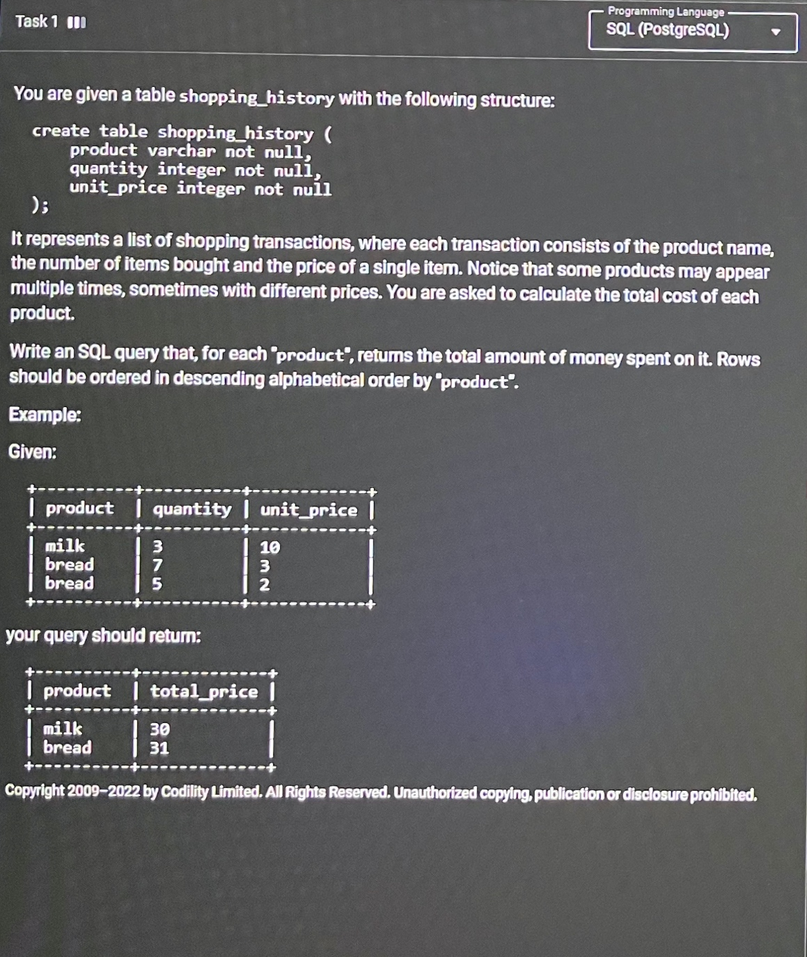

**Query:**

SELECT PRODUCT,SUM(QUATITY*UNIT_PRICE) AS TOTAL_AMOUNT FROM SHOPPING_HISTORY ;

GROUP BY PRODUCT ORDER BY PRODUCT DESC ;

**Task 2:**

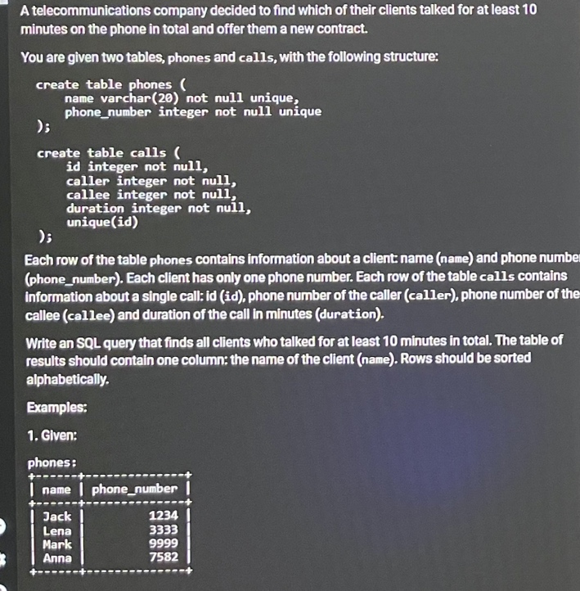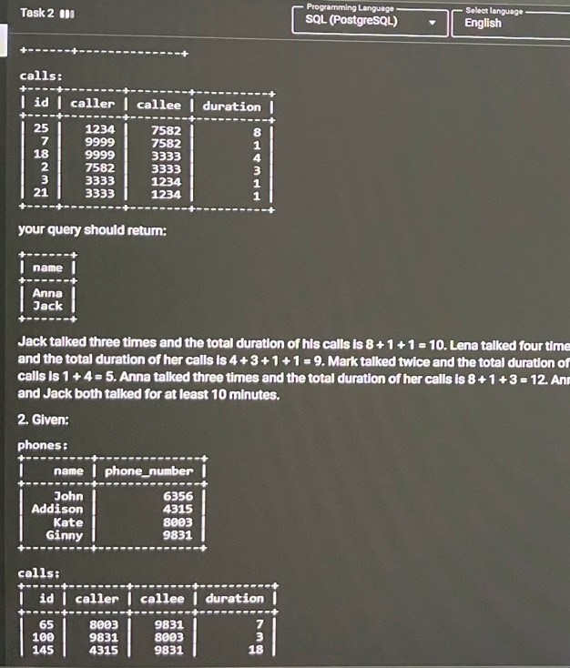

**Query:**

SELECT PHONE.NAME FROM PHONE

INNER JOIN CALLS ON

PHONE.PHONE_NUMBER=CALLS.CALLER OR PHONE.PHONE_NUMBER=CALLS.CALLEE

GROUP BY PHONE.NAME

HAVING SUM(CALLS.DURATION)>=10;

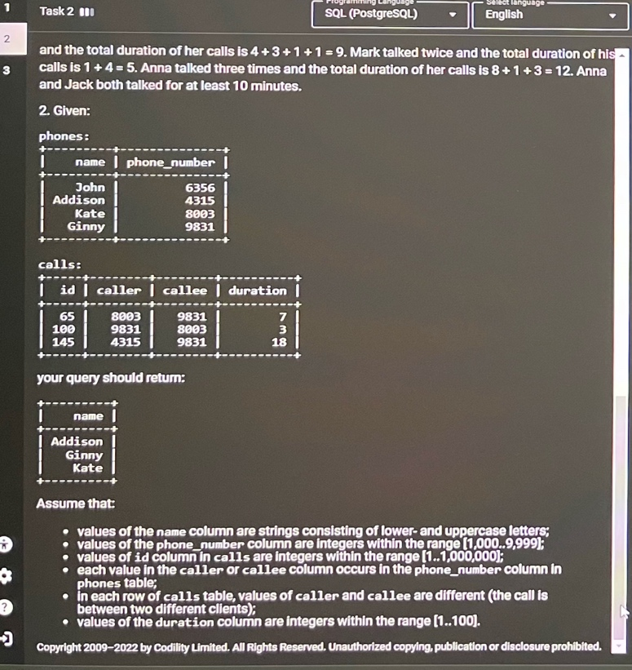

**Task 3:Output display is just one column balance**

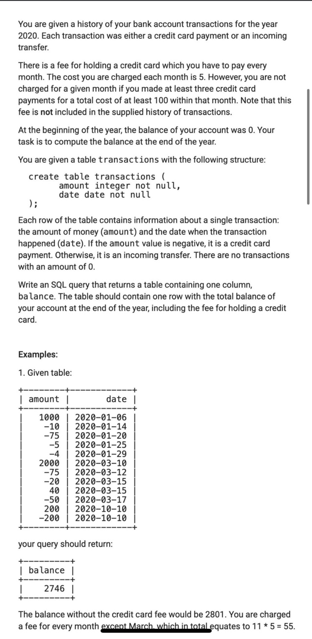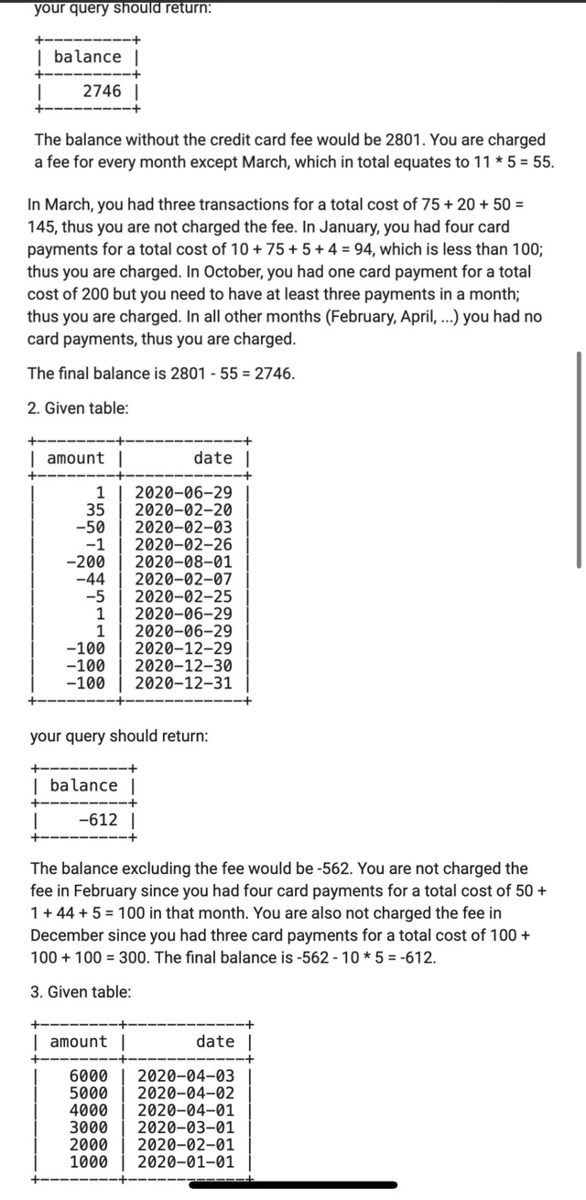

**Query:**

**SELECT SUM(AMOUNT)- SUM(CASE**

**WHEN EXTRACT(MONTH FROM DATE) != 3 THEN 5**

**ELSE 0**

**END) AS TOTAL_FEE**

**FROM TRANSACTIONS;**

**Query:**

**SELECT SUM(AMOUNT)- SUM(CASE**

**WHEN EXTRACT(MONTH FROM DATE) != 2 THEN 5**

**WHEN EXTRACT(MONTH FROM DATE) != 12 THEN 5**

**ELSE 0**

**END) AS TOTAL_FEE**

**FROM TRANSACTIONS;**

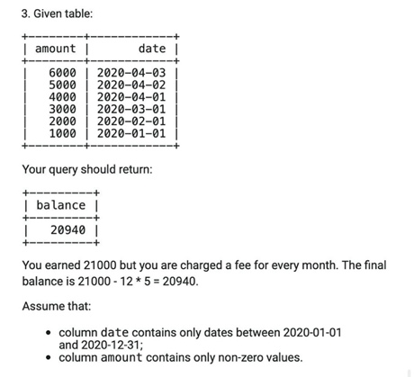

**Query:**

**SELECT SUM(AMOUNT)-(12*5) AS BALANCE FROM TRANSACTIONS3;**

You can add the following data in the table

