Cardiology Consult & ECG Review — Workflow Overview
SYNTHETIC TEST DATA — This document was generated for RAG system development and testing only. It does not represent real clinical guidance, a real hospital policy, or real patient information. Do not use for actual patient care.
Document ID: DOC_075 | Type: workflow | Domain: cardiology | Workflow: WF_002

Purpose
Capture a cardiology consult, acquire and review an ECG, and finalize the cardiology report.

Screen Sequence
Order | Screen ID | Screen Name
1 | SCREEN_07 | Cardiology Consult Intake
2 | SCREEN_08 | ECG Acquisition & Lead Placement Check
3 | SCREEN_09 | ECG Waveform Review
4 | SCREEN_10 | Cardiology Report Sign-off

Reference Visual (Synthetic)
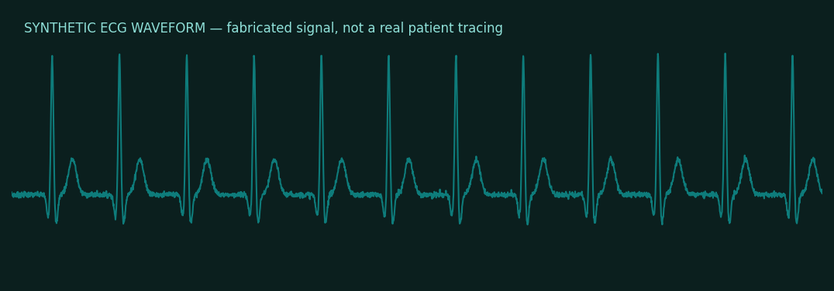

This is a synthetic example document created for RAG system testing. It is not a substitute for actual institutional policy or clinical guidance.

