Medication Administration — Workflow Overview
SYNTHETIC TEST DATA — This document was generated for RAG system development and testing only. It does not represent real clinical guidance, a real hospital policy, or real patient information. Do not use for actual patient care.
Document ID: DOC_076 | Type: workflow | Domain: pharmacy | Workflow: WF_003

Purpose
Safely verify and document administration of an ordered medication, with adverse-reaction monitoring.

Screen Sequence
Order | Screen ID | Screen Name
1 | SCREEN_11 | Medication Order Review
2 | SCREEN_12 | Five Rights Verification
3 | SCREEN_13 | Barcode Medication Scan
4 | SCREEN_14 | Administration Documentation
5 | SCREEN_15 | Adverse Reaction Monitoring

Reference Visual (Synthetic)
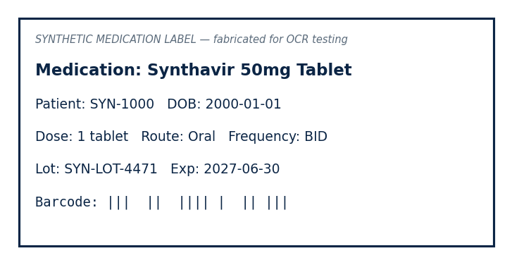

This is a synthetic example document created for RAG system testing. It is not a substitute for actual institutional policy or clinical guidance.

