Lab Specimen Collection & Results — Workflow Overview
SYNTHETIC TEST DATA — This document was generated for RAG system development and testing only. It does not represent real clinical guidance, a real hospital policy, or real patient information. Do not use for actual patient care.
Document ID: DOC_078 | Type: workflow | Domain: laboratory | Workflow: WF_005

Purpose
Order, collect, label, and result a laboratory specimen, including critical value notification.

Screen Sequence
Order | Screen ID | Screen Name
1 | SCREEN_21 | Specimen Collection Order
2 | SCREEN_22 | Specimen Labeling Verification
3 | SCREEN_23 | Lab Result Entry
4 | SCREEN_24 | Critical Value Notification

Reference Visual (Synthetic)
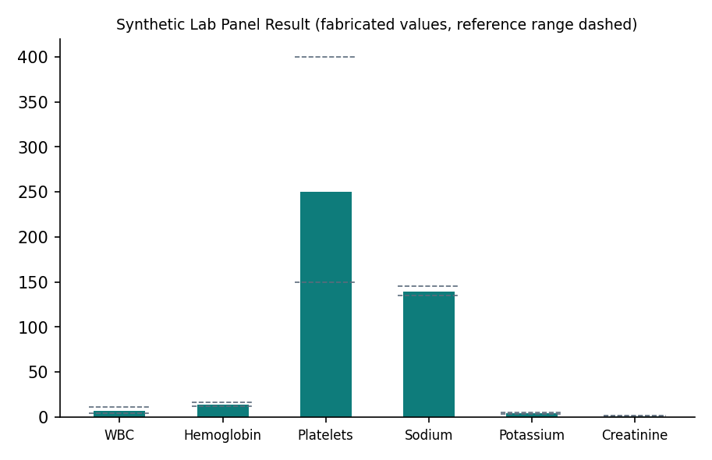

This is a synthetic example document created for RAG system testing. It is not a substitute for actual institutional policy or clinical guidance.

