Patient Identification Standard Operating Procedure
SYNTHETIC TEST DATA — This document was generated for RAG system development and testing only. It does not represent real clinical guidance, a real hospital policy, or real patient information. Do not use for actual patient care.
Document ID: DOC_079 | Type: sop | Domain: general_medicine

Purpose
Defines the standard sequence of actions for this procedure within the synthetic hospital environment modeled by this system.

Procedure
Step | Action
1 | Ask the patient to state their full name and date of birth (do not lead with the name)
2 | Compare stated identifiers against the wristband and the active record
3 | Resolve any mismatch before proceeding with any clinical action
4 | Document identity verification at each required checkpoint

Reference Visual (Synthetic)
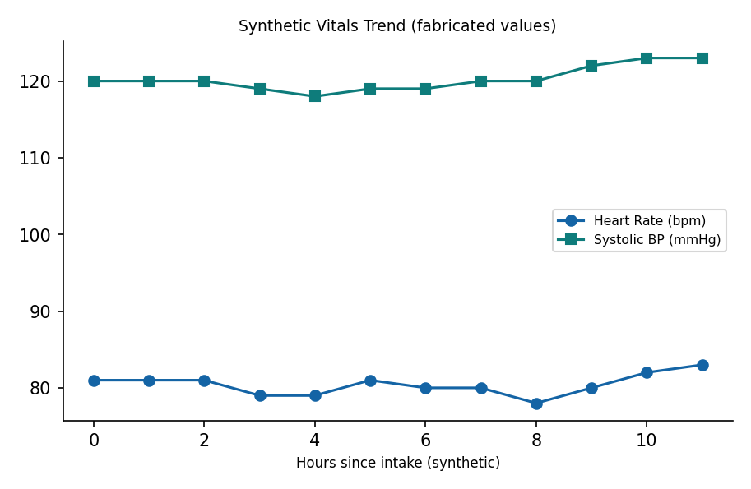

This is a synthetic example document created for RAG system testing. It is not a substitute for actual institutional policy or clinical guidance.

