Informed Consent Process Standard Operating Procedure
SYNTHETIC TEST DATA — This document was generated for RAG system development and testing only. It does not represent real clinical guidance, a real hospital policy, or real patient information. Do not use for actual patient care.
Document ID: DOC_081 | Type: sop | Domain: general_medicine

Purpose
Defines the standard sequence of actions for this procedure within the synthetic hospital environment modeled by this system.

Procedure
Step | Action
1 | Confirm the patient (or authorized representative) has decision-making capacity
2 | Explain the procedure, risks, benefits, and alternatives in plain language
3 | Answer questions before requesting signature
4 | Document consent, including date, time, and witness where required

Reference Visual (Synthetic)
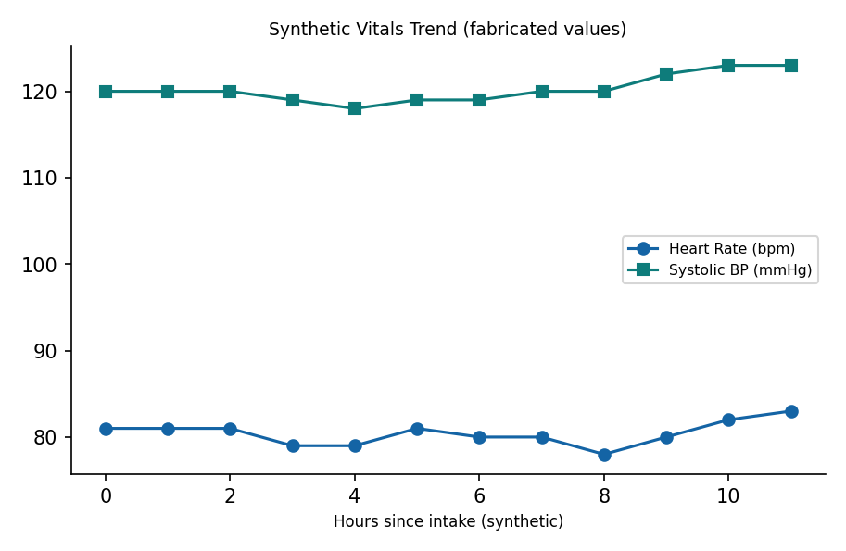

This is a synthetic example document created for RAG system testing. It is not a substitute for actual institutional policy or clinical guidance.

