Clinical Handoff Communication Standard Operating Procedure
SYNTHETIC TEST DATA — This document was generated for RAG system development and testing only. It does not represent real clinical guidance, a real hospital policy, or real patient information. Do not use for actual patient care.
Document ID: DOC_084 | Type: sop | Domain: general_medicine

Purpose
Defines the standard sequence of actions for this procedure within the synthetic hospital environment modeled by this system.

Procedure
Step | Action
1 | Use a structured handoff format covering situation, background, assessment, and recommendation
2 | Allow time for the receiving clinician to ask questions
3 | Confirm receipt of critical pending results or action items
4 | Document that handoff occurred

Reference Visual (Synthetic)
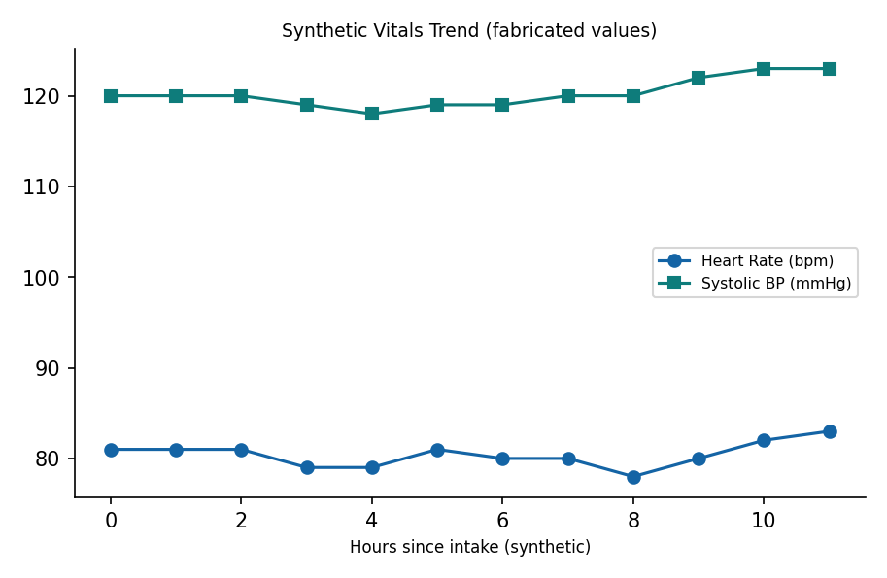

This is a synthetic example document created for RAG system testing. It is not a substitute for actual institutional policy or clinical guidance.

