Imaging Safety & MRI Screening Standard Operating Procedure
SYNTHETIC TEST DATA — This document was generated for RAG system development and testing only. It does not represent real clinical guidance, a real hospital policy, or real patient information. Do not use for actual patient care.
Document ID: DOC_086 | Type: sop | Domain: radiology | Workflow: WF_001

Purpose
Defines the standard sequence of actions for this procedure within the synthetic hospital environment modeled by this system.

Procedure
Step | Action
1 | Complete the MRI safety screening questionnaire with the patient
2 | Verify absence of contraindicated implants or devices
3 | Confirm contrast safety screening where contrast is ordered
4 | Document screening completion before the patient enters the scan room

Reference Visual (Synthetic)
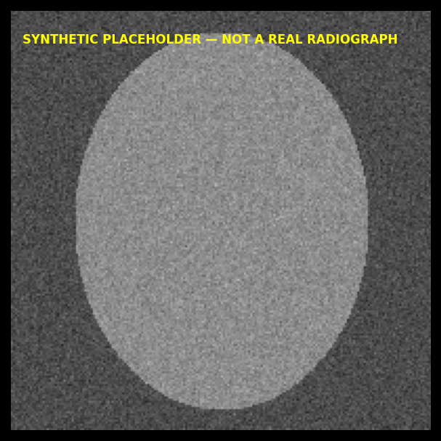

This is a synthetic example document created for RAG system testing. It is not a substitute for actual institutional policy or clinical guidance.

