Discharge Planning Standard Operating Procedure
SYNTHETIC TEST DATA — This document was generated for RAG system development and testing only. It does not represent real clinical guidance, a real hospital policy, or real patient information. Do not use for actual patient care.
Document ID: DOC_088 | Type: sop | Domain: general_medicine

Purpose
Defines the standard sequence of actions for this procedure within the synthetic hospital environment modeled by this system.

Procedure
Step | Action
1 | Confirm disposition and discharge readiness criteria are met
2 | Reconcile discharge medications against the home medication list
3 | Provide follow-up instructions and confirm patient understanding
4 | Document discharge time and responsible provider

Reference Visual (Synthetic)
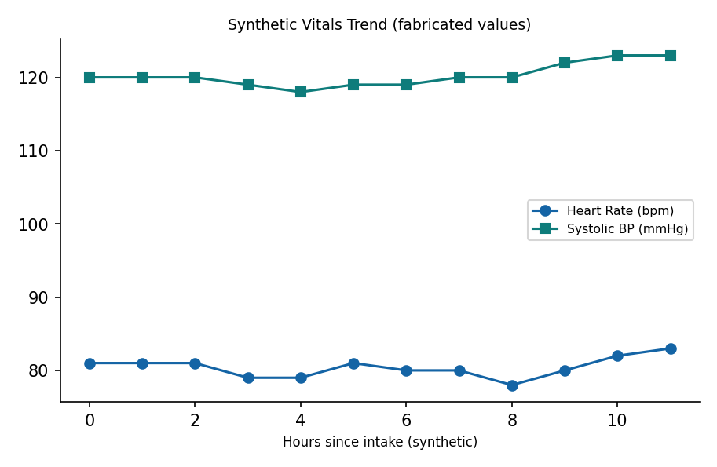

This is a synthetic example document created for RAG system testing. It is not a substitute for actual institutional policy or clinical guidance.

