Screen Navigation & Workflow Guide
SYNTHETIC TEST DATA — This document was generated for RAG system development and testing only. It does not represent real clinical guidance, a real hospital policy, or real patient information. Do not use for actual patient care.
Document ID: DOC_090 | Type: app_documentation | Domain: general_medicine

Purpose
Reference documentation for the medical application's structure, supporting both human users and the future Medical AI Agent's understanding of the platform it operates within.

Reference Table
Workflow ID | Screen Count | Entry Trigger
WF_001 | 6 | Active order or referral
WF_002 | 4 | Active order or referral
WF_003 | 5 | Active order or referral
WF_004 | 5 | Active order or referral
WF_005 | 4 | Active order or referral

Reference Visual (Synthetic)
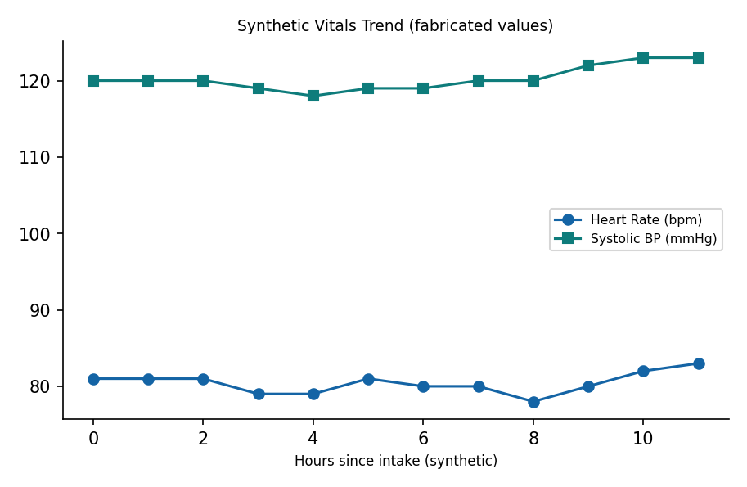

This is a synthetic example document created for RAG system testing. It is not a substitute for actual institutional policy or clinical guidance.

