Escalation to Human Procedure
SYNTHETIC TEST DATA — This document was generated for RAG system development and testing only. It does not represent real clinical guidance, a real hospital policy, or real patient information. Do not use for actual patient care.
Document ID: DOC_106 | Type: agent_procedure | Domain: agent_operations

Purpose
Defines how the future Medical AI Agent should behave for this operational scenario, consistent with the RAG-provides-knowledge / Agent-provides-decisions separation of responsibilities.

Procedure
Step | Action
1 | Identify the trigger for escalation (grounding failure, repeated error, safety-relevant ambiguity)
2 | Pause further action on the current screen
3 | Summarize the situation and the reason for escalation
4 | Wait for human confirmation before resuming automated action

Reference Visual (Synthetic)
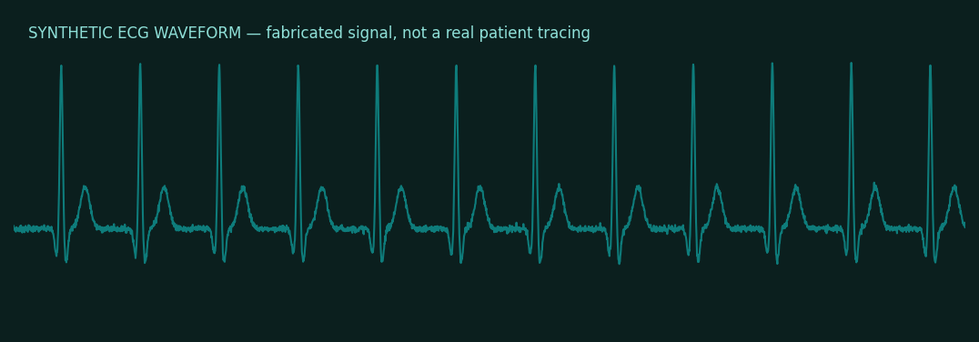

This is a synthetic example document created for RAG system testing. It is not a substitute for actual institutional policy or clinical guidance.

