Memory & Context Management Procedure
SYNTHETIC TEST DATA — This document was generated for RAG system development and testing only. It does not represent real clinical guidance, a real hospital policy, or real patient information. Do not use for actual patient care.
Document ID: DOC_107 | Type: agent_procedure | Domain: agent_operations

Purpose
Defines how the future Medical AI Agent should behave for this operational scenario, consistent with the RAG-provides-knowledge / Agent-provides-decisions separation of responsibilities.

Procedure
Step | Action
1 | Persist the current workflow_id, screen_id, and completed steps at each transition
2 | Retrieve prior context when resuming an interrupted workflow
3 | Discard context that is no longer relevant once a workflow completes
4 | Never carry patient-identifying context across unrelated patient encounters

Reference Visual (Synthetic)
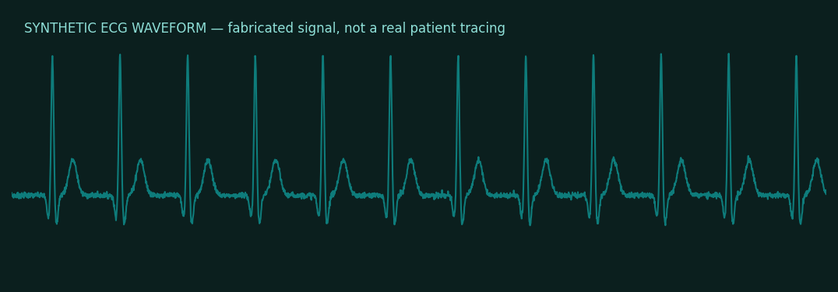

This is a synthetic example document created for RAG system testing. It is not a substitute for actual institutional policy or clinical guidance.

