Safety Override & Stop Conditions Procedure
SYNTHETIC TEST DATA — This document was generated for RAG system development and testing only. It does not represent real clinical guidance, a real hospital policy, or real patient information. Do not use for actual patient care.
Document ID: DOC_108 | Type: agent_procedure | Domain: agent_operations

Purpose
Defines how the future Medical AI Agent should behave for this operational scenario, consistent with the RAG-provides-knowledge / Agent-provides-decisions separation of responsibilities.

Procedure
Step | Action
1 | Recognize conditions that require an immediate stop (critical value, safety validation failure, repeated grounding failure)
2 | Halt all further automated actions on the affected workflow
3 | Notify a human operator with full context of the stop condition
4 | Do not resume automated action on that workflow until human clearance is given

Reference Visual (Synthetic)
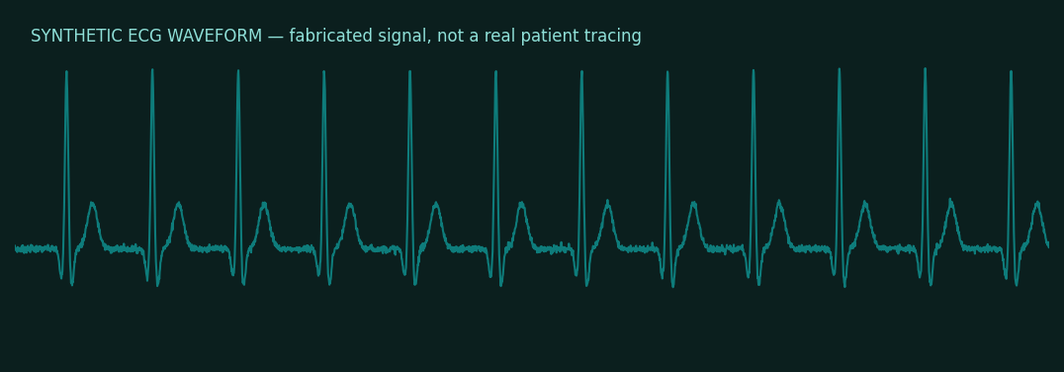

This is a synthetic example document created for RAG system testing. It is not a substitute for actual institutional policy or clinical guidance.

