Emergency Triage & Intake — Workflow Overview
SYNTHETIC TEST DATA — This document was generated for RAG system development and testing only. It does not represent real clinical guidance, a real hospital policy, or real patient information. Do not use for actual patient care.
Document ID: DOC_077 | Type: workflow | Domain: emergency | Workflow: WF_004

Purpose
Intake an emergency department patient, score acuity, capture vitals and allergies, and route to disposition.

Screen Sequence
Order | Screen ID | Screen Name
1 | SCREEN_16 | Emergency Intake & Chief Complaint
2 | SCREEN_17 | Triage Acuity Scoring
3 | SCREEN_18 | Vital Signs Capture
4 | SCREEN_19 | Allergy & Medication Reconciliation
5 | SCREEN_20 | Disposition Decision

Reference Visual (Synthetic)
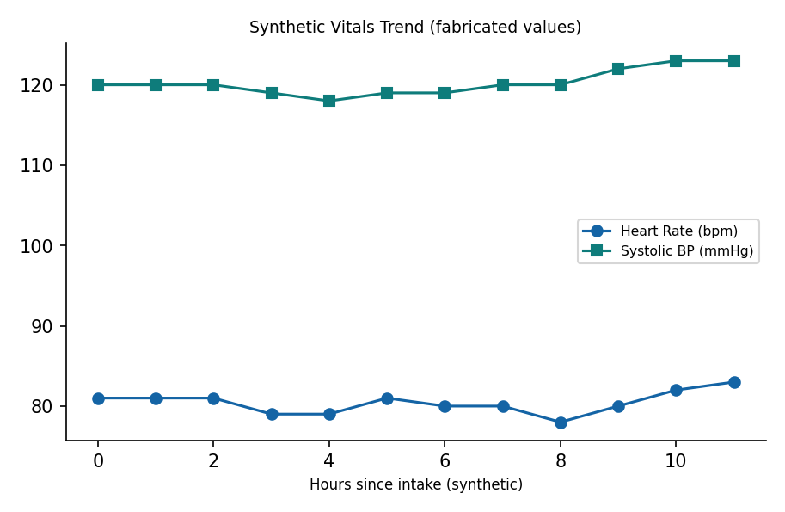

This is a synthetic example document created for RAG system testing. It is not a substitute for actual institutional policy or clinical guidance.

