Medication Administration Standard Operating Procedure
SYNTHETIC TEST DATA — This document was generated for RAG system development and testing only. It does not represent real clinical guidance, a real hospital policy, or real patient information. Do not use for actual patient care.
Document ID: DOC_080 | Type: sop | Domain: pharmacy | Workflow: WF_003

Purpose
Defines the standard sequence of actions for this procedure within the synthetic hospital environment modeled by this system.

Procedure
Step | Action
1 | Review the pharmacist-verified order
2 | Complete the five rights verification
3 | Scan patient wristband and medication barcode
4 | Administer and document administration time immediately
5 | Begin the appropriate monitoring interval

Reference Visual (Synthetic)
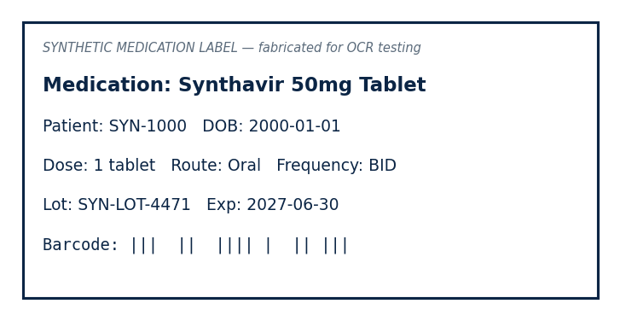

This is a synthetic example document created for RAG system testing. It is not a substitute for actual institutional policy or clinical guidance.

