Hand Hygiene & Infection Control Standard Operating Procedure
SYNTHETIC TEST DATA — This document was generated for RAG system development and testing only. It does not represent real clinical guidance, a real hospital policy, or real patient information. Do not use for actual patient care.
Document ID: DOC_082 | Type: sop | Domain: infection_control

Purpose
Defines the standard sequence of actions for this procedure within the synthetic hospital environment modeled by this system.

Procedure
Step | Action
1 | Perform hand hygiene before patient contact
2 | Apply appropriate personal protective equipment based on isolation status
3 | Perform hand hygiene after patient contact and after glove removal
4 | Document any breach and follow the exposure-reporting process

Reference Visual (Synthetic)
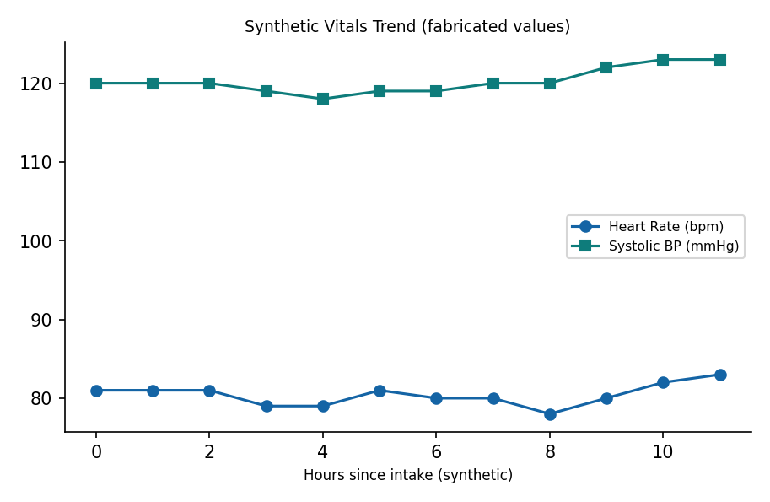

This is a synthetic example document created for RAG system testing. It is not a substitute for actual institutional policy or clinical guidance.

