Fall Prevention Standard Operating Procedure
SYNTHETIC TEST DATA — This document was generated for RAG system development and testing only. It does not represent real clinical guidance, a real hospital policy, or real patient information. Do not use for actual patient care.
Document ID: DOC_083 | Type: sop | Domain: general_medicine

Purpose
Defines the standard sequence of actions for this procedure within the synthetic hospital environment modeled by this system.

Procedure
Step | Action
1 | Assess fall risk on admission and at defined intervals
2 | Apply appropriate visual indicators for high-risk patients
3 | Ensure call bell and mobility aids are within reach
4 | Reassess after any fall event and update the care plan

Reference Visual (Synthetic)
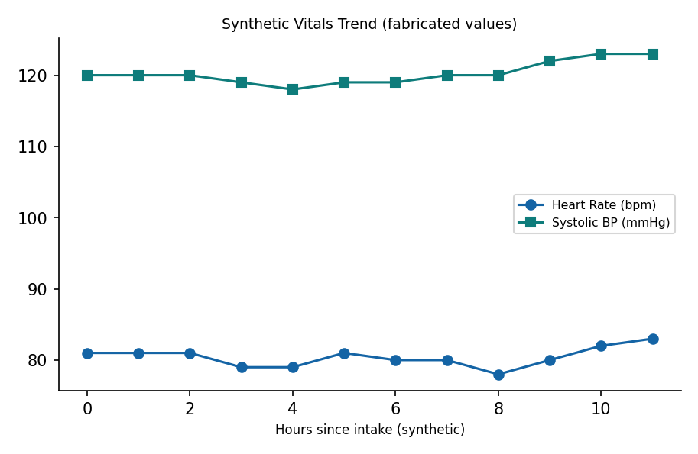

This is a synthetic example document created for RAG system testing. It is not a substitute for actual institutional policy or clinical guidance.

