Laboratory Specimen Handling Standard Operating Procedure
SYNTHETIC TEST DATA — This document was generated for RAG system development and testing only. It does not represent real clinical guidance, a real hospital policy, or real patient information. Do not use for actual patient care.
Document ID: DOC_085 | Type: sop | Domain: laboratory | Workflow: WF_005

Purpose
Defines the standard sequence of actions for this procedure within the synthetic hospital environment modeled by this system.

Procedure
Step | Action
1 | Confirm the order and required specimen type before collection
2 | Perform positive patient identification immediately before collection
3 | Label the specimen at the bedside immediately after collection
4 | Transport per the required handling conditions for the test

Reference Visual (Synthetic)
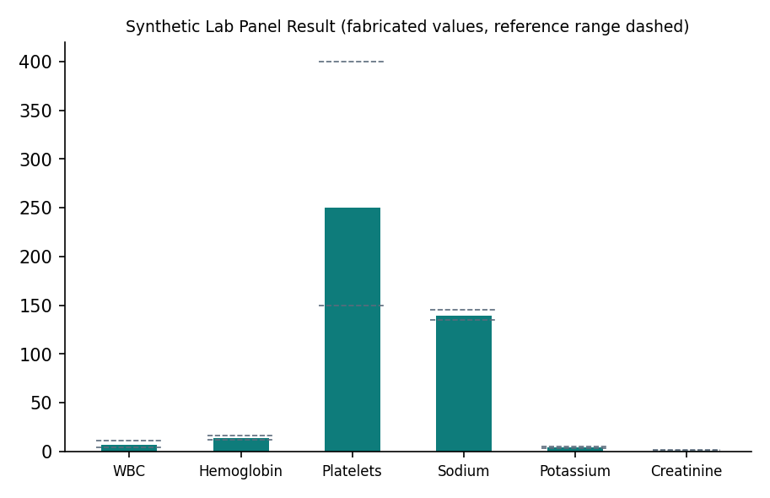

This is a synthetic example document created for RAG system testing. It is not a substitute for actual institutional policy or clinical guidance.

