Emergency Rapid Response Standard Operating Procedure
SYNTHETIC TEST DATA — This document was generated for RAG system development and testing only. It does not represent real clinical guidance, a real hospital policy, or real patient information. Do not use for actual patient care.
Document ID: DOC_087 | Type: sop | Domain: emergency | Workflow: WF_004

Purpose
Defines the standard sequence of actions for this procedure within the synthetic hospital environment modeled by this system.

Procedure
Step | Action
1 | Recognize and call for the rapid response / code team per early warning criteria
2 | Begin initial stabilization measures per role
3 | Communicate status using a structured handoff format on team arrival
4 | Document the event timeline after the patient is stabilized

Reference Visual (Synthetic)
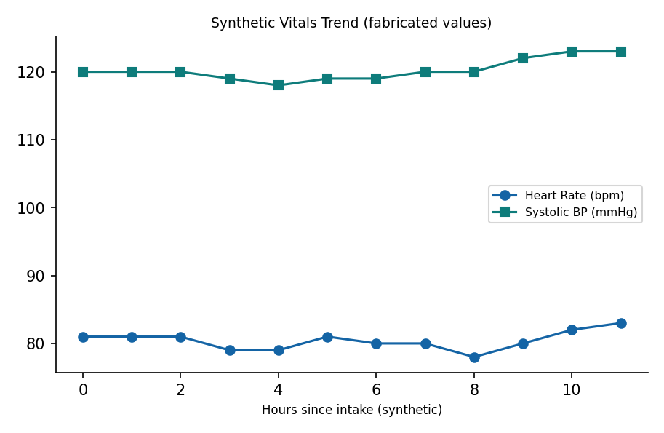

This is a synthetic example document created for RAG system testing. It is not a substitute for actual institutional policy or clinical guidance.

