Medical Application System Overview
SYNTHETIC TEST DATA — This document was generated for RAG system development and testing only. It does not represent real clinical guidance, a real hospital policy, or real patient information. Do not use for actual patient care.
Document ID: DOC_089 | Type: app_documentation | Domain: general_medicine

Purpose
Reference documentation for the medical application's structure, supporting both human users and the future Medical AI Agent's understanding of the platform it operates within.

Reference Table
Module | Responsibility
Screens | 24 connected screens across 5 clinical workflows
Order Management | Tracks active orders driving workflow entry
Documentation Engine | Persists field values entered on each screen
Notification Service | Delivers critical-value and escalation alerts

Reference Visual (Synthetic)
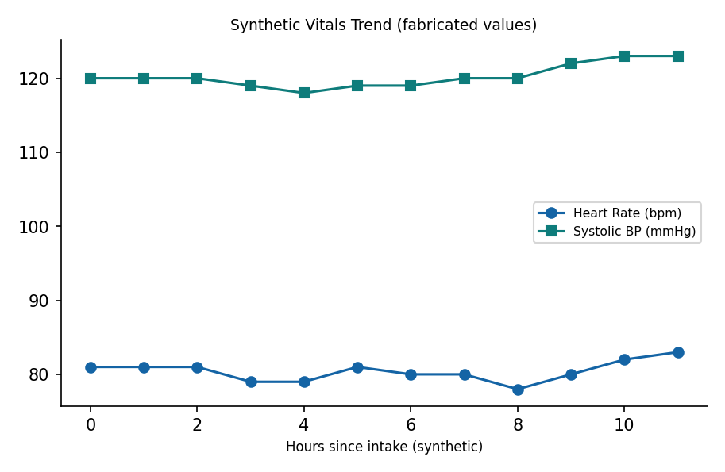

This is a synthetic example document created for RAG system testing. It is not a substitute for actual institutional policy or clinical guidance.

