Data Entry Standards & Field Conventions
SYNTHETIC TEST DATA — This document was generated for RAG system development and testing only. It does not represent real clinical guidance, a real hospital policy, or real patient information. Do not use for actual patient care.
Document ID: DOC_091 | Type: app_documentation | Domain: general_medicine

Purpose
Reference documentation for the medical application's structure, supporting both human users and the future Medical AI Agent's understanding of the platform it operates within.

Reference Table
Convention | Rule
Identifiers | Always two patient identifiers minimum
Dates | ISO 8601 (YYYY-MM-DD) for all stored dates
Required fields | Cannot be left blank; explicit 'none' values used where applicable
Free text | Discouraged for anything with a structured equivalent

Reference Visual (Synthetic)
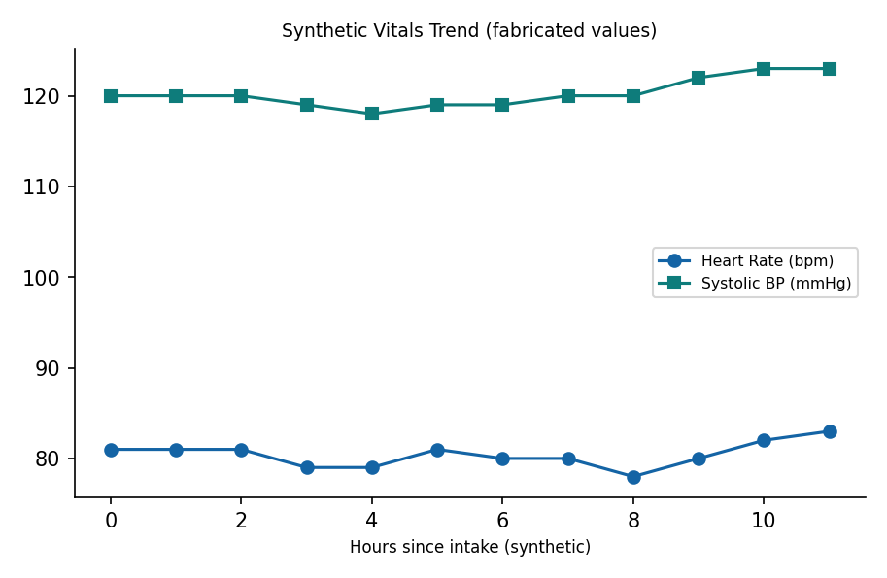

This is a synthetic example document created for RAG system testing. It is not a substitute for actual institutional policy or clinical guidance.

