Error Handling & Recovery Guide
SYNTHETIC TEST DATA — This document was generated for RAG system development and testing only. It does not represent real clinical guidance, a real hospital policy, or real patient information. Do not use for actual patient care.
Document ID: DOC_092 | Type: app_documentation | Domain: general_medicine

Purpose
Reference documentation for the medical application's structure, supporting both human users and the future Medical AI Agent's understanding of the platform it operates within.

Reference Table
Error Class | System Behavior
Validation failure | Screen blocks advancement and displays the failed rule
Scan mismatch | Administration blocked pending manual resolution
Connectivity loss | Local draft retained; sync retried on reconnect
Duplicate order | Flagged for reconciliation before proceeding

Reference Visual (Synthetic)
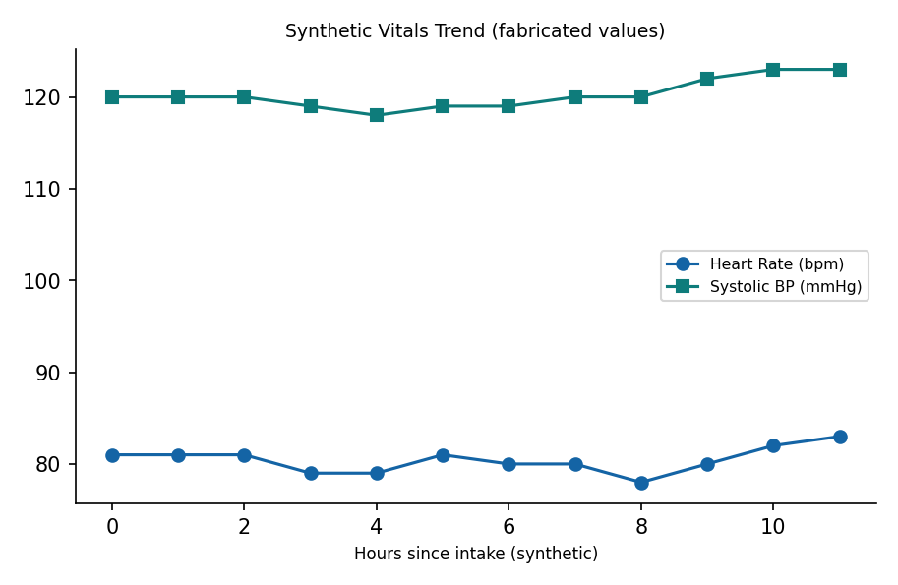

This is a synthetic example document created for RAG system testing. It is not a substitute for actual institutional policy or clinical guidance.

