Integration Points & Upstream Data Sources
SYNTHETIC TEST DATA — This document was generated for RAG system development and testing only. It does not represent real clinical guidance, a real hospital policy, or real patient information. Do not use for actual patient care.
Document ID: DOC_093 | Type: app_documentation | Domain: general_medicine

Purpose
Reference documentation for the medical application's structure, supporting both human users and the future Medical AI Agent's understanding of the platform it operates within.

Reference Table
Source System | Data Provided
Order Entry System | Active orders and referrals
Pharmacy System | Verified medication orders and formulary data
Laboratory Information System | Specimen orders and result values
Registration System | Patient identifiers and encounter data

Reference Visual (Synthetic)
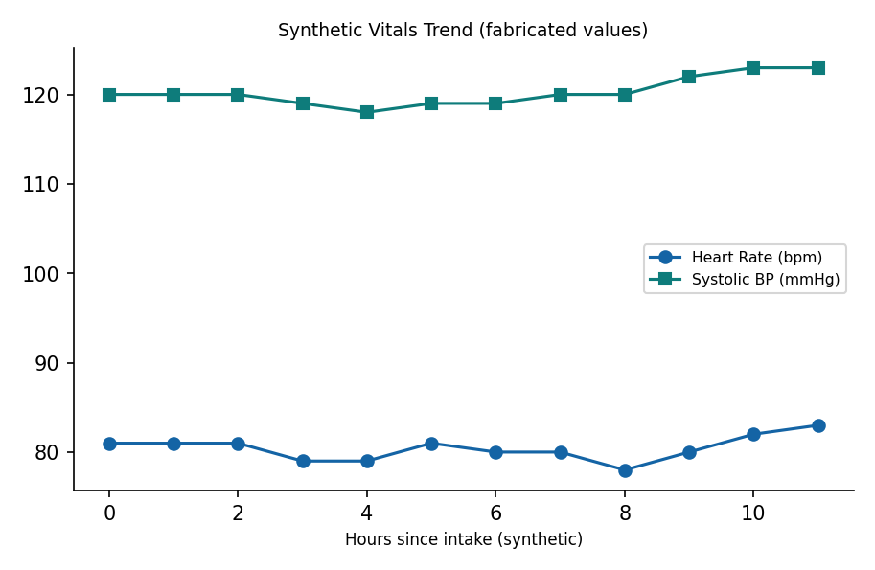

This is a synthetic example document created for RAG system testing. It is not a substitute for actual institutional policy or clinical guidance.

