OCR Tool — Agent Tool Instructions
SYNTHETIC TEST DATA — This document was generated for RAG system development and testing only. It does not represent real clinical guidance, a real hospital policy, or real patient information. Do not use for actual patient care.
Document ID: DOC_094 | Type: tool_instruction | Domain: agent_operations

Purpose
Extracts machine-readable text from a screenshot or scanned document region.

Usage Reference
Aspect | Description
Purpose | Extracts machine-readable text from a screenshot or scanned document region.
Typical Input | Current screen region, coordinates, or field reference
Typical Output | Extracted text, confirmation status, or updated screen state
Precondition | The target screen or region must be visible and stable before use
Postcondition | The action's effect is verifiable on the next screen read

Reference Visual (Synthetic)
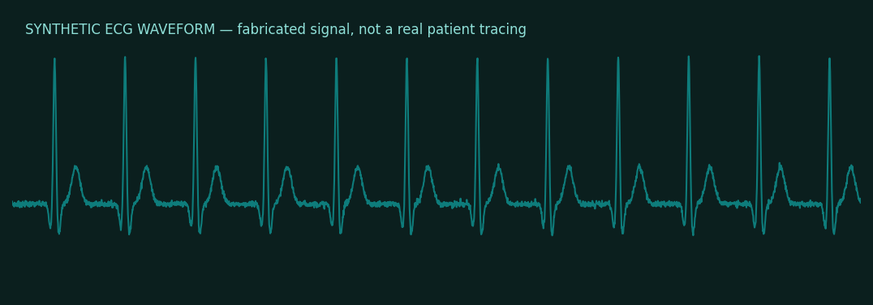

This is a synthetic example document created for RAG system testing. It is not a substitute for actual institutional policy or clinical guidance.

