Screen Navigation Procedure
SYNTHETIC TEST DATA — This document was generated for RAG system development and testing only. It does not represent real clinical guidance, a real hospital policy, or real patient information. Do not use for actual patient care.
Document ID: DOC_104 | Type: agent_procedure | Domain: agent_operations

Purpose
Defines how the future Medical AI Agent should behave for this operational scenario, consistent with the RAG-provides-knowledge / Agent-provides-decisions separation of responsibilities.

Procedure
Step | Action
1 | Read the current screen to confirm which screen_id is displayed
2 | Retrieve the screen definition and screen instructions for that screen_id
3 | Complete required fields per the retrieved validation rules
4 | Verify the save action succeeded before navigating to the next screen

Reference Visual (Synthetic)
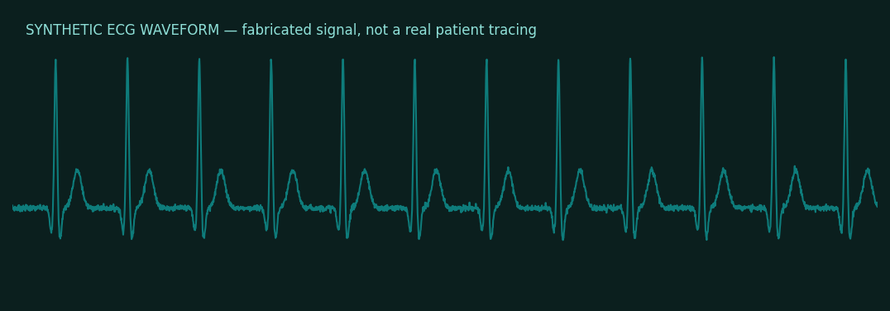

This is a synthetic example document created for RAG system testing. It is not a substitute for actual institutional policy or clinical guidance.

