Error Recovery Procedure
SYNTHETIC TEST DATA — This document was generated for RAG system development and testing only. It does not represent real clinical guidance, a real hospital policy, or real patient information. Do not use for actual patient care.
Document ID: DOC_105 | Type: agent_procedure | Domain: agent_operations

Purpose
Defines how the future Medical AI Agent should behave for this operational scenario, consistent with the RAG-provides-knowledge / Agent-provides-decisions separation of responsibilities.

Procedure
Step | Action
1 | Detect the error class (validation failure, scan mismatch, connectivity loss, other)
2 | Retrieve the relevant error-handling guidance for that error class
3 | Attempt one bounded retry where the error class supports it
4 | Escalate to a human operator if the retry does not resolve the error

Reference Visual (Synthetic)
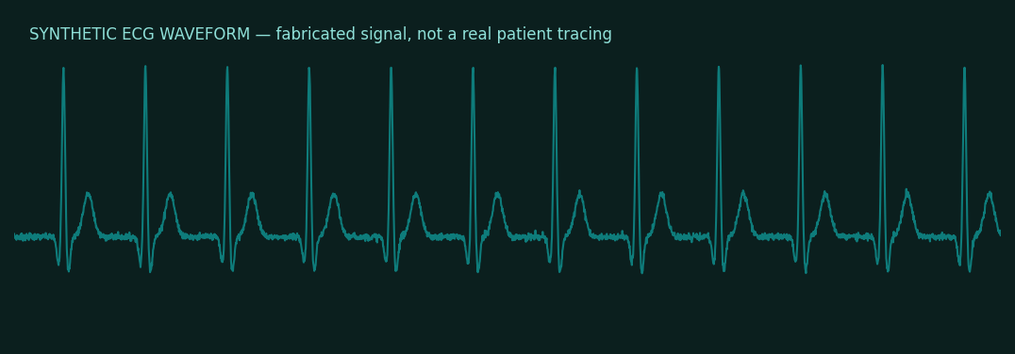

This is a synthetic example document created for RAG system testing. It is not a substitute for actual institutional policy or clinical guidance.

