Follow the bellow steps to successfully fetch the inventory: -
- Open “File Explorer”.
- Navigate to “Local Disk (C:) > Inventory>”.
- Open “System_Ips” (Excel file).
- Provide the details of the SUT (ILO-IP, ILO-UserName, ILO-Password).
- Save the file and close it before proceeding to the next step.
- Now, Open command prompt (run as administrator).
- Change the directory to “C:\Inventory>”.
- Execute the following command: - “python result.py”.
- The test execution will start.
- You are advised not to close the Command Prompt until you find the
“Successful, OK!!” Message.
- Now you can close the Command Prompt and find the “REPORT FILE”.
- Path to Report: - “C:\Inventory\Report.txt”
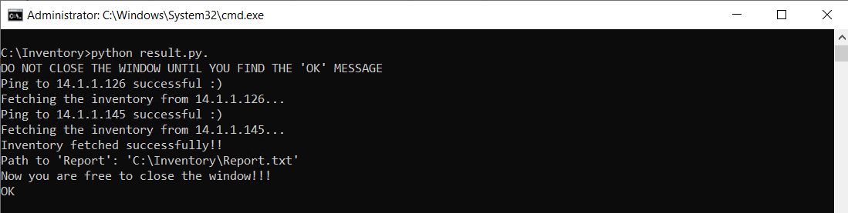

QA:
- How to identify if all the servers have been executed successfully?
A) If any of the servers have failed to fetch the data, you will find the following message on the command prompt:
“!!!!!PLEASE VERIFY THE FOLLOWING IP: {ILO_IP}!!!!!”
- Can I use the same code on another system ?
A) Yes, you can copy the same code to another system and run the script. Make sure you follow the below steps: -
i. Python must be installed on the system.
ii. Open command prompt (run as administrator).
iii. pip install pandas.
iv. pip install openpyxl.
v. pip install requests.
vi. Now copy the Inventory folder from Local Disk (C:) to your desired system to the same path: “Local Disk (C:) > Inventory>”.

