**De-Commissioning Plan**

**LUZ - Colombia**

**(MIC – MicroGrid Intelligent Connect)**

**For Migraine & Multiple Sclerosis**

|  |  |
| --- | --- |
|  |  |

|  |  |
| --- | --- |
| Document Type | De-Commissioning Plan |
| Document # | DP # 1/ 2023 |
| Project Title | LUZ - Colombia (Migraine & Multiple Sclerosis) |
| Project Type | Implementation |
| Client | Novartis Services Inc. |
| PO # | C028-3005353596 |
| Service Provider | Microgrid Inc. |
| SOW # | SoW # 6/ 2021 |
| Deployment Date | 27th May,2022 |
| Hypercare Completion | 12th June,2022 |
| De-Commissioning Date | 12th June,2023 |

|  |  |  |
| --- | --- | --- |
| Anant P | Rama Narayana Vedula | Isabella Andrade Carabali |
| MicroGrid - Project Manager | MicroGrid - Head Operations | NVS - Patient Experience Analyst |
| **Prepared by** | **Reviewed by** | **Approved by** |

* **NGINX SERVER:**

To stop the NGINX server running on a Google Cloud VM instance, you can follow these steps:

1. Connect to your VM instance via SSH.
2. Once connected to the VM instance, execute the following command to stop the NGINX service:

**sudo service nginx stop**

1. This command will send a signal to the NGINX process to gracefully stop and terminate.
2. Verify that NGINX has stopped by checking the status of the service. You can use the following command:

**sudo service nginx status**

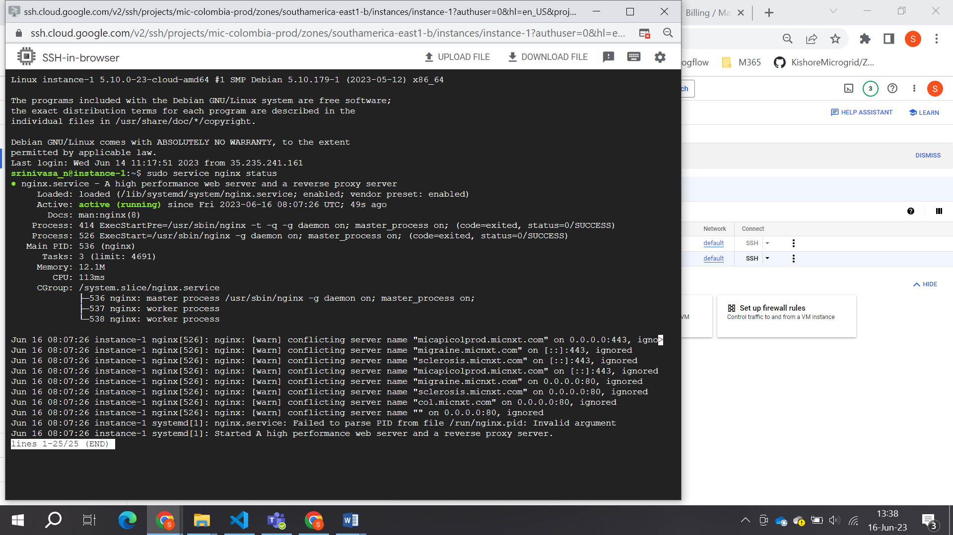

1. If the NGINX service is stopped, you should see a message indicating that it is not running.
2. By executing the sudo service nginx stop command, you are instructing the system to stop the NGINX service. This will halt the operation of the NGINX web server and prevent it from serving any further requests.
3. If you want to disable NGINX from starting automatically on boot, you can use the following command:

**sudo systemctl disable nginx**

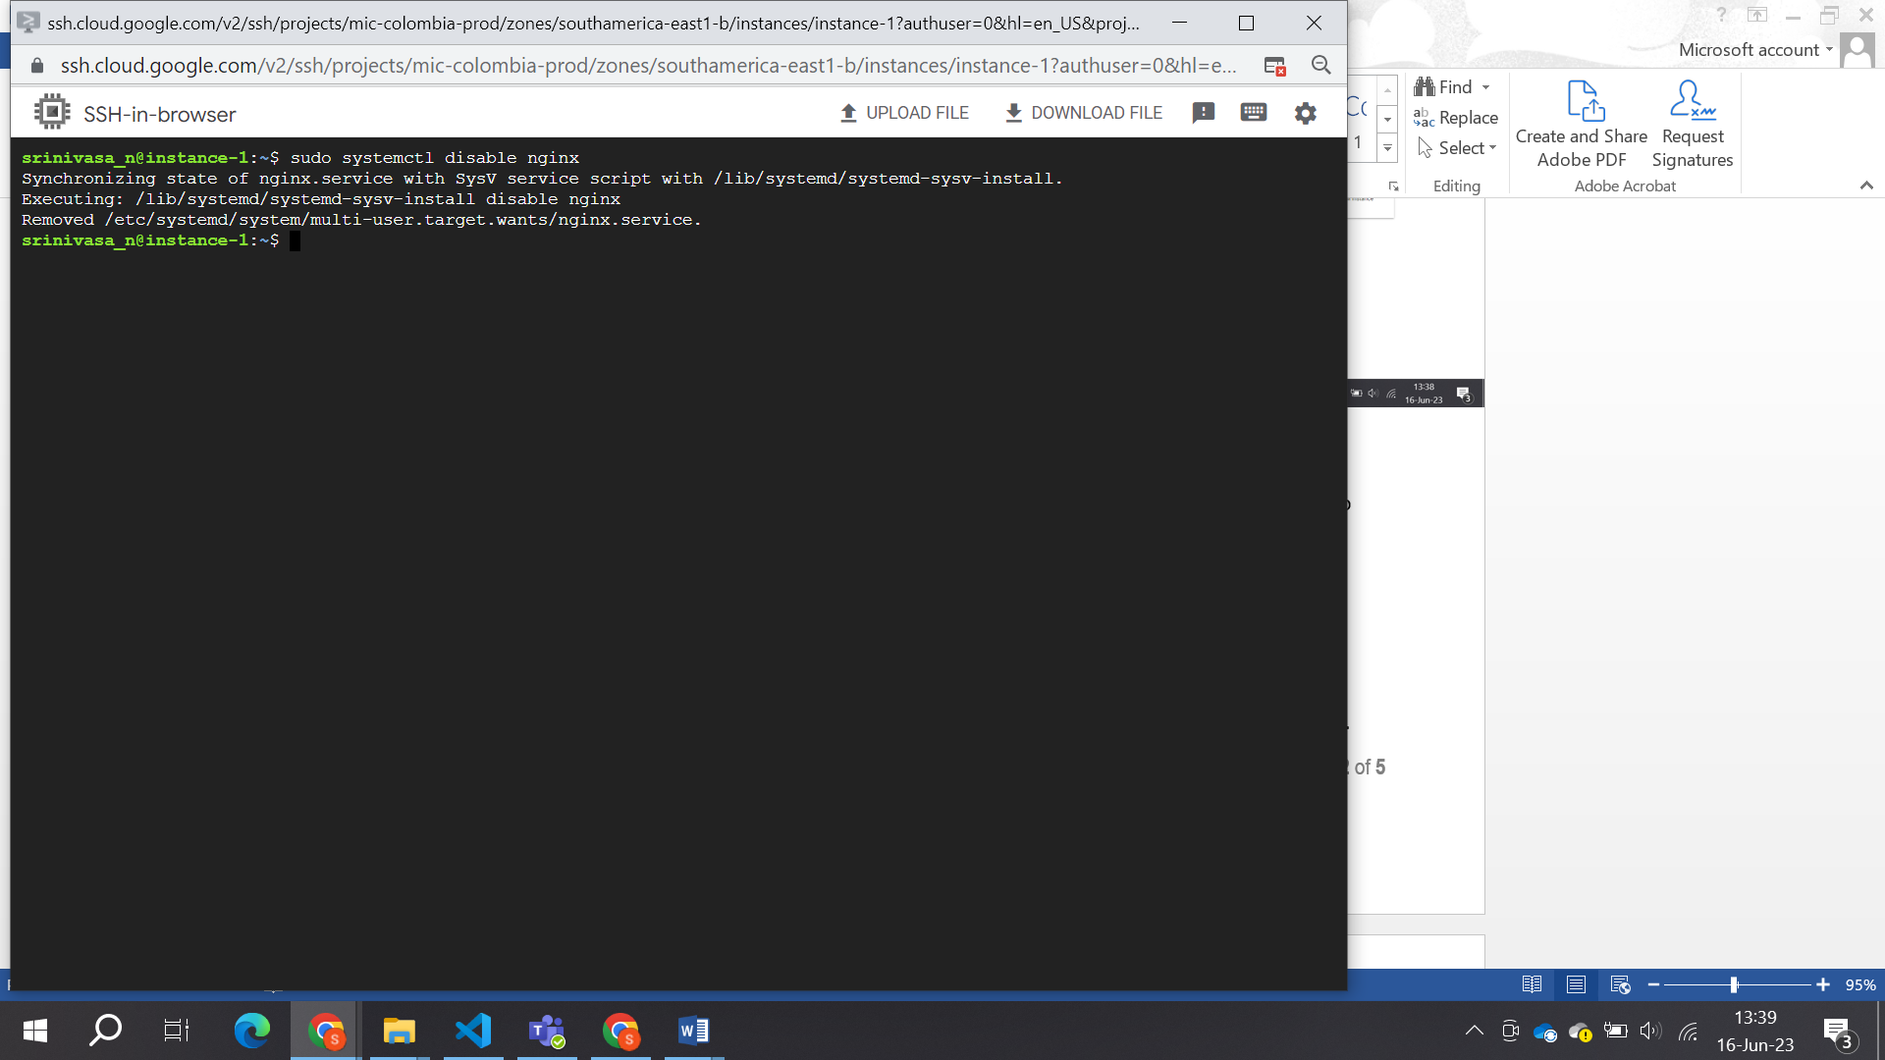

1. This command will prevent NGINX from automatically starting during system startup.
2. Remember to consider any implications or dependencies your applications or services may have on NGINX before stopping or disabling the service.

* **VM INSTANCE:**

To disable VM instances in a project in Google Cloud Platform (GCP), please follow these steps:

* 1. Go to the GCP Console: <https://console.cloud.google.com/>.

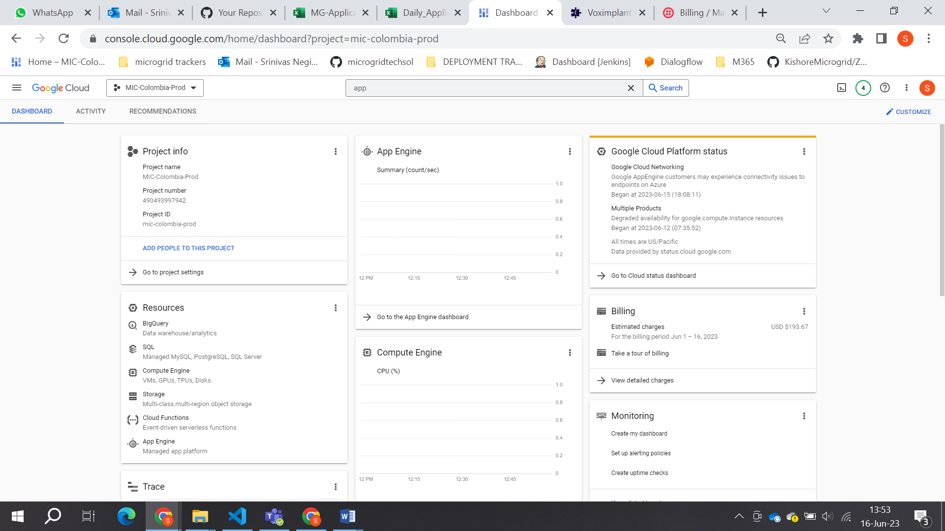

* 1. Select the project that contains the VM instances you want to disable from the project drop-down menu at the top of the page.
  2. In the navigation menu on the left, click on "Compute Engine" under the "Compute" section.
  3. On the Compute Engine page, you will see a list of your VM instances.
  4. Identify the VM instances you want to disable and select them by clicking the checkboxes next to their names. You can select multiple instances at once if needed.
  5. Once you have selected the desired instances, click on the "Stop" button at the top of the VM instances list. This will initiate the shutdown process for the selected instances.

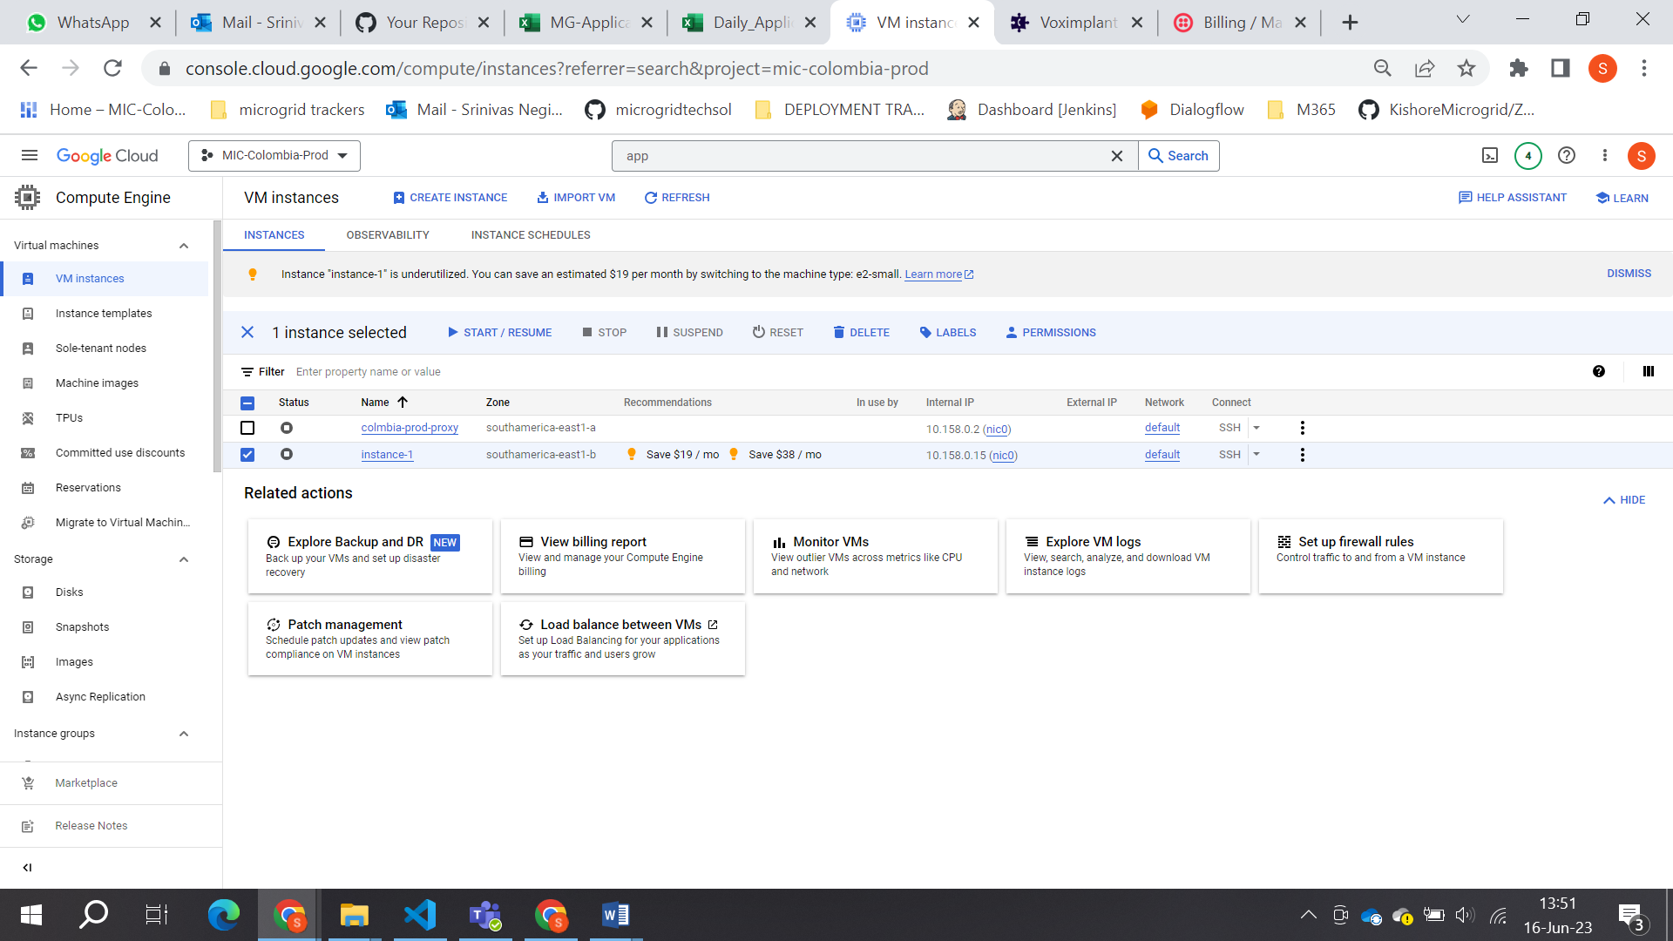

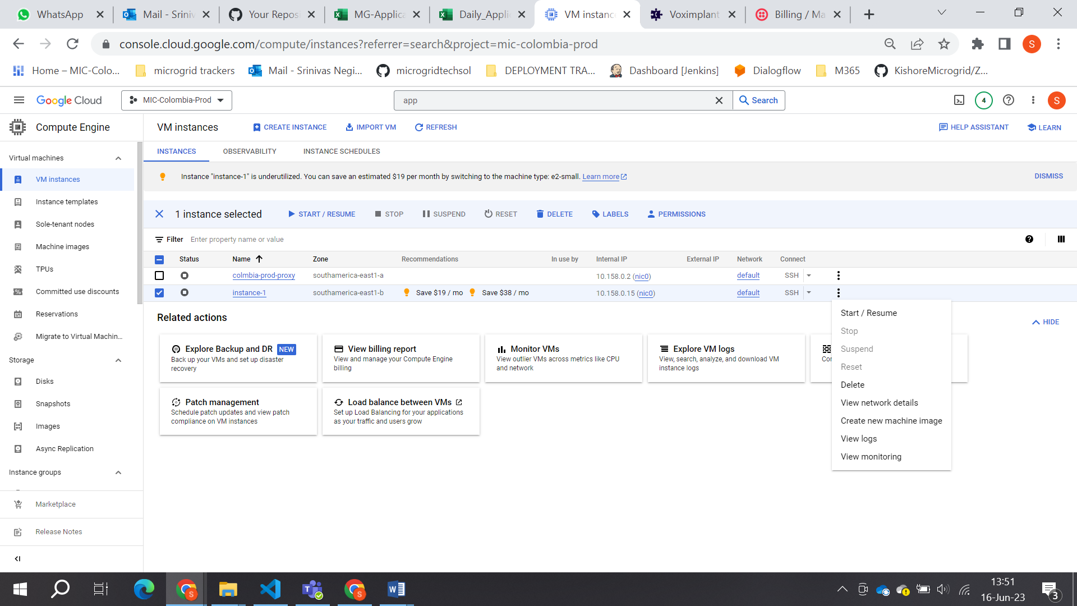

* 1. In the confirmation dialog box that appears, review the details and click on the "Stop" button to confirm the action.
* **PostgreSQL:**

To disable PostgreSQL instances for a project in Google Cloud Platform (GCP) and reduce billing, you can follow these steps:

1. Go to the Google Cloud Console: <https://console.cloud.google.com/>
2. Select your project from the project selector dropdown at the top of the page.
3. Open the Cloud SQL menu from the left navigation panel.
4. On the Cloud SQL page, you will see a list of your database instances.
5. Identify the PostgreSQL instance you want to disable and click on it.
6. In the instance details page, click on the "Delete" button at the top of the page.
7. Confirm the deletion when prompted.

* **APP ENGINE:**

To disable App Engine services in a project to reduce billing in Google Cloud Platform (GCP), follow these steps:

1. Go to the GCP Console: <https://console.cloud.google.com/>.



1. Select the project that contains the App Engine services you want to disable from the project drop-down menu at the top of the page.
2. In the navigation menu on the left, click on "App Engine."
3. On the App Engine page, you will see a list of your App Engine services.
4. Identify the App Engine service you want to disable and select it by clicking on its name.
5. Once you are on the service's page, click on the "Stop" button at the top of the page. This will initiate the process of disabling the App Engine service.

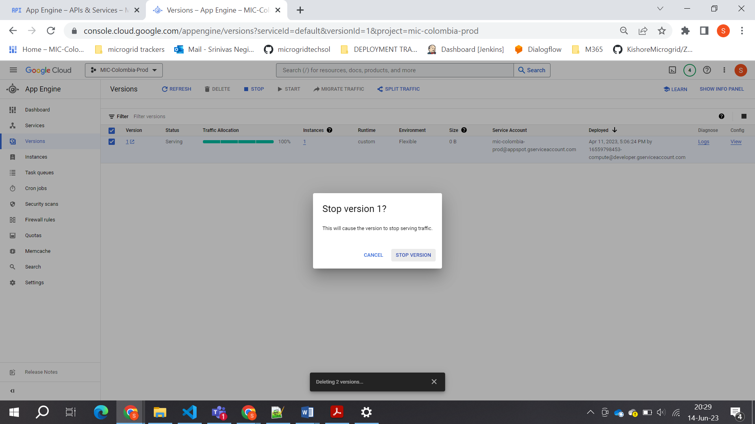

1. If you want to delete the service click on delete.

* **CLOUD FUNCTIONS:**

To disable Cloud Functions for a project in Google Cloud Platform (GCP) and reduce billing, please follow these steps:

1. Go to the Google Cloud Console: <https://console.cloud.google.com/>
2. Select your project from the project selector dropdown at the top of the page.
3. Open the Cloud Functions menu from the left navigation panel.
4. In the Cloud Functions page, you will see a list of all the functions deployed in your project.
5. Identify the functions you want to disable and click on the checkbox next to each function.
6. Once you have selected the functions, click on the "Disable" button at the top of the page.
7. Confirm the disable operation when prompted.

* **CLOUD STORAGE BUCKET:**

To disable cloud storage sources for a project in Google Cloud Platform (GCP) and reduce billing, Please follow these steps:

1. Go to the Google Cloud Console: <https://console.cloud.google.com/>
2. Select your project from the project selector dropdown at the top of the page.
3. Open the Storage menu from the left navigation panel and select "Browser."
4. In the Storage Browser, you will see a list of buckets associated with your project. Select the bucket(s) you want to disable.
5. Click the "Delete" button at the top of the page to delete the selected bucket(s).

**Note:** Deleting a bucket will also delete all objects stored within it, so make sure you have a backup if needed.

1. Confirm the deletion when prompted.

* **APIs & Services:**

To disable an API in Google Cloud Platform (GCP), please follow these steps:

1. Go to the GCP Console: <https://console.cloud.google.com/>.
2. Select the project that contains the API you want to disable from the project drop-down menu at the top of the page.
3. In the navigation menu on the left, click on "APIs & Services" and then select "Library" from the sub-menu.
4. In the Library section, you will see a list of available APIs. Use the search bar or scroll through the list to find the API you want to disable.
5. Once you locate the API, click on it to open its details page.
6. On the API details page, you will find an "Enable" button indicating that the API is currently enabled. Click on the "Enable" button.
7. In the dialog box that appears, click on the "Disable" button to confirm the action.