RESQONE AI+ — COMPLETE SYSTEM ARCHITECTURE
AI-Powered Emergency Detection, Decision Support, Resource Allocation & Rescue Coordination
Architecture document for second review, implementation and research-paper methodology
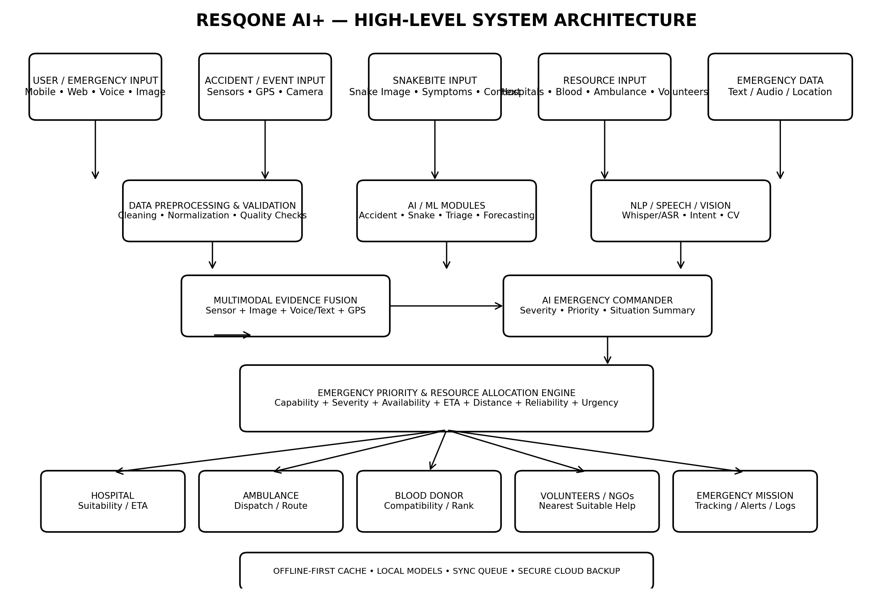

1. Architecture objective
The RESQONE AI+ architecture is designed as an emergency intelligence and coordination pipeline. It receives emergency reports and multimodal evidence, validates and preprocesses the information, runs specialized AI models, fuses their outputs, determines emergency severity and priority, ranks suitable resources, creates an emergency mission, and continuously tracks the response.
The architecture deliberately separates AI prediction from safety-critical decision rules. For example, medical blood compatibility must remain a deterministic constraint; AI should rank eligible donors rather than invent compatibility.

2. Core architecture layers
Layer | Main components | Purpose
1. User & Input Layer | Mobile/Web UI, emergency form, voice, camera, GPS, optional phone sensors | Collect emergency evidence and location.
2. Data Validation Layer | Schema validation, cleaning, normalization, quality checks, confidence checks | Prevent malformed or unreliable input from reaching models.
3. AI Inference Layer | Accident model, snake classifier, severity/triage model, forecasting model, NLP/ASR | Convert raw inputs into structured predictions/features.
4. Multimodal Fusion Layer | Feature/output fusion, confidence aggregation, context fusion | Combine heterogeneous evidence into one emergency situation representation.
5. AI Emergency Commander | Severity, priority, situation summary, next-action recommendation | Convert model outputs into a coherent emergency state.
6. Resource Allocation Layer | Hospital, ambulance, donor, volunteer/NGO ranking | Select suitable resources using constraints + ranking.
7. Mission & Coordination Layer | Mission creation, alerts, dispatch, status, tracking, escalation | Turn recommendations into an operational workflow.
8. Offline & Sync Layer | Local database, model cache, queue, synchronization | Keep essential functions available during connectivity loss.
9. Data/Monitoring Layer | Audit logs, model results, metrics, feedback | Support research evaluation, monitoring and traceability.

3. End-to-end workflow
- User reports an emergency or an automatic accident event is generated.
- System captures available location, text, voice, image and sensor evidence.
- Input validation checks required fields, data type, timestamp and confidence.
- Preprocessing normalizes sensor windows, images, speech/text and location data.
- Specialized AI modules independently analyze the relevant evidence.
- Outputs are converted into a common structured emergency representation.
- Multimodal fusion combines evidence and confidence values.
- AI Emergency Commander determines emergency category, severity and priority.
- Resource Allocation Engine applies hard safety constraints first.
- Eligible hospitals, ambulances, donors and responders are ranked using suitability factors.
- System creates an Emergency Mission with selected resources and reason codes.
- Notifications/dispatch requests are sent to authorized participants.
- Mission status is tracked: created → assigned → accepted → en route → arrived → completed/cancelled.
- Offline mode queues actions locally when connectivity is unavailable.
- When connectivity returns, synchronization reconciles queued records with the server.
- Audit logs and outcomes are stored for evaluation and future model improvement.

4. Input layer

4.1 Emergency user input
- Emergency type: accident, snakebite, medical emergency, blood requirement, other.
- Location: GPS coordinates or manually selected location.
- Text description and structured symptoms/context.
- Voice report converted to text when speech input is enabled.
- Image/video evidence where relevant.
- Optional contact and consent information.

4.2 Accident/sensor input
- Accelerometer: acceleration magnitude, axes and derived jerk.
- Gyroscope: angular velocity and rotation.
- GPS: location, speed and movement context.
- Optional camera evidence.
- Timestamp and device/session metadata.

4.3 Snakebite input
- Snake image.
- Approximate location and environment.
- User-provided symptoms/context.
- Time since bite and emergency status where safely collected.
- Model confidence and uncertainty.

5. Preprocessing and validation layer
This layer is essential because the AI models should not receive raw uncontrolled data.
- Sensor: remove invalid values, resample, normalize, create fixed time windows and derive features.
- Images: resize, normalize, quality-check and augment only within the training pipeline.
- Speech/text: speech-to-text, language normalization, controlled intent extraction.
- Location: validate coordinates and calculate route/distance only after consent/authorization.
- Structured records: schema validation, missing-value handling and range checks.
- Data leakage prevention: split by person/device/session where relevant rather than randomly mixing correlated samples.

6. Specialized AI modules
Module | Input | Recommended implementation | Output
Accident Detection | Accelerometer + gyroscope + GPS | XGBoost baseline; 1D-CNN/BiLSTM or lightweight Transformer for sequences | Accident probability, event type, confidence
Accident Severity | Sensor/context/accident features | XGBoost/LightGBM + explainability | Severity class/score
Snake Identification | Snake image | MobileNet/EfficientNet/ConvNeXt; optional YOLO for localization | Species/top-K prediction + confidence
Emergency Triage | Symptoms, event type, context | Rule baseline + XGBoost/ML classifier | Urgency/severity score
Speech/Intent | Voice | Whisper/ASR + controlled intent classifier | Text + intent + confidence
Demand Forecasting | Historical resource demand | ARIMA baseline + XGBoost/LSTM/TFT comparison | Expected resource demand
Resource Ranking | Eligible resources + context | Rule-based baseline + XGBoost/ranking model | Ranked resources + reason codes

7. Multimodal evidence fusion
Fusion is the bridge between specialized models and the Emergency Commander. Each model produces structured evidence rather than directly issuing an operational command.
Example emergency representation: {event_type, severity, confidence, location, required_capability, time, evidence_sources, uncertainty}.
A practical first implementation is late fusion: each module produces a probability/confidence score, and the fusion layer combines those scores and structured context. This is easier to debug and validate than a single end-to-end black-box model.

8. AI Emergency Commander
The AI Emergency Commander is the central reasoning/orchestration layer. It does not replace emergency professionals. Its job is to summarize evidence, assign priority, determine what resource categories are required, and initiate the next workflow.
- Situation classification.
- Severity and urgency estimation.
- Required resource categories.
- Confidence and uncertainty display.
- Recommended next action.
- Escalation if confidence is low or no resource is available.
- Human override and audit trail.

9. Emergency Priority & Resource Allocation Engine
This is the core coordination layer. It should use hard constraints first and ranking second.

9.1 Hard constraints
- Medical/blood compatibility rules.
- Resource availability.
- Required facility capability.
- Responder authorization.
- Emergency safety rules.
- Data privacy/consent constraints.

9.2 Ranking factors
- Emergency severity/urgency.
- Resource capability and suitability.
- Travel distance/estimated time.
- Current availability.
- Reliability/acceptance history where legally and ethically appropriate.
- Expected response time.
- Resource scarcity and demand.
A research prototype can compare three approaches: nearest-resource baseline, weighted rule-based ranking, and ML-based ranking. This makes the claimed improvement measurable.

10. Resource modules
Resource | Selection logic | Action
Hospital | Capability + severity + ETA + known suitability | Recommend/notify suitable facility.
Ambulance | Availability + proximity + route + emergency priority | Dispatch/request and track.
Blood donor | Compatibility filter + availability + distance + urgency | Rank eligible donors and request response.
Volunteer/NGO | Skill + authorization + proximity + task type + availability | Create/request community mission.
Emergency contacts | Emergency type + location + escalation policy | Notify authorized responders.

11. Emergency Mission state machine
Recommended mission states:
CREATED → VALIDATED → PRIORITIZED → RESOURCES_REQUESTED → RESOURCE_ACCEPTED → EN_ROUTE → ARRIVED → ASSISTANCE_IN_PROGRESS → COMPLETED
Exception states: CANCELLED, EXPIRED, NO_RESOURCE_AVAILABLE, ESCALATED.
Every transition should have timestamp, actor/system source, reason and audit record.

12. Offline-first architecture
Offline operation should be designed around essential emergency functions, not around pretending that live cloud data is available without connectivity.
- Local model cache for supported AI models.
- Local encrypted database for essential reference data.
- Local emergency form and mission creation.
- Local queue for actions requiring server synchronization.
- Connectivity detector.
- Conflict-aware synchronization.
- Timestamp and source metadata on queued actions.
- Clear UI indication when data is stale or offline.
When online: local queue → secure API → validation → server database → synchronization acknowledgement → local state update.

13. Data architecture
Data store | Example contents | Purpose
Local SQLite/IndexedDB | Emergency drafts, cached resources, model metadata, sync queue | Offline operation.
Backend relational DB | Users, emergencies, missions, resources, assignments, audit events | Transactional system of record.
Object storage | Images, approved evidence, model artifacts | Large files and model assets.
Analytics store (optional) | Aggregated metrics and experiment outputs | Research evaluation and dashboards.

14. Backend architecture
Recommended implementation for a college prototype:
- Frontend: React/Next.js or an equivalent web/mobile UI.
- Backend API: Node.js + Express (or FastAPI if the AI service is primarily Python).
- AI service: Python + FastAPI for model inference.
- Database: PostgreSQL for structured production-like data; MongoDB can be retained if it is already implemented and working.
- ML: scikit-learn/XGBoost/PyTorch.
- Maps/routing: OpenStreetMap-based routing or another authorized mapping service.
- Authentication: JWT/session-based authentication with role-based access control.
- Realtime: WebSocket/Socket.IO for mission status where connectivity exists.
If your current backend already works, do not rebuild it unnecessarily. Add the AI inference and orchestration services around the existing working components.

15. API-level architecture
API | Example purpose
POST /emergencies | Create emergency report.
POST /emergencies/{id}/analyze | Run relevant AI modules.
GET /emergencies/{id} | Get emergency state and explanation.
POST /emergencies/{id}/prioritize | Generate severity/priority.
GET /resources/hospitals | Retrieve suitable hospital resources.
GET /resources/donors | Retrieve eligible donor candidates.
POST /missions | Create coordinated rescue mission.
POST /missions/{id}/assign | Assign/request a resource.
PATCH /missions/{id}/status | Update mission state.
POST /sync | Synchronize offline queued operations.
GET /audit/{emergency_id} | Review decisions and system events.

16. Security and privacy architecture
- Role-based access: citizen, responder, hospital staff, admin, volunteer and research/admin roles.
- Encrypt sensitive data in transit and at rest.
- Store only necessary personal information.
- Use consent and purpose limitation for donor/volunteer data.
- Separate research datasets from operational identifiers.
- Audit access and important emergency decisions.
- Do not expose patient/donor information in public dashboards.
- Use synthetic or properly consented data for college demonstrations.

17. Research architecture — how to prove the project works
Experiment | Baseline | RESQONE method | Primary outcome
Accident detection | Single sensor / threshold | Sensor fusion + ML | Lower false-alert rate / better F1
Hospital selection | Nearest hospital | Capability + severity + ETA ranking | Higher suitable-facility rate
Donor selection | Simple blood-group filter | Compatibility + urgency + availability + distance ranking | Better Precision@K / match rate
Snake module | Basic image classifier | Confidence-aware classifier + emergency routing | Better macro-F1 + safe uncertainty handling
Coordination | Manual fragmented workflow | Emergency Commander + mission engine | Less time/manual steps
Connectivity | Cloud-only | Offline-first cache + sync | More core functions available during outage

18. Implementation roadmap
- Freeze requirements and define emergency states.
- Inspect and preserve the current working codebase.
- Create database schema for emergencies, resources and missions.
- Implement emergency intake and validation.
- Implement accident model pipeline.
- Implement snake model pipeline.
- Implement triage/severity engine.
- Implement resource databases and deterministic constraints.
- Implement resource ranking baseline.
- Implement AI ranking and explainability.
- Build Emergency Commander orchestration.
- Build mission tracking and notifications.
- Add offline cache and synchronization.
- Add monitoring, audit logs and evaluation dashboard.
- Run baseline, ablation and failure-case experiments.
- Document limitations, results and research contribution.

19. Recommended project folder architecture
RESQONE-AI/
├── frontend/
├── backend/
│ ├── routes/
│ ├── controllers/
│ ├── services/
│ ├── models/
│ ├── middleware/
│ └── database/
├── ai-services/
│ ├── accident/
│ ├── snakebite/
│ ├── triage/
│ ├── speech/
│ ├── forecasting/
│ └── ranking/
├── data/
│ ├── raw/
│ ├── processed/
│ ├── metadata/
│ └── splits/
├── models/
├── offline/
│ ├── cache/
│ └── sync/
├── experiments/
├── evaluation/
├── docs/
└── tests/

20. Second-review explanation of the architecture
“RESQONE AI+ follows a layered architecture. First, the system collects emergency information from the user, sensors, images, voice, GPS and resource databases. The preprocessing layer validates and standardizes these inputs. Specialized AI models then detect accidents, estimate severity, identify snakes, process speech and predict resource requirements. Their outputs are fused into a common emergency representation. The AI Emergency Commander determines the situation, severity and required resource categories. The Emergency Priority & Resource Allocation Engine then applies hard safety constraints and ranks hospitals, ambulances, blood donors and volunteers using suitability, availability, urgency and ETA. Finally, an emergency mission is created and tracked. An offline-first layer allows core functions to continue during connectivity loss and synchronizes the data when the network returns.”

21. Key architectural novelty
- Not a collection of disconnected AI demos: modules feed a common emergency state.
- AI predictions are separated from safety-critical constraints.
- Resource selection is a coordinated ranking problem rather than simple nearest-resource search.
- Multimodal evidence is fused before emergency prioritization.
- Offline-first execution is part of the architecture, not an afterthought.
- Every recommendation can carry confidence and reason codes.
- The architecture is measurable through baselines and ablation experiments.

22. Important claims to avoid
- Do not claim that RESQONE invented CNN, XGBoost, YOLO, LSTM, Whisper or A*.
- Do not claim real-time ambulance/hospital availability unless an actual authorized API supplies it.
- Do not claim the snake model diagnoses or treats snakebite.
- Do not claim live donor matching without real authorized donor data.
- Do not claim the prototype has saved lives unless there is documented real-world evidence.
- Do not claim offline mode provides live cloud information; cached data must be clearly marked.

23. Final architecture summary
The final RESQONE architecture is: Multimodal Input → Validation/Preprocessing → Specialized AI Models → Multimodal Evidence Fusion → AI Emergency Commander → Emergency Priority & Resource Allocation Engine → Hospital/Ambulance/Blood/Volunteer Coordination → Emergency Mission → Tracking/Audit → Offline Synchronization.
This architecture is suitable for a college implementation because the modules can be developed and evaluated independently while still forming one coherent research system. It is also suitable for a paper because every proposed improvement can be converted into a measurable experiment against a baseline.
RESQONE AI+ — System Architecture | Second Review & Research Implementation Document

