**Design and Implementation**

**Introduction:**

Since the project contains many functions like selecting a file, sending the file information to the server-the project demands Graphical User Interface for the user to easily handle the process.The main graphical user interface has been written using the Java.Swing.* package and designing of the interface has been done using Swings panel in ‘Netbeans’.

**Front End :**

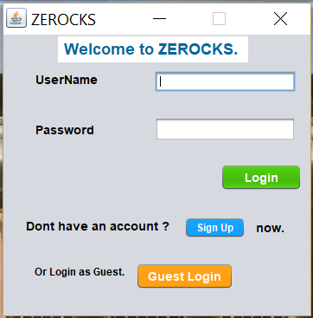

Login Window

The Login Window contains the following components :

1.JTextField- for username

2.JPasswordField- for Password.

3.JButton for login.

4.JButton for signup.

5.JButton for Guest login.

**Back end :**

1.Backend Code for Login button.

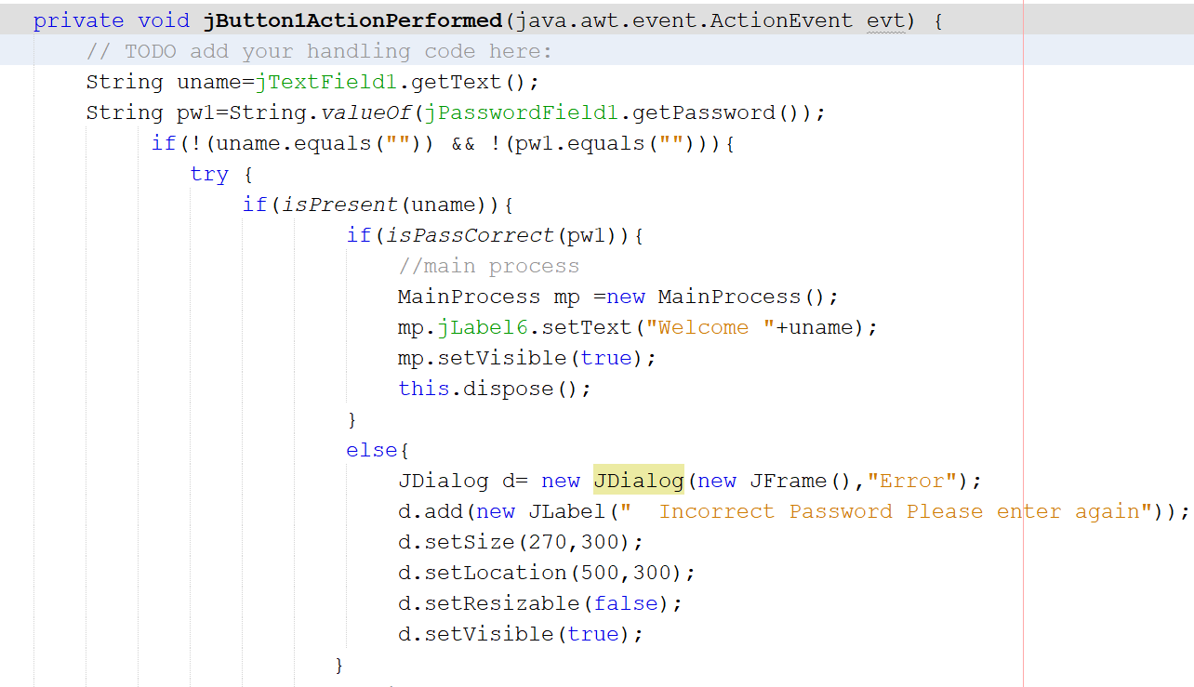

2. Sign-Up button.

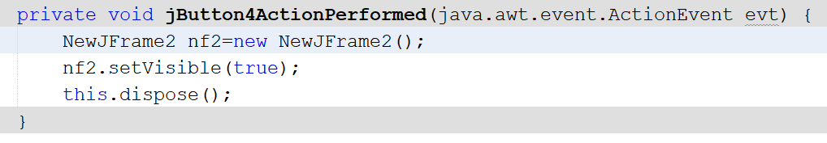

3.Guest-Login.

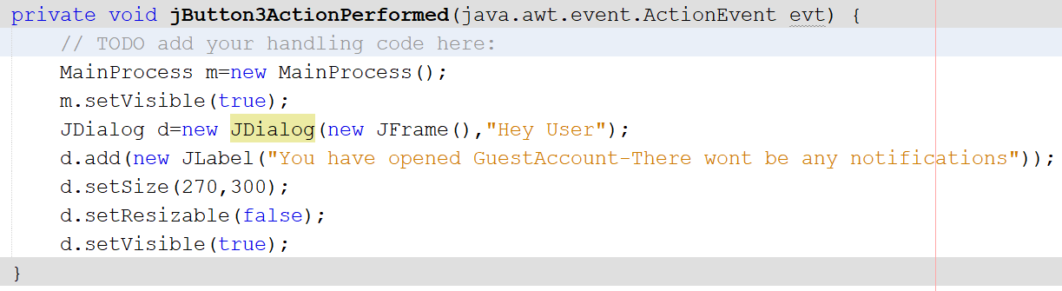

**Signup Window :**

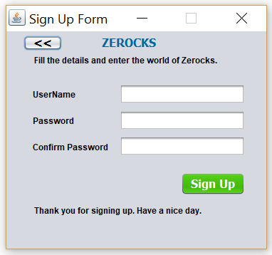

Signup window pops up when the user presses the sign-up button in the Login window.

Components of signup window :

1.JTextField for username

2.Two JPasswordFields for password and password conformation.

3.JButton for signing up.

**Back End :**

