University of Central Missouri

Department of Computer Science & Cybersecurity

CS5760 Natural Language Processing

Fall 2026

Homework 1.

Student name:

Srinivas Reddy Pittu
Submission Requirements:
- Once finished your assignment push your source code to your repo (GitHub) and explain the work through the ReadMe file properly. Make sure you add your student info in the ReadMe file.
- Submit your GitHub link on the Bright Space.
- Comment your code appropriately IMPORTANT.
- Any submission after provided deadline is considered as a late submission.

Q1. Regex
Task: Write a regex to find
- U.S. ZIP codes (disjunction + token boundaries)
Match 12345 or 12345-6789 or 12345 6789 (hyphen or space allowed for the +4 part). Make sure you only match whole tokens (not inside longer strings).
- Negation in disjunction (word start rules)
Find all words that do not start with a capital letter. Words may include internal apostrophes/hyphens like don’t, state-of-the-art.
- Convenient aliases (numbers, a bit richer)
Extract all numbers that may have:
  - optional sign (+/-),
  - optional thousands separators (commas),
  - optional decimal part,
  - optional scientific notation (e.g., 1.23e-4).
- More disjunction (spelling variants)
Match any spelling of “email”: email, e-mail, or e mail. Accept either a space or a hyphen (including en‐dash –) between e and mail, and be case-insensitive.
- Wildcards, optionality, repetition (with punctuation)
Match the interjection go, goo, gooo, … (one or more o), as a word, and allow an optional trailing punctuation mark ! . , ? (e.g., gooo!).
- Anchors (line/sentence end with quotes)
Match lines that end with a question mark possibly followed only by closing quotes/brackets like ")”’] and spaces.
Ans:
import re

# 1. U.S. ZIP codes
zip_pattern = re.compile(r"\b\d{5}(?:[-\s]\d{4})?\b")
zip_tests = ["12345", "12345-6789", "12345 6789", "123456", "abc12345"]
print("ZIP:", [m.group() for t in zip_tests for m in zip_pattern.finditer(t)])

# 2. Words not starting with a capital letter
word_pattern = re.compile(r"\b(?![A-Z])[A-Za-z]+(?:['’-][A-Za-z]+)*\b")
word_tests = ["dog", "Cat", "don’t", "state-of-the-art", "Hello"]
print("Non-capitalized words:", [m.group() for t in word_tests for m in word_pattern.finditer(t)])

# 3. Numbers (signs, commas, decimals, scientific notation)
num_pattern = re.compile(r"[+-]?(?:\d{1,3}(?:,\d{3})*|\d+)(?:\.\d+)?(?:[eE][+-]?\d+)?")
num_tests = ["123", "+123.45", "-1,234", "1.23e-4", "12,345,678.90e+10"]
print("Numbers:", [m.group() for t in num_tests for m in num_pattern.finditer(t)])

# 4. Email spelling variants
email_pattern = re.compile(r"(?i)\be[-\s–]?mail\b")
email_tests = ["email", "E-mail", "e mail", "E–mail", "Mail"]
print("Email variants:", [m.group() for t in email_tests for m in email_pattern.finditer(t)])

# 5. Interjection go/goo/gooo... with optional punctuation
go_pattern = re.compile(r"\bgo+[\!\.\,\?]?\b")
go_tests = ["go", "goo", "gooo!", "go?", "gone", "gooo,"]
print("Go variants:", [m.group() for t in go_tests for m in go_pattern.finditer(t)])

# 6. Lines ending with question mark + optional closing symbols
question_pattern = re.compile(r"\?[)\"'\]\s]*$")
question_tests = [
"Is this working?",
"What time is it?\") ",
"Really?'",
"No way!",
]
print("Questions:", [t for t in question_tests if question_pattern.search(t)])
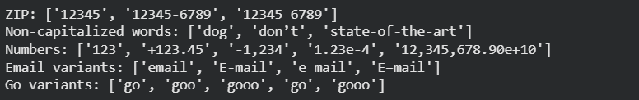

Q2. Manual BPE on a toy corpus
2.1 Using the same corpus from class:
low low low low low lowest lowest newer newer newer newer newer newer wider wider wider new new
- Add the end-of-word marker _ and write the initial vocabulary (characters + _).
Answer:
Word frequencies are low: 5, lowest: 2, newer: 6, wider: 3, and new: 2, for 18 word occurrences. Each occurrence contributes to the pair counts.
Initial vocabulary V0 = {_, d, e, i, l, n, o, r, s, t, w}
Vocabulary size = 11
l o w _ x 5
l o w e s t _ x 2
n e w e r _ x 6
w i d e r _ x 3
n e w _ x 2
- Compute bigram counts and perform the first three merges by hand:
  - Step 1: most frequent pair → merge → updated corpus snippet (show at least 2 lines).
Step 1 answer:
Initial pair counts:
(e,r):9 (r,_):9 (e,w):8 (n,e):8 (w,e):8
(l,o):7 (o,w):7 (w,_):7
(d,e):3 (i,d):3 (w,i):3
(e,s):2 (s,t):2 (t,_):2
Both (e, r) and (r, _) have count 9. The tie rule selects (e, r), so e + r becomes er. For example, the count is 6 from newer plus 3 from wider.
Updated corpus snippet:
n e w er _ x 6
w i d er _ x 3
New token: er; vocabulary size: 12
  - Step 2: repeat.
Step 2 answer:
Pair counts after Step 1:
(er,_):9 (e,w):8 (n,e):8
(l,o):7 (o,w):7 (w,_):7 (w,er):6
(d,er):3 (i,d):3 (w,i):3
(e,s):2 (s,t):2 (t,_):2 (w,e):2
The most frequent pair is now (er, _) with count 9. Merging it produces er_, which includes the end-of-word marker.
Updated corpus snippet:
n e w er_ x 6
w i d er_ x 3
New token: er_; vocabulary size: 13
  - Step 3: repeat.
Step 3 answer:
Pair counts after Step 2:
(e,w):8 (n,e):8
(l,o):7 (o,w):7 (w,_):7 (w,er_):6
(d,er_):3 (i,d):3 (w,i):3
(e,s):2 (s,t):2 (t,_):2 (w,e):2
The pairs (e, w) and (n, e) both have count 8. The tie rule selects (e, w), which forms ew. This pair appears six times in newer and twice in new.
Updated corpus snippet:
n ew er_ x 6
n ew _ x 2
New token: ew; vocabulary size: 14
- After each merge, list the new token and the updated vocabulary
Updated vocabularies:
V1 = {_, d, e, i, l, n, o, r, s, t, w, er}
V2 = {_, d, e, i, l, n, o, r, s, t, w, er, er_}
V3 = {_, d, e, i, l, n, o, r, s, t, w, er, er_, ew}

2.2 — Code a mini-BPE learner
- Use the classroom code above (or your own) to learn BPE merges for the toy corpus.
  - Print the top pair at each step and the evolving vocabulary size.
Python code:
The learner uses the same weighted counts and tie rule as the manual solution. The vocabulary size includes the original character inventory. The encoder applies learned merges in their original order.
from collections import Counter

def pair_counts(corpus):
"""Count adjacent token pairs, weighted by word frequency."""
counts = Counter()
for tokens, frequency in corpus.items():
for pair in zip(tokens, tokens[1:]):
counts[pair] += frequency
return counts

def merge_pair(tokens, pair):
"""Merge nonoverlapping occurrences from left to right."""
result, index = [], 0
while index < len(tokens):
if tuple(tokens[index:index + 2]) == pair:
result.append("".join(pair))
index += 2
else:
result.append(tokens[index])
index += 1
return tuple(result)

def train_bpe(words, maximum_merges):
"""Keep base characters and every learned token in the vocabulary."""
corpus = Counter({tuple(w) + ("_",): n
for w, n in Counter(words).items()})
vocabulary = {t for word in corpus for t in word}
history = []
for step in range(1, maximum_merges + 1):
counts = pair_counts(corpus)
if not counts:
break
# Highest frequency wins; ties use alphabetical pair order.
pair = min(counts, key=lambda p: (-counts[p], p))
updated = Counter()
for tokens, frequency in corpus.items():
updated[merge_pair(tokens, pair)] += frequency
corpus = updated
vocabulary.add("".join(pair))
history.append({
"step": step, "pair": pair, "count": counts[pair],
"token": "".join(pair), "vocab_size": len(vocabulary)
})
return history, vocabulary, corpus

def encode_bpe(word, history):
"""Apply learned merges in training order to a new word."""
tokens = tuple(word) + ("_",)
for item in history:
tokens = merge_pair(tokens, tuple(item["pair"]))
return list(tokens)

def print_history(history):
for item in history:
a, b = item["pair"]
print(f"{item['step']:2}: ({a}, {b}) -> "
f"{item['token']}; count={item['count']}; "
f"vocabulary={item['vocab_size']}")
TOY = ("low low low low low lowest lowest "
"newer newer newer newer newer newer "
"wider wider wider new new")
TOY_TARGETS = ["new", "newer", "lowest", "widest", "newestest"]
toy_history, toy_vocabulary, _ = train_bpe(TOY.split(), 20)
print_history(toy_history)
for word in TOY_TARGETS:
print(word, encode_bpe(word, toy_history))
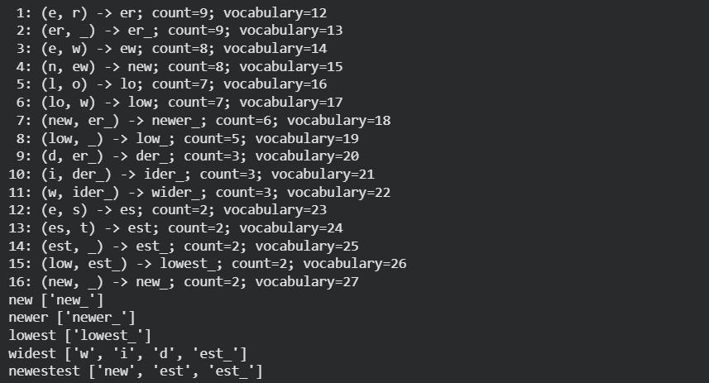
- Segment the words: new, newer, lowest, widest, and one word you invent (e.g., newestest).
  - Include the subword sequence produced (tokens with _ where applicable).
Word segmentation output:
new: new_
newer: newer_
lowest: lowest_
widest: w | i | d | est_
newestest: new | est | est_
The vertical bars show token boundaries. The invented word is newestest; it is absent from the training corpus. The word widest is also absent. The final underscore marks the end of each word.
- In 5–6 sentences, explain:
  - How subword tokens solved the OOV (out-of-vocabulary) problem.
  - One example where subwords align with a meaningful morpheme (e.g., er_ as English agent/comparative suffix).
Explanation in six sentences:
BPE reduces the out-of-vocabulary problem by representing an unseen word with smaller known pieces. A word can still be encoded when its full form is missing, as long as its characters belong to the training alphabet. For example, the unseen word widest becomes w, i, d, and est_, and the invented word newestest becomes new, est, and est_. The learned token er_ matches the comparative ending in newer and wider. However, BPE follows frequency, so a learned token does not always match a meaningful morpheme. A completely unseen character still needs another method, such as an unknown-character token or a byte-level fallback.

2.3 — Your language (or English if you prefer)
Pick one short paragraph (4–6 sentences) in your own language (or English if that’s simpler).
Selected language and paragraph:
English is used for this exercise. The paragraph contains five sentences:
Students study language because language connects people. A student studies words and learns how useful word parts repeat. Teachers explain tokenization, while students compare tokens from different sentences. Reusable patterns help readers understand unfamiliar words such as microarchitecture. Learning these patterns makes reading and writing easier.
- Train BPE on that paragraph (or a small file of your choice).
  - Use end-of-word _.
  - Learn at least 30 merges (adjust if the text is very small).
Training code:
The paragraph is lowercased, punctuation is removed, and each word receives _. The same BPE functions from Q2.2 are reused. Exactly 30 merges are learned, increasing the vocabulary from 24 initial symbols to 54 tokens.
import re

PARAGRAPH = (
"Students study language because language connects people. "
"A student studies words and learns how useful word parts repeat. "
"Teachers explain tokenization, while students compare tokens "
"from different sentences. Reusable patterns help readers "
"understand unfamiliar words such as microarchitecture. "
"Learning these patterns makes reading and writing easier."
)
PARAGRAPH_TARGETS = [
"language", "students", "tokenization", "microarchitecture", "reusable"
]
words = re.findall(r"[a-z]+", PARAGRAPH.lower())
history, vocabulary, _ = train_bpe(words, 30)
print_history(history)
top_five = sorted(
history, key=lambda x: (-x["count"], x["step"])
)[:5]
longest = sorted(
vocabulary, key=lambda t: (-len(t.rstrip("_")), t)
)[:5]
print("Most frequent:", top_five)
print("Longest:", longest)
for word in PARAGRAPH_TARGETS:
print(word, encode_bpe(word, history))

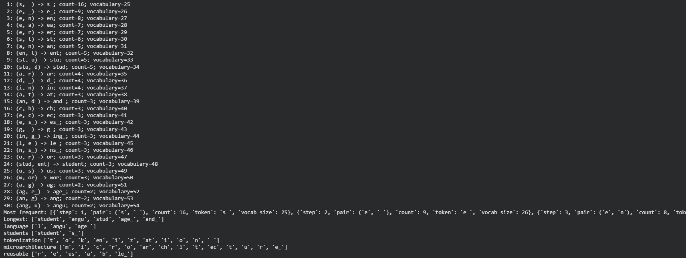
- Show the five most frequent merges and the resulting five longest subword tokens.
Five most frequent merge events:
Counts are recorded when each merge is selected; ties use learning-step order.
1. (s, _) -> s_; count 16; vocabulary 25
2. (e, _) -> e_; count 9; vocabulary 26
3. (e, n) -> en; count 8; vocabulary 27
4. (e, a) -> ea; count 7; vocabulary 28
5. (e, r) -> er; count 7; vocabulary 29
Five longest learned tokens:
student (7); angu (4); stud (4); age_ (3); and_ (3)
Lengths exclude _. Ties use alphabetical order. Tokens come from the retained vocabulary, so the intermediate token stud remains eligible.
- Segment 5 different words from the paragraph:
  - Include one rare word and one derived/inflected form.
Five word segmentations:
language: l | angu | age_
students: student | s_
tokenization: t | o | k | en | i | z | at | i | o | n | _
microarchitecture: m | i | c | r | o | ar | ch | i | t | ec | t | u | r | e_
reusable: r | e | us | a | b | le_
Rare word: microarchitecture, which appears once. Inflected form: students, split into student and the plural ending s_.
- Brief reflection (5–8 sentences):
  - What kinds of subwords were learned (prefixes, suffixes, stems, whole words)?
  - Two concrete pros/cons of subword tokenization for your language.
Reflection in seven sentences:
The model learned a stem such as student and suffix-like pieces such as s_ and ing_. It also learned a complete word, and_, together with fragments such as angu that are not useful morphemes by themselves. It did not learn a clear re- prefix for reusable within the 30-merge limit. One advantage is that student can be reused in students, which reduces the need to store every word form separately. Another advantage is that the rare word microarchitecture can be represented without adding the whole word to the vocabulary. One disadvantage is that this rare word needs 14 tokens, which makes its sequence long. Another disadvantage is that frequency-based pieces can hide word structure, as language becomes l, angu, and age_ instead of meaningful English parts.
Q3. Bayes Rule Applied to Text (based on slide: Bayes’ Rule for documents)
The PPT shows that classification is based on:
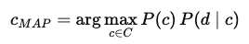

Tasks:
- Explain in your own words what each term means: P(c), P(d∣c) and P(c∣d).
Answer:
P(c) is the prior probability of class c before reading the document. It represents how common that class is; for example, three negative documents out of five give a negative prior of 3/5.
P(d | c) is the likelihood of observing document d if its class is c. In a text classifier, the words in the document provide evidence for this likelihood.
P(c | d) is the posterior probability that document d belongs to class c after its words have been observed. It combines the prior with the evidence from the document.
$$P(c | d) =\frac{P(d | c) P(c)}{P(d)}$$
- Why can the denominator P(d) be ignored when comparing classes?
Answer:
For the same document, P(d) has the same positive value for every candidate class. Dividing each class score by this common value does not change which score is largest, so the classifier compares P(c) multiplied by P(d | c). The denominator is needed when actual normalized posterior probabilities are required, rather than only the winning class.

Q4. Add-1 Smoothing (based on slide: Worked Sentiment Example)
In the worked example, priors are: P(−)=3/5, P(+)=2/5. Vocabulary size = 20.

Tasks:
- For the negative class, the total token count is 14. Compute the denominator for likelihood estimation using add-1 smoothing.
Answer:
Add-1 smoothing adds one count for every vocabulary word. The denominator is the negative-class token count plus the vocabulary size: 14 + 20 = 34.
- Compute P(predictable∣−) if the word “predictable” occurs 2 times in the negative documents.
Answer:
The observed count is 2, so the smoothed count is 3:
$$P(predictable | −) =\frac{2 + 1}{14 + 20}=\frac{3}{34}≈ 0.088235$$
Compute P(fun∣−) if “fun” never appeared in any negative documents.
Answer:
The observed count is 0, so add-1 smoothing gives it one count:
$$P(fun | −) =\frac{0 + 1}{14 + 20}=\frac{1}{34}≈ 0.029412$$
Smoothing gives fun a nonzero probability in the negative class. The class priors, 3/5 and 2/5, are used separately when computing class scores; they are not part of these word-likelihood denominators.

Q5. Programming Question:
1. Tokenize a paragraph
Take a short paragraph (3–4 sentences) in your language (e.g., from news, a story, or social media).
Selected paragraph in English:
The students' project is working well in New York. They're building a state-of-the-art app, and it doesn't crash during testing. The teachers' feedback helped the team break the ice. We enjoyed ice cream after finishing the app.
- Do naïve space-based tokenization.
Naïve space-based tokens:
Using paragraph.split() produces 37 tokens. Sentence labels are only for presentation; all tokens belong to one paragraph.
Sentence 1:
['The', "students'", 'project', 'is', 'working', 'well', 'in', 'New', 'York.']
Sentence 2:
["They're", 'building', 'a', 'state-of-the-art', 'app,', 'and', 'it', "doesn't", 'crash', 'during', 'testing.']
Sentence 3:
['The', "teachers'", 'feedback', 'helped', 'the', 'team', 'break', 'the', 'ice.']
Sentence 4:
['We', 'enjoyed', 'ice', 'cream', 'after', 'finishing', 'the', 'app.']
- Manually correct the tokens by handling punctuation, suffixes, and clitics.
Submit both versions and highlight differences.
Manually corrected tokens:
The manual policy separates punctuation, possessive markers, contractions, and selected inflectional suffixes. Hyphenated state-of-the-art stays together. This is a morphology-aware choice for this exercise; ordinary word tokenization may keep inflected words whole. The result contains 54 tokens.
Sentence 1:
['The', 'student', 's', "'", 'project', 'is', 'work', 'ing', 'well', 'in', 'New', 'York', '.']
Sentence 2:
['They', "'re", 'build', 'ing', 'a', 'state-of-the-art', 'app', ',', 'and', 'it', 'does', "n't", 'crash', 'during', 'test', 'ing', '.']
Sentence 3:
['The', 'teacher', 's', "'", 'feedback', 'help', 'ed', 'the', 'team', 'break', 'the', 'ice', '.']
Sentence 4:
['We', 'enjoy', 'ed', 'ice', 'cream', 'after', 'finish', 'ing', 'the', 'app', '.']
Highlighted changes:
students' becomes student + s + '; teachers' becomes teacher + s + '. The plural suffix and the possessive marker are kept separate.
They're becomes They + 're, and doesn't becomes does + n't. These clitic pieces are retained rather than expanded into new words.
working becomes work + ing; building becomes build + ing; testing becomes test + ing; finishing becomes finish + ing. helped becomes help + ed, and enjoyed becomes enjoy + ed.
York., testing., ice., and app. lose their attached periods, which become separate tokens. The comma in app, also becomes a separate token.
2. Compare with a Tool
Run the paragraph through an NLP tool that supports your language (e.g., NLTK, spaCy, or any open-source tokenizer if available).
NLTK code:
The code uses NLTK TreebankWordTokenizer, version 3.10.3 in the executed run. The four known sentences are tokenized separately so every sentence-final period is split. This tokenizer needs no downloaded language model. The sentences and manual token lists are included in the runnable code below.
from nltk.tokenize import TreebankWordTokenizer, MWETokenizer

SENTENCES = [
"The students' project is working well in New York.",
"They're building a state-of-the-art app, and it doesn't "
"crash during testing.",
"The teachers' feedback helped the team break the ice.",
"We enjoyed ice cream after finishing the app.",
]

# Manual policy: separate punctuation, clitics, and selected suffixes.
# Keep hyphenated compounds intact. MWEs are grouped separately below.
MANUAL_SENTENCES = [
["The", "student", "s", "'", "project", "is", "work", "ing",
"well", "in", "New", "York", "."],
["They", "'re", "build", "ing", "a", "state-of-the-art",
"app", ",", "and", "it", "does", "n't", "crash", "during",
"test", "ing", "."],
["The", "teacher", "s", "'", "feedback", "help", "ed", "the",
"team", "break", "the", "ice", "."],
["We", "enjoy", "ed", "ice", "cream", "after", "finish", "ing",
"the", "app", "."],
]
MWES = [("New", "York"), ("break", "the", "ice"), ("ice", "cream")]

paragraph = " ".join(SENTENCES)
naive = paragraph.split()
manual = [t for s in MANUAL_SENTENCES for t in s]
tokenizer = TreebankWordTokenizer()
tool_sentences = [tokenizer.tokenize(s) for s in SENTENCES]
tool = [t for s in tool_sentences for t in s]
grouped = MWETokenizer(MWES, separator="_").tokenize(tool)
print("Naive:", naive)
print("Manual:", manual)
print("NLTK:", tool)
print("With MWEs:", grouped)
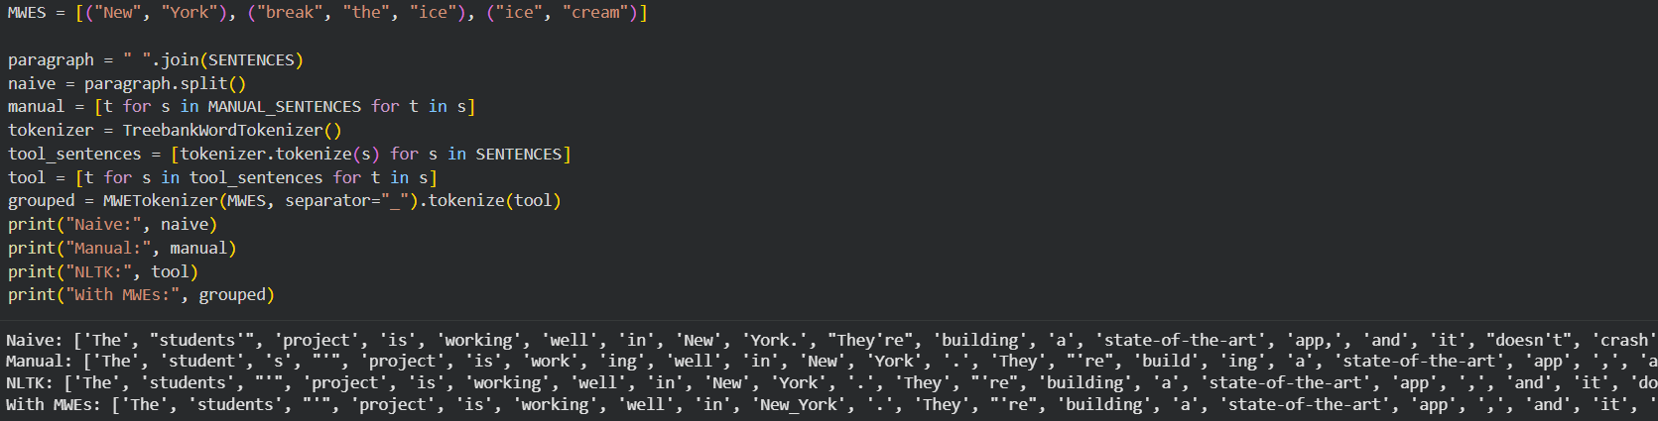
- Compare tool output vs. your manual tokens.
NLTK output:
NLTK produces 46 tokens:
Sentence 1:
['The', 'students', "'", 'project', 'is', 'working', 'well', 'in', 'New', 'York', '.']
Sentence 2:
['They', "'re", 'building', 'a', 'state-of-the-art', 'app', ',', 'and', 'it', 'does', "n't", 'crash', 'during', 'testing', '.']
Sentence 3:
['The', 'teachers', "'", 'feedback', 'helped', 'the', 'team', 'break', 'the', 'ice', '.']
Sentence 4:
['We', 'enjoyed', 'ice', 'cream', 'after', 'finishing', 'the', 'app', '.']
- Which tokens differ? Why?
Differences between the tool and manual tokens:
students -> student | s
working -> work | ing
building -> build | ing
testing -> test | ing
teachers -> teacher | s
helped -> help | ed
enjoyed -> enjoy | ed
finishing -> finish | ing
These eight differences occur because the manual version splits selected suffixes while TreebankWordTokenizer keeps ordinary inflected words intact. Both versions separate the possessive apostrophes, contractions, comma, and sentence-final periods. Both preserve state-of-the-art as one token and initially keep the three MWEs as separate words. The extra suffix splits account for the increase from 46 tool tokens to 54 manual tokens.
3. Multiword Expressions (MWEs)
Identify at least 3 multiword expressions (MWEs) in your language. Example:
- Place names, idioms, or common fixed phrases.
- Explain why they should be treated as single tokens.
Answer:
New York is a place name. Grouping it as New_York helps the system recognize one location rather than interpreting New and York independently.
break the ice is an idiom meaning to make people feel more comfortable at the start of an interaction. Grouping it as break_the_ice preserves this meaning instead of suggesting that someone is physically breaking ice.
ice cream names one food item. Grouping it as ice_cream keeps the phrase attached to that concept.
These expressions can be treated as single semantic units for tasks such as entity recognition or phrase analysis. Grouping is task-dependent, and the idiom must be interpreted in context. NLTK MWETokenizer merges the three listed expressions and changes the tool output from 46 to 42 tokens.
New | York -> New_York
break | the | ice -> break_the_ice
ice | cream -> ice_cream
4. Reflection (5–6 sentences)
- What was the hardest part of tokenization in your language?
- How does it compare with tokenization in English?
- Do punctuation, morphology, and MWEs make tokenization more difficult?
Reflection in six sentences:
The hardest part was deciding how far to split words that contain both a suffix and a possessive marker, such as students'. Since I chose English, this exercise directly shows the issues found in English tokenization. Spaces locate many word boundaries, but they leave punctuation and contractions attached. Splitting working into work and ing helps show its structure, although a general word tokenizer can reasonably keep working together. Multiword expressions create another difficulty because New York and break the ice have meanings that depend on the complete phrase. A useful tokenizer therefore needs a clear policy for punctuation, morphology, clitics, and the phrases needed by its task.
References
Python Software Foundation. re — Regular expression operations. https://docs.python.org/3/library/re.html
NLTK. TreebankWordTokenizer documentation. https://www.nltk.org/api/nltk.tokenize.TreebankWordTokenizer.html
Sennrich, R., Haddow, B., and Birch, A. (2016). Neural Machine Translation of Rare Words with Subword Units. https://aclanthology.org/P16-1162/

